**Angular - 2014**

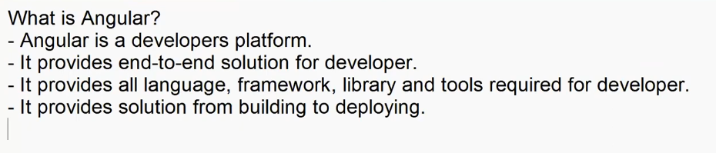

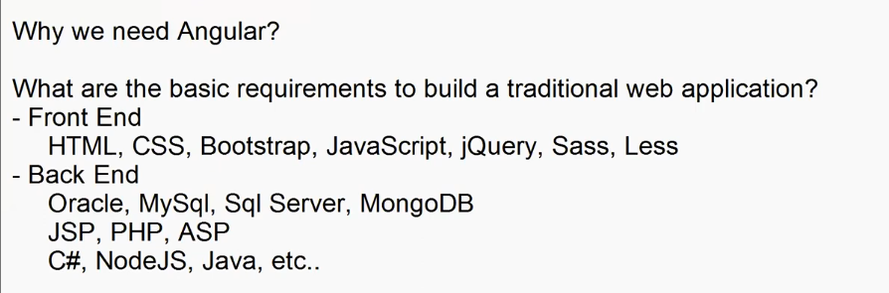

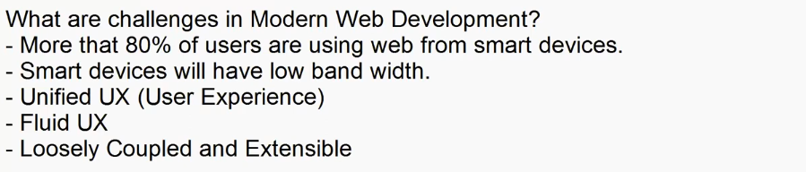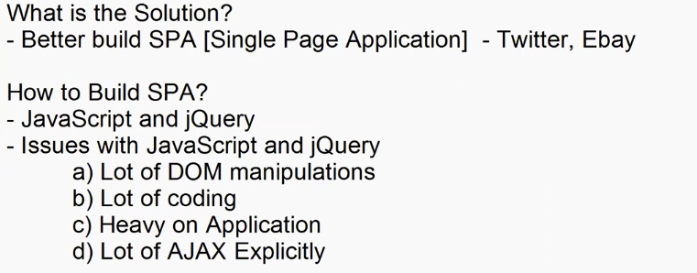

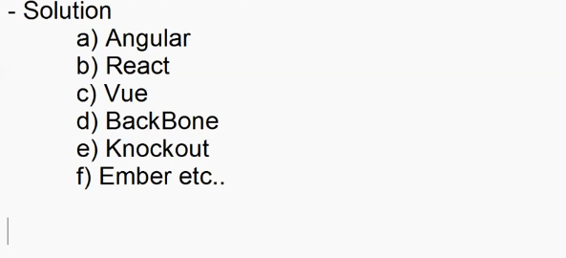

+

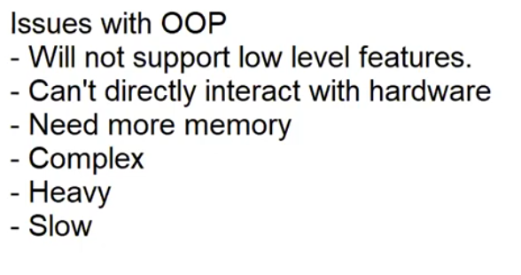

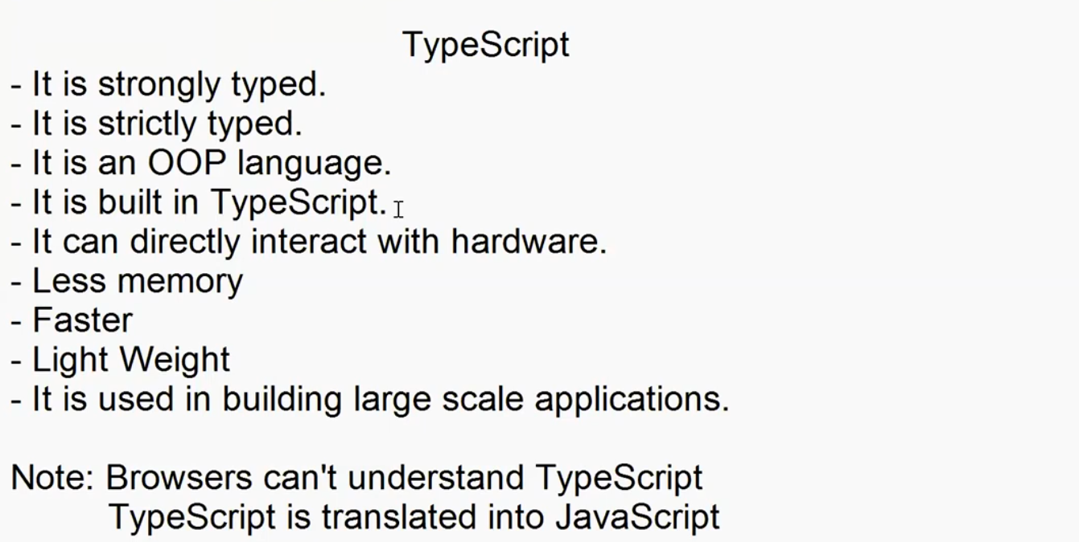

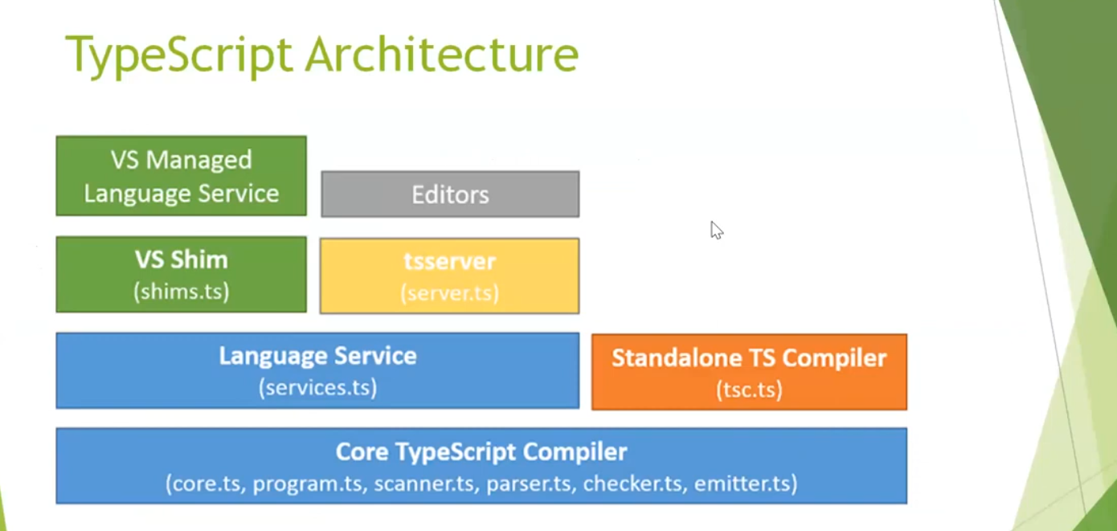

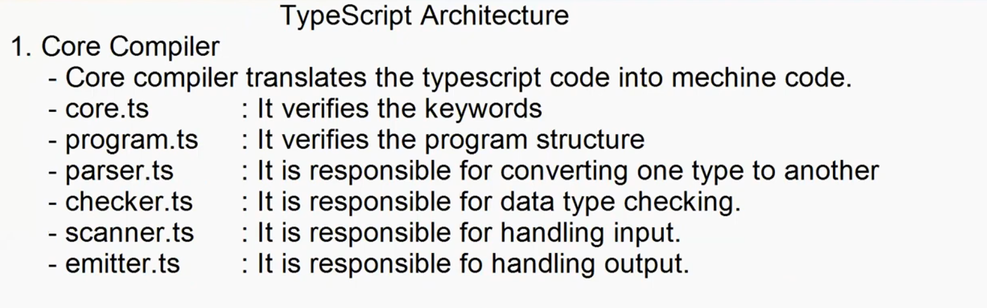

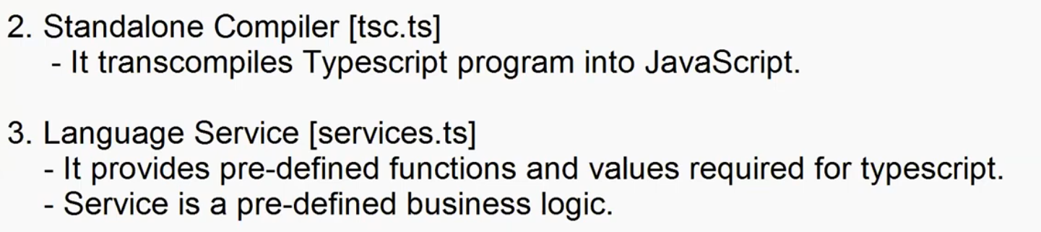

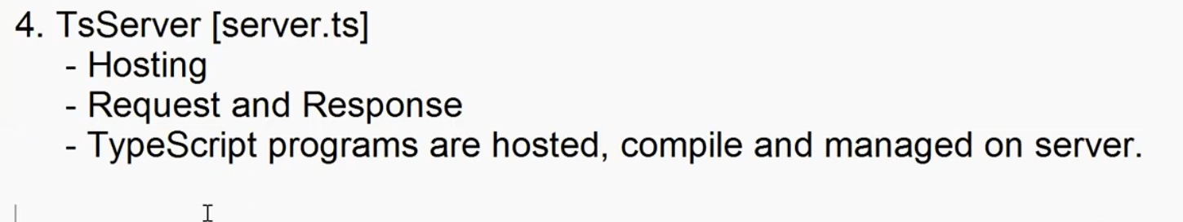

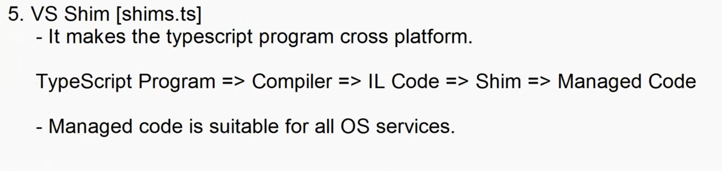

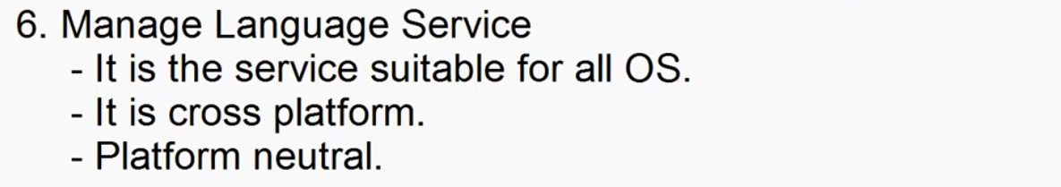

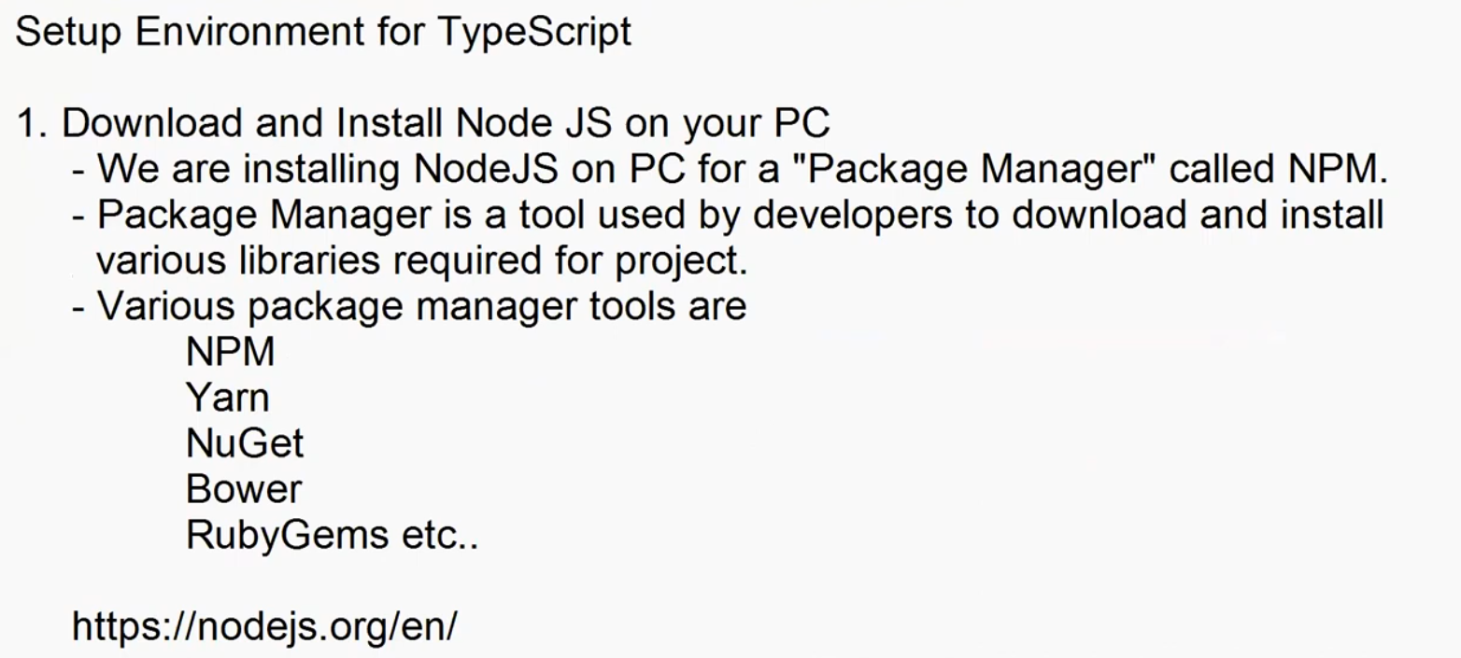

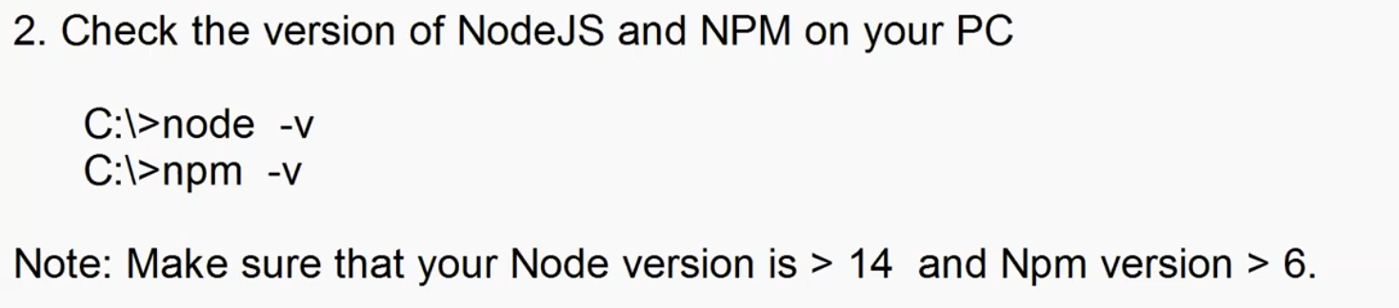

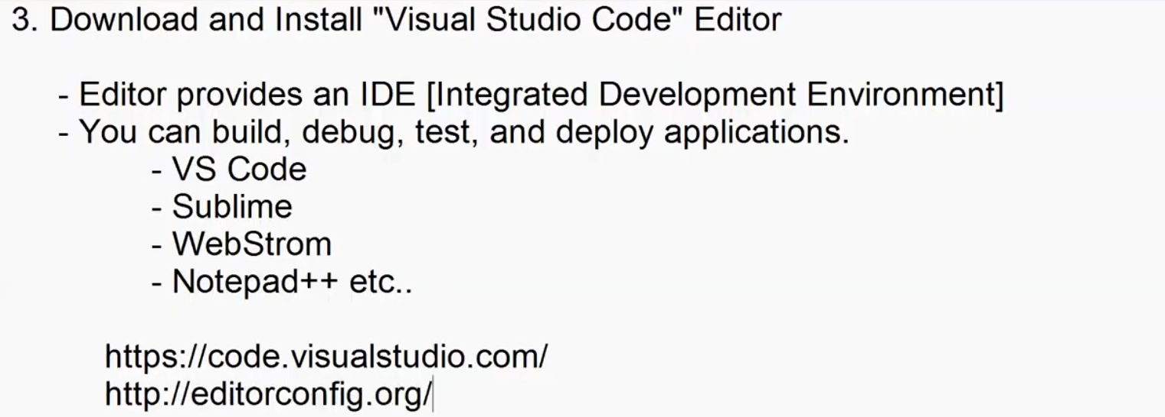

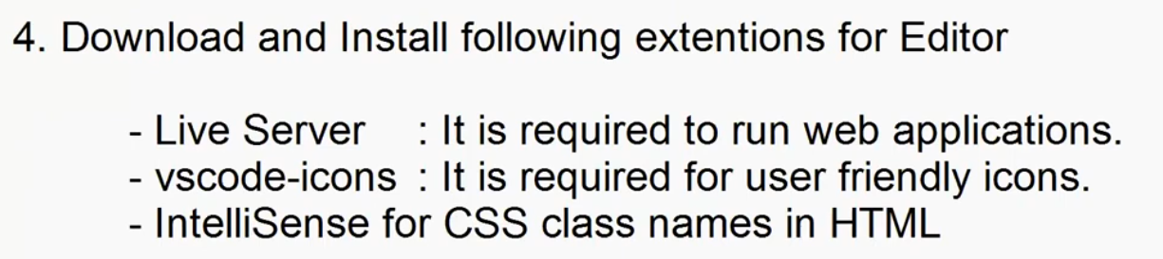

-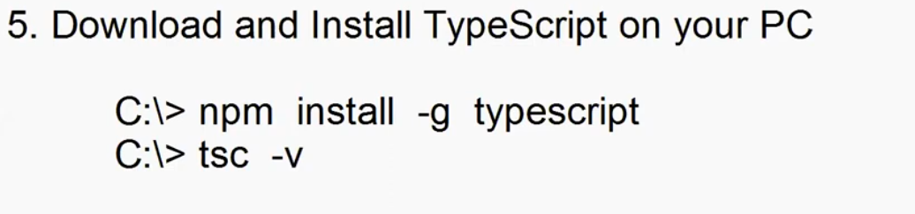

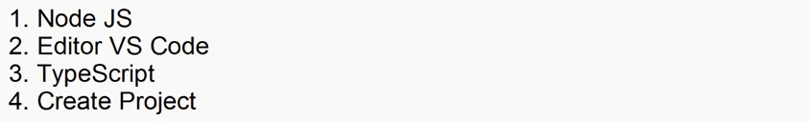

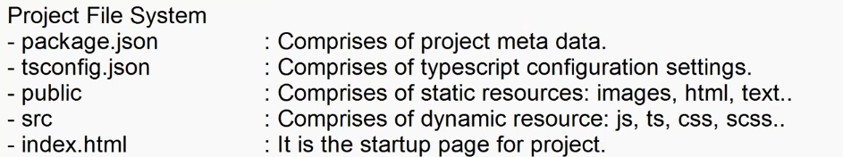

TypeScrips Language Basics

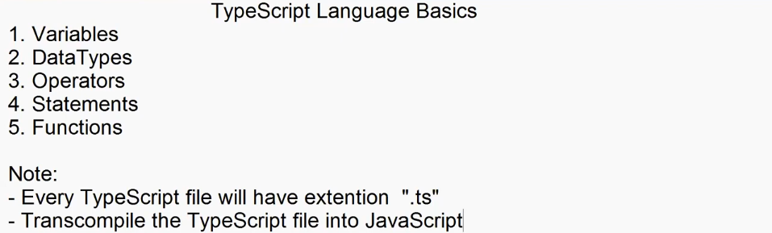

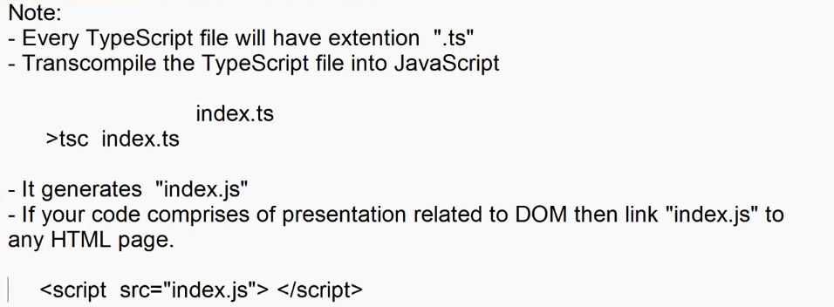

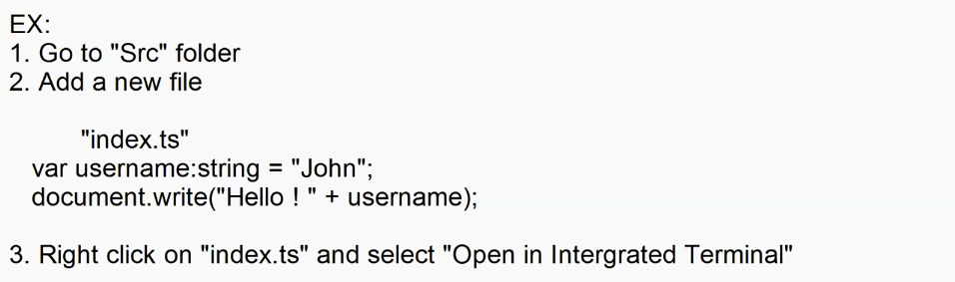

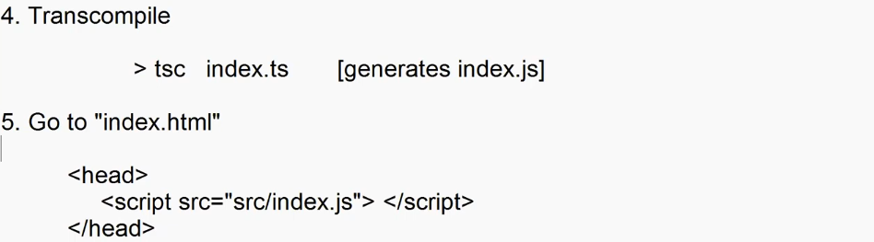

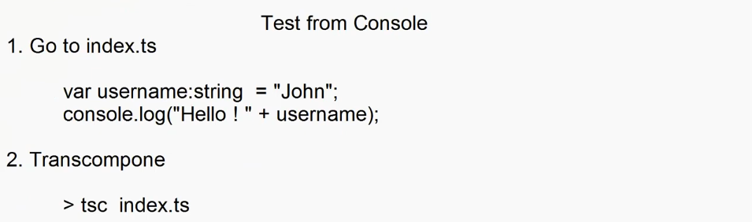

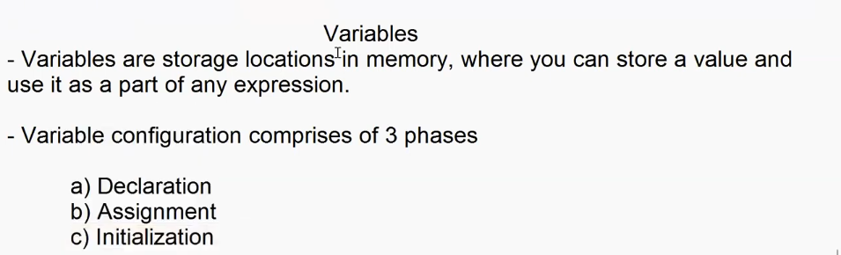

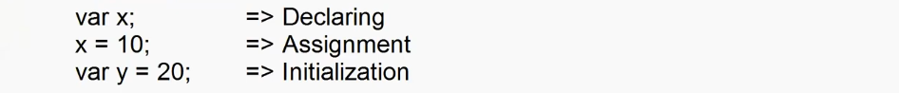

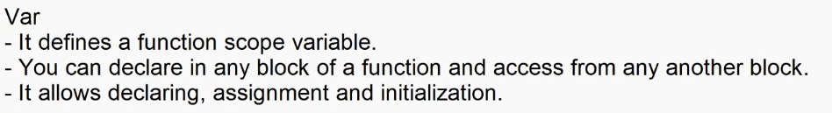

function Demo()

{

    var x;

    x=10;

    if(x==10)

    {

        var y = 20;

var y = 30;//shadowing

    }

    console.log("x = "+x +"\ny= "+y);//can access var outide the function

}

Demo();

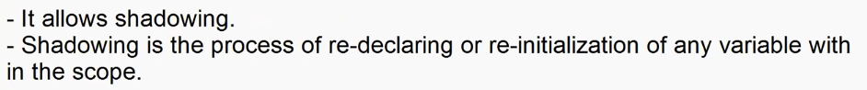

function Demo(){

    x=10;

    console.log("x= "+ x);

    var x; // hoisting

}

Demo();



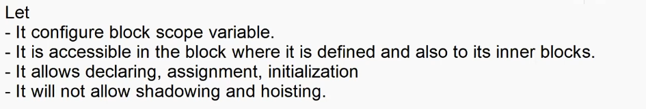

function Demo()

{

    let x;

    x=10;

    if(x==10)

    {

        let y = 20;

        console.log("x = "+x +"\n y= "+y);//can access let inside the function/block

    }

    console.log("x = "+x +"\n y= "+y);//cannot access let outside the function/block

}

Demo();

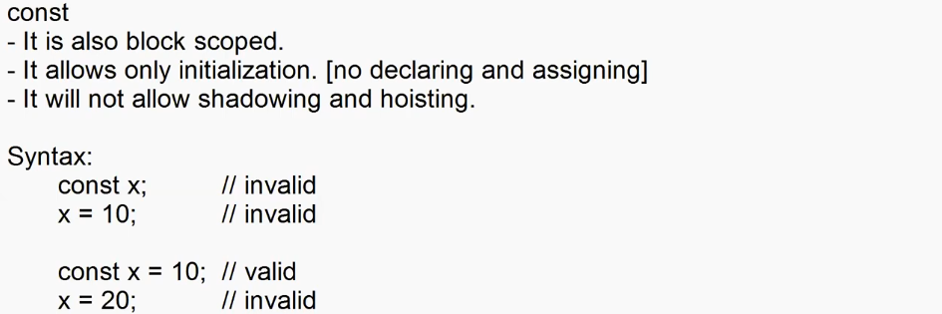

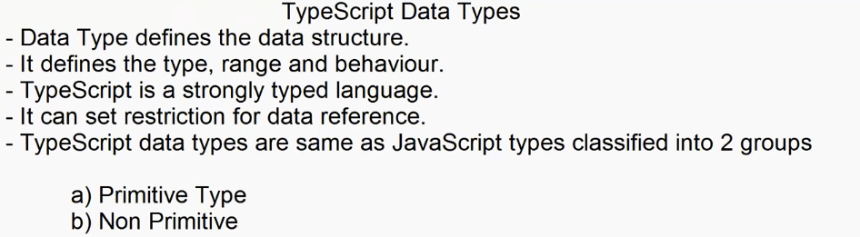

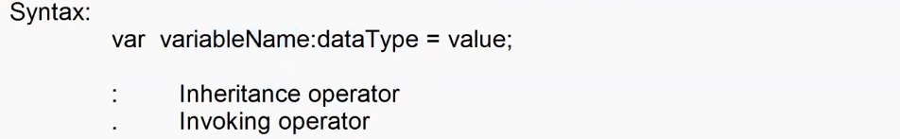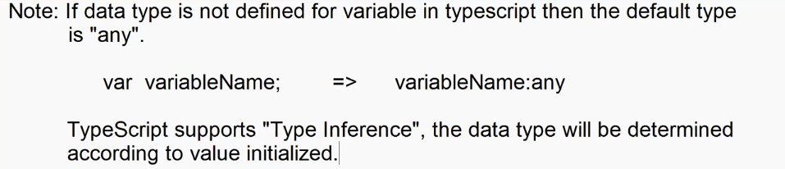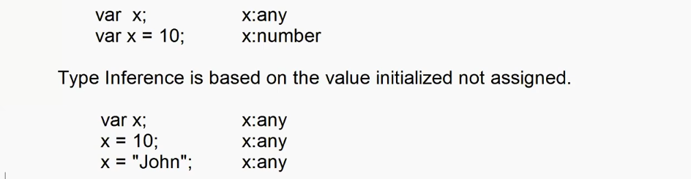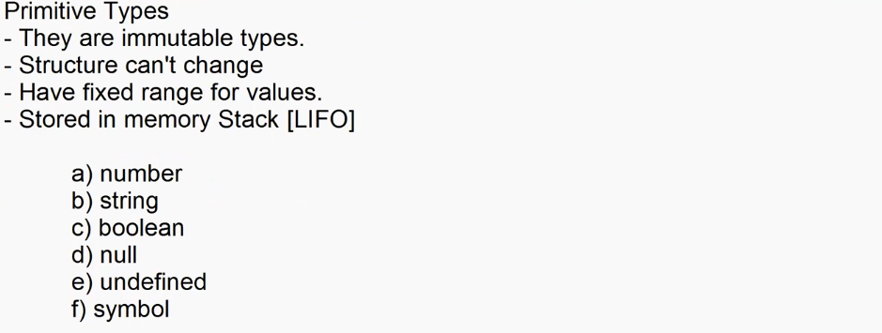

**Number**

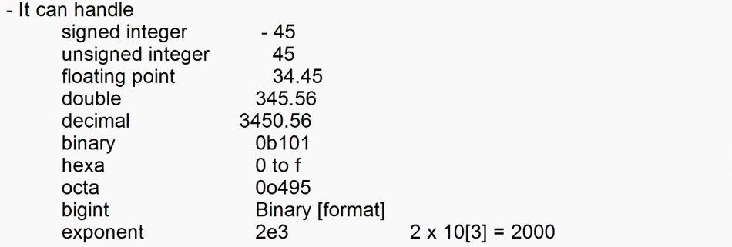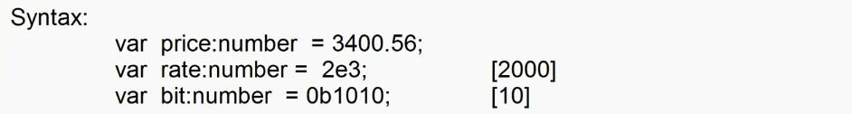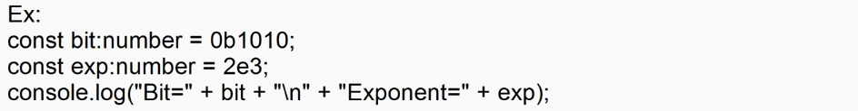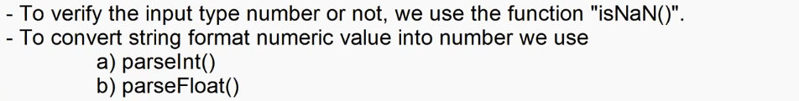

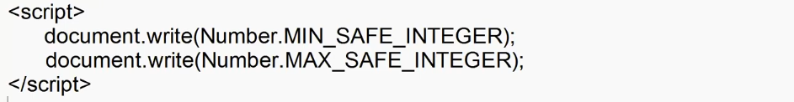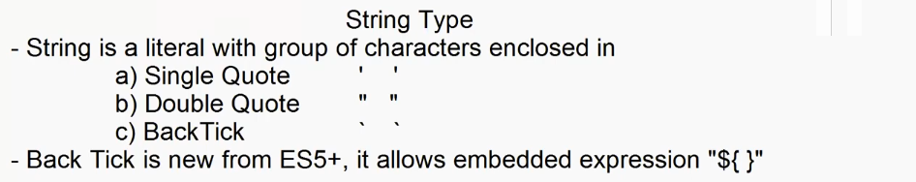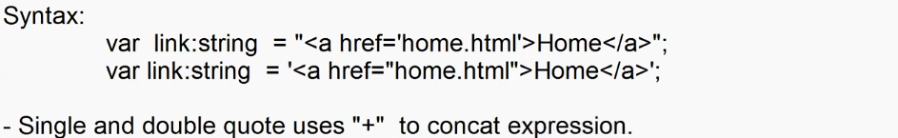

var username:String = "Adesh";

var age:number = 23;

var msg1 = "Hello ! "+ username + " you will be "+age+" next year.";

var msg2 = `Hello ! ${username} you will be ${age} next year.`;

console.log(msg1);

console.log(msg2);

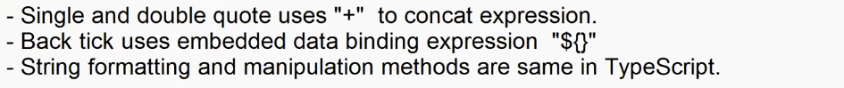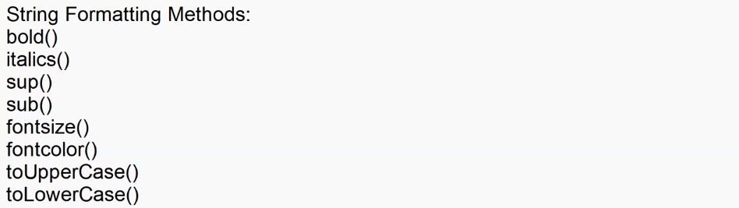

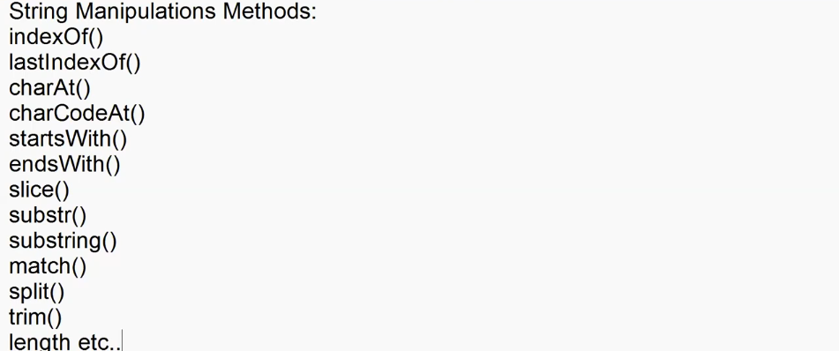

var mobile:string = "+919876543210";

if(mobile.match(/\+91\d{10}/)){

    console.log("Otp send");

}

else{

    console.log("Invalid Mobile");

}

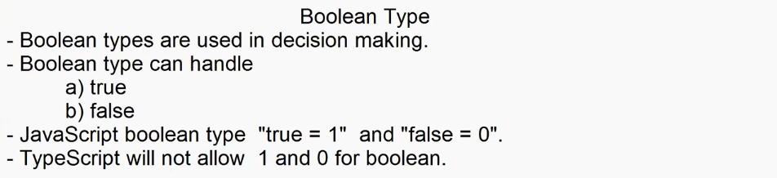

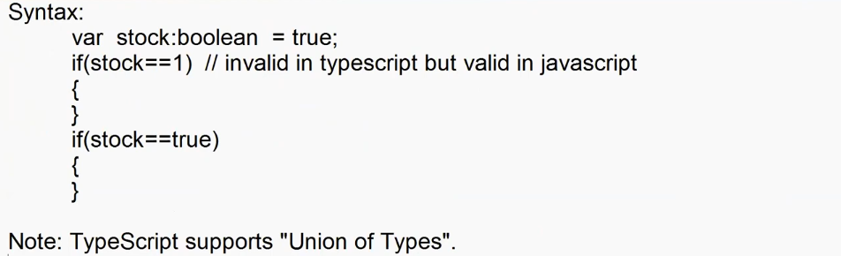

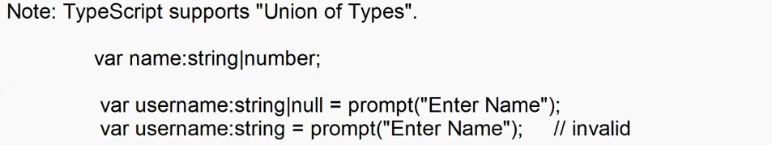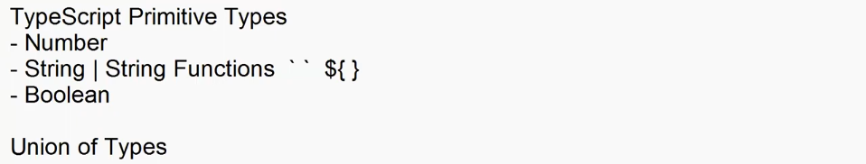

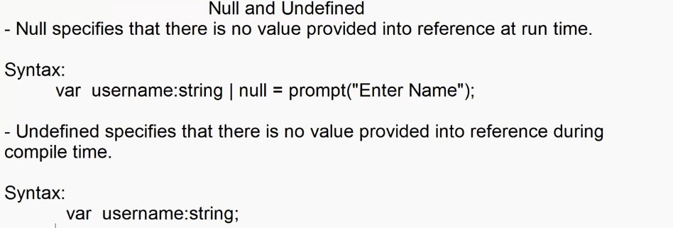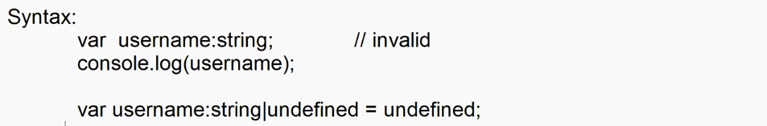

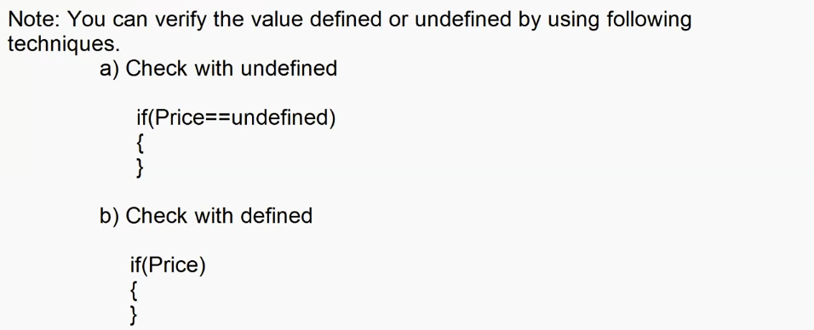

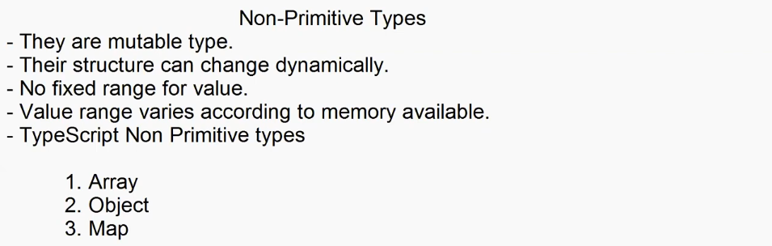

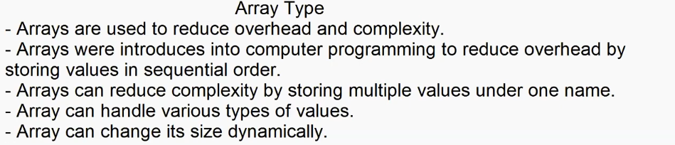

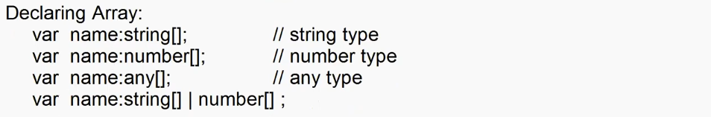

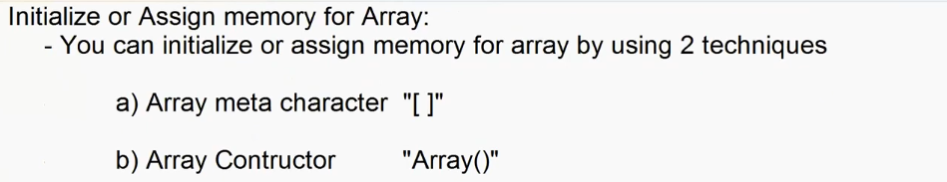

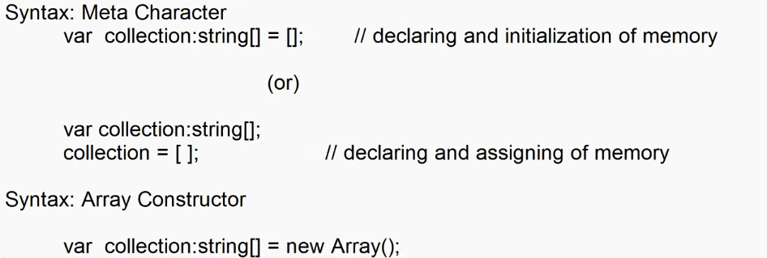

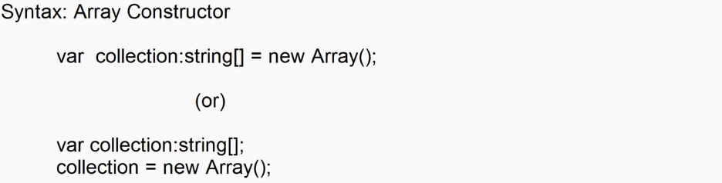

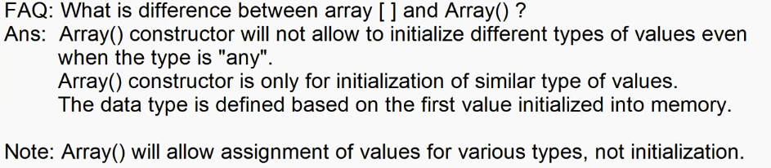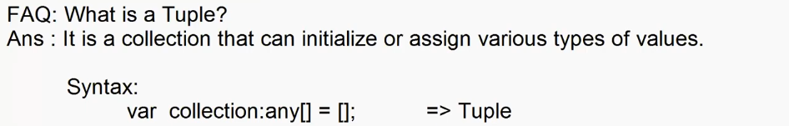

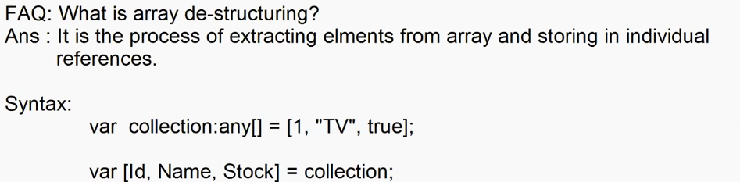

**Old**

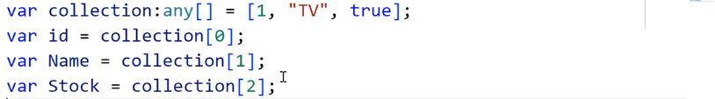

**New**

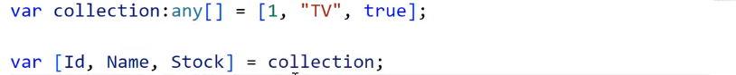

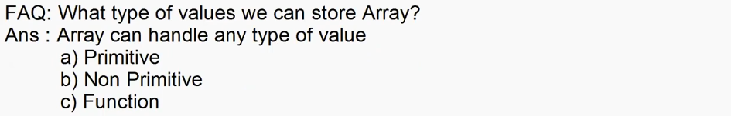

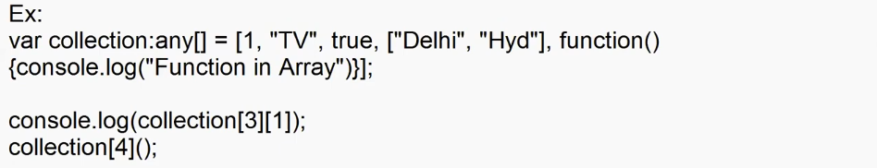

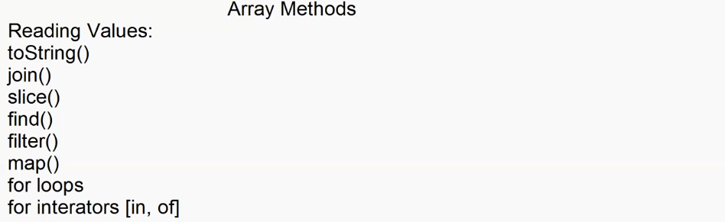

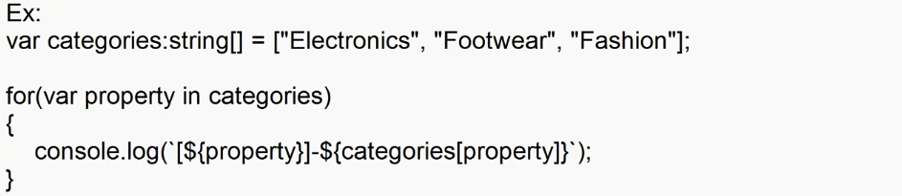

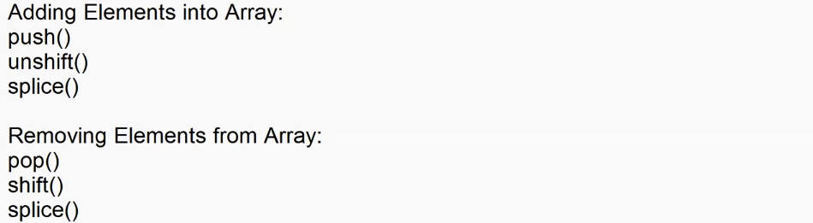



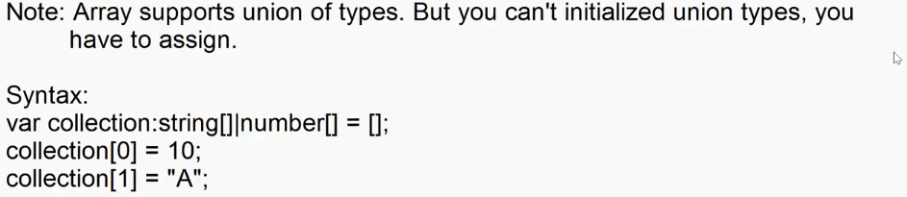

**Object**

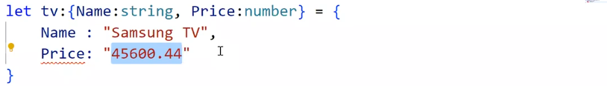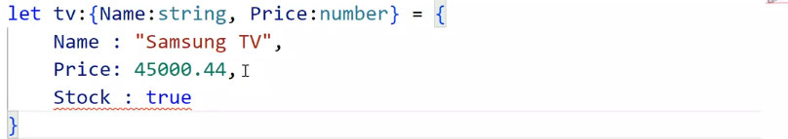

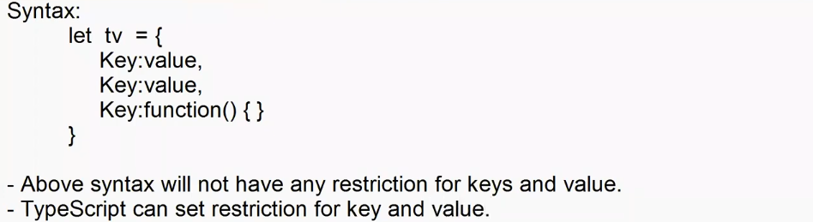

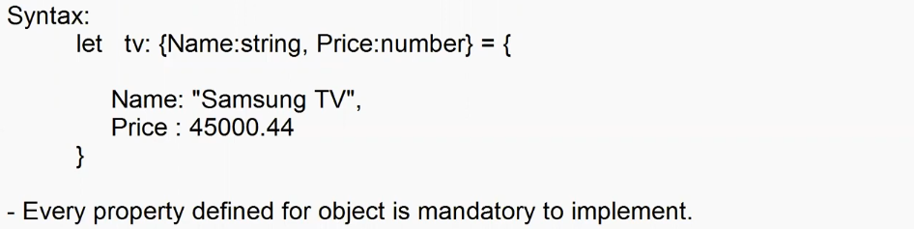

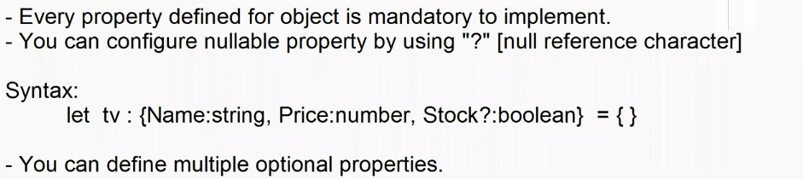

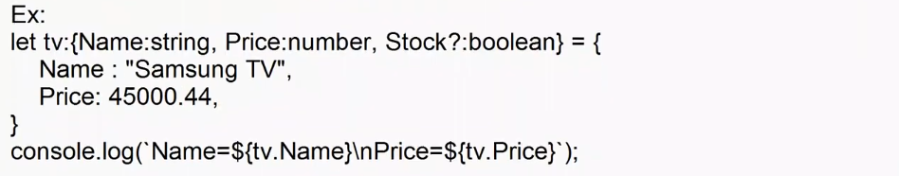

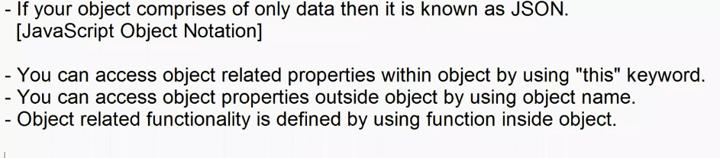

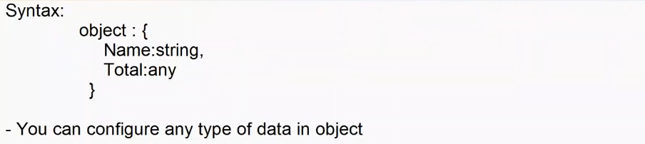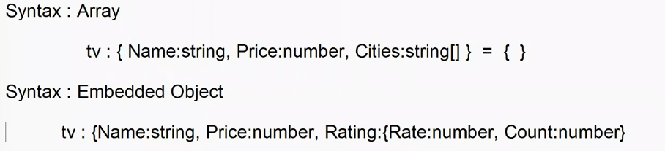

Ex:

let tv:{Name:String, Price:number, Qty:number, Cities:string[], Rating:any, Total:any, Print?:any } = {

    Name : "Samsung TV",

    Price:45000.44,

    Qty: 2,

    Total: function(){

        return this.Price*this.Qty;

    },

    Cities:["Pune","Hyd"],

    Rating: {Rate:4.3,Count:600},

    Print: function(){

        console.log(`

            Name=${this.Name}\n

            Price=${this.Price}\n

            Qty=${this.Qty}\n

            Rating=${this.Rating.t}\n

            Cities=${this.Cities.toString()}\n

            Rating=${this.Rating.Rate} [${this.Rating.Count}]\n

            Total=${this.Total()}\n`

        );

    }

}

tv.Print();



**\*\*\***

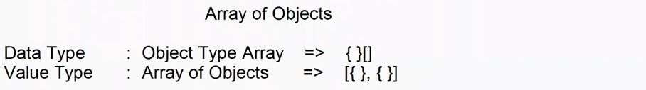**Wrong**

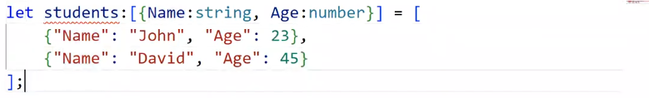

**Right**

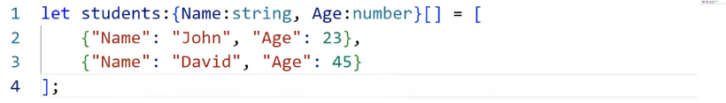

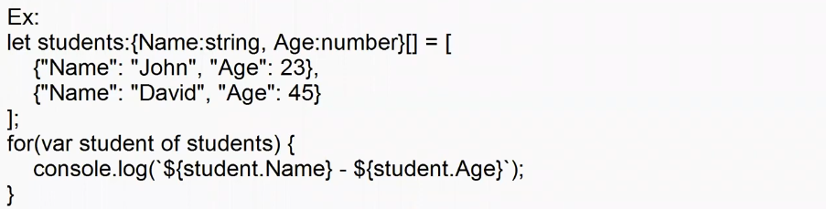

**Map Type**

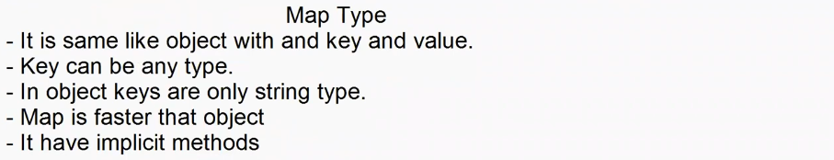

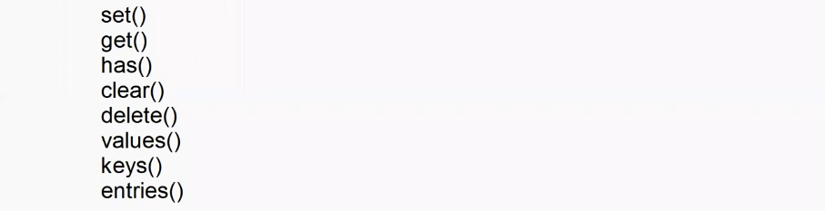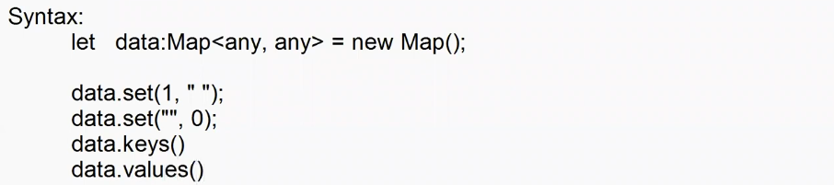

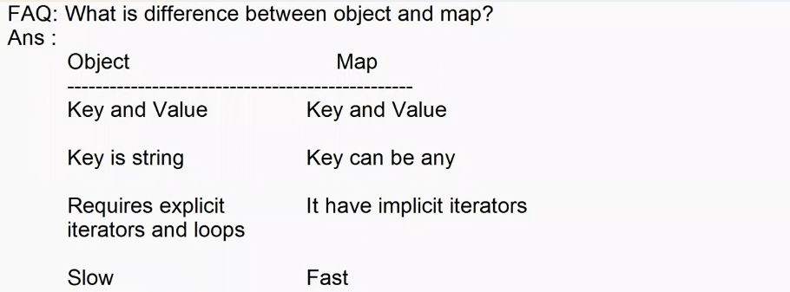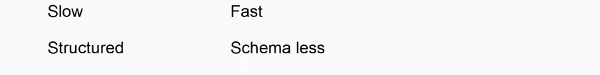

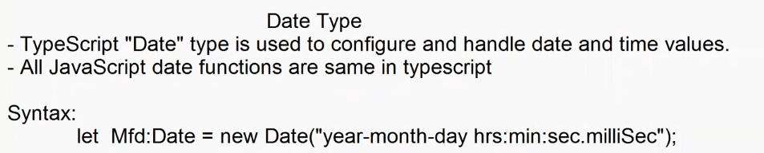

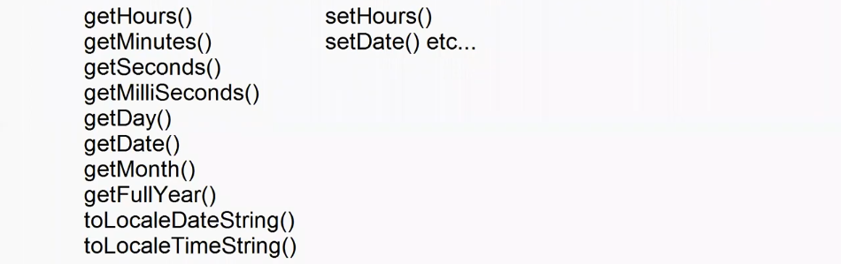 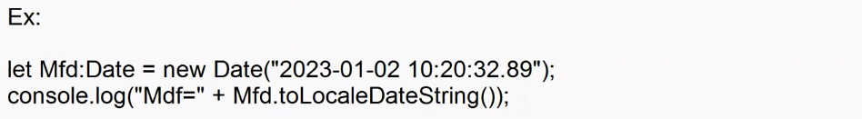

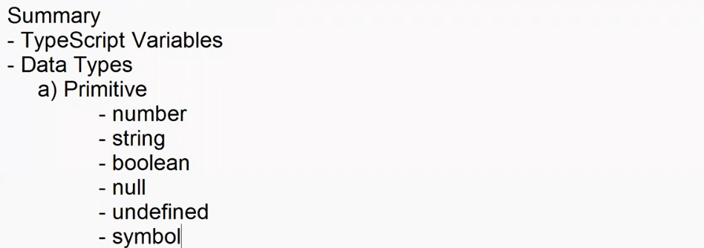

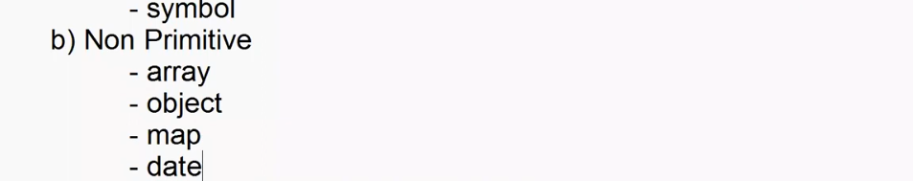

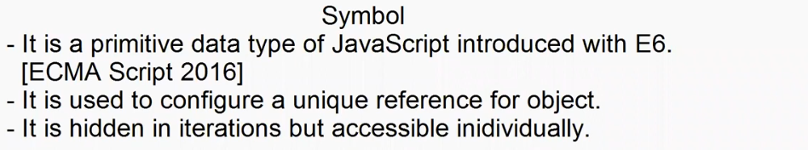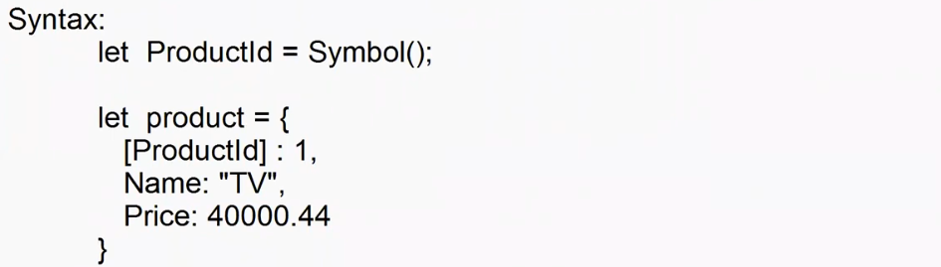

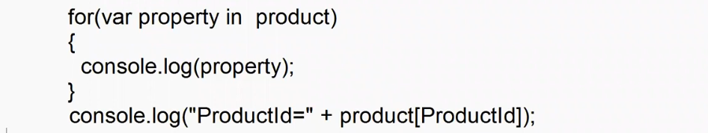

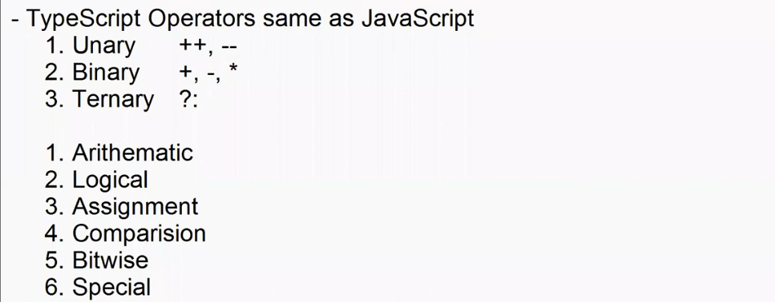

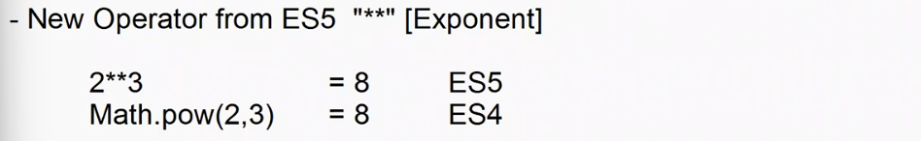

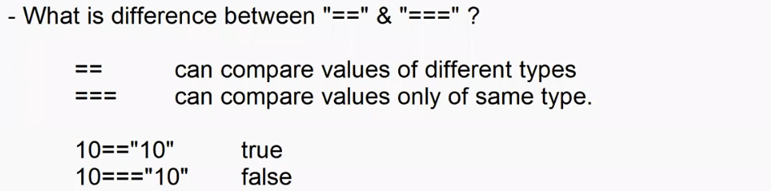

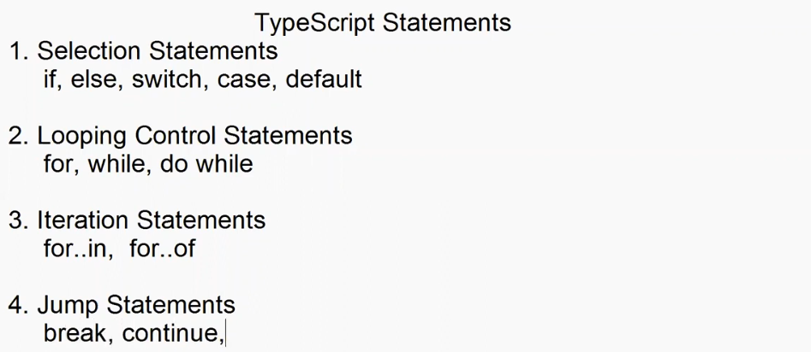



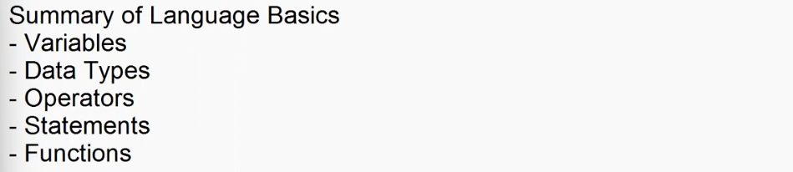

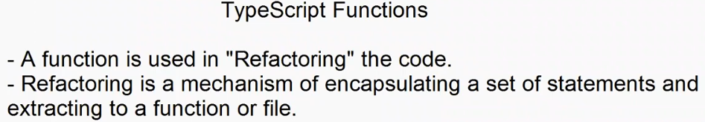

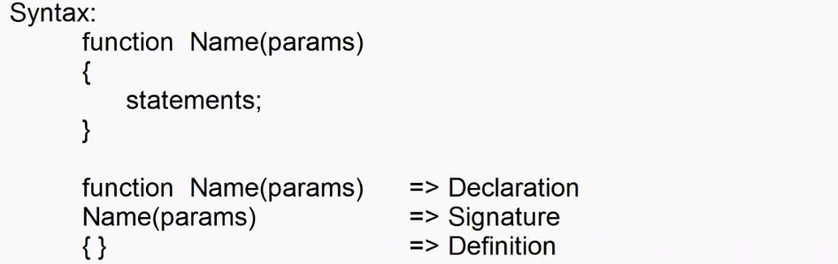

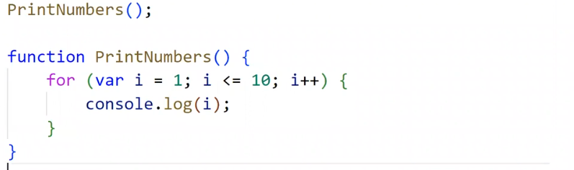

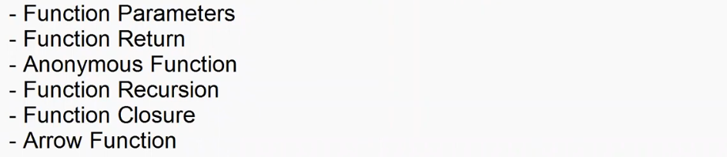

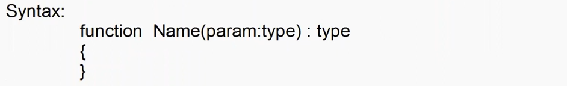

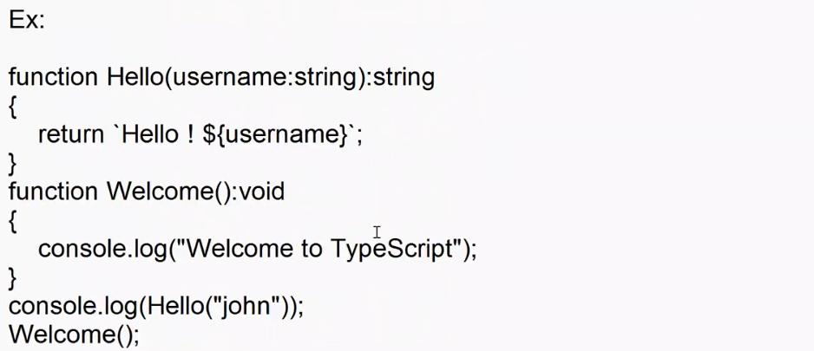

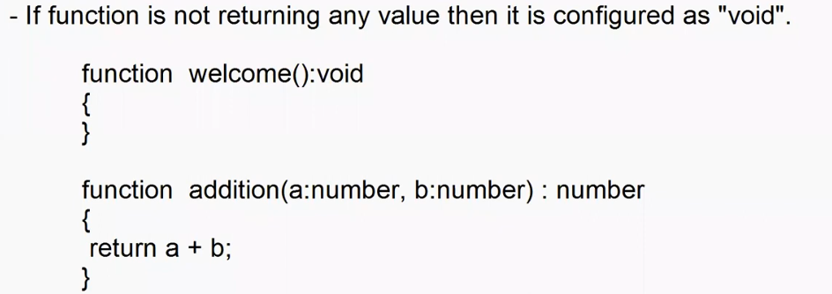

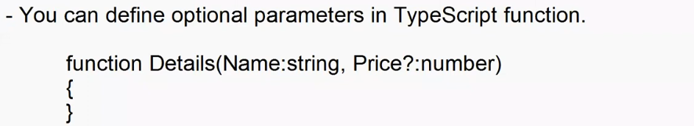



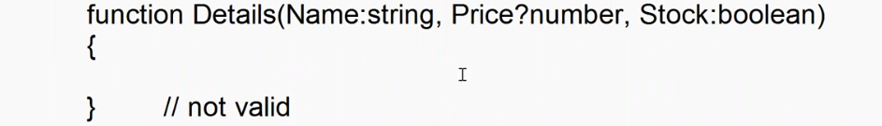

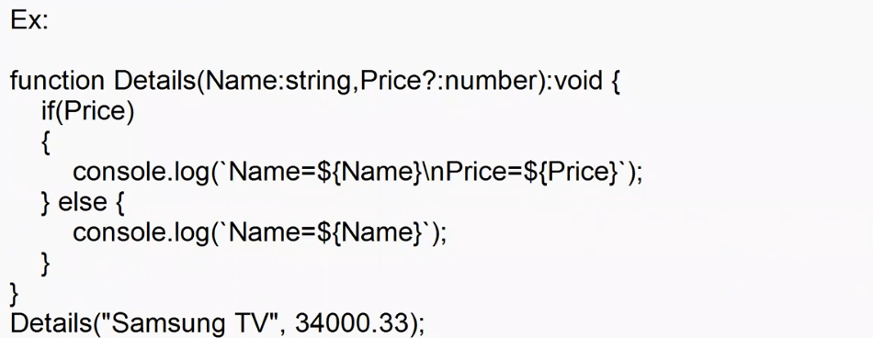

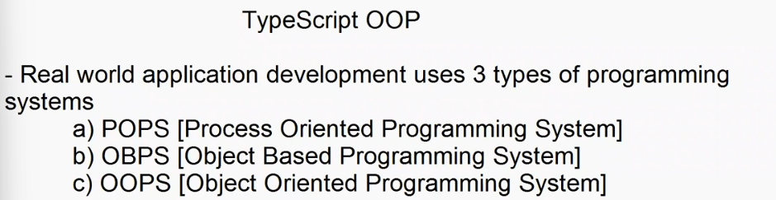

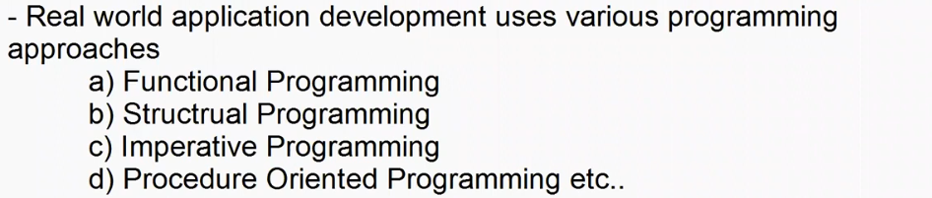

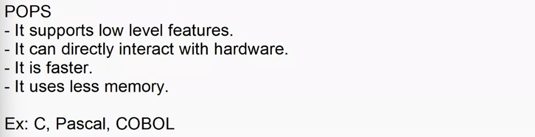

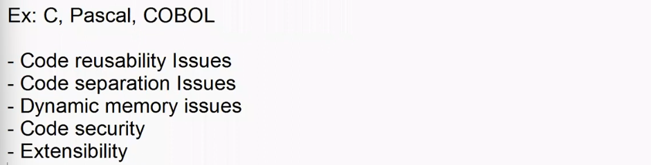

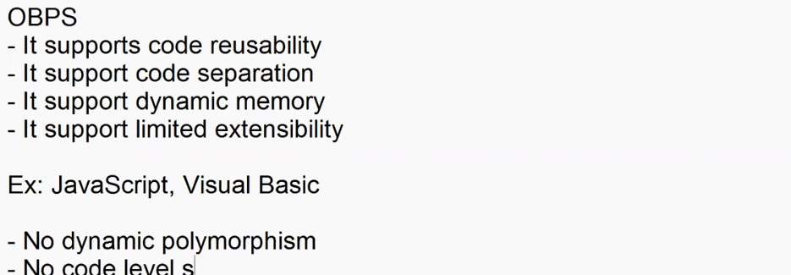



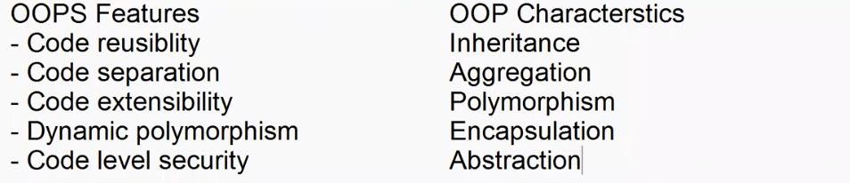

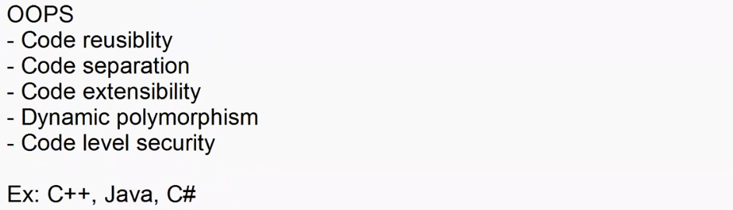

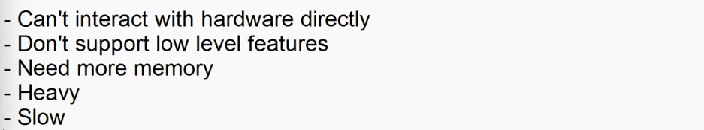

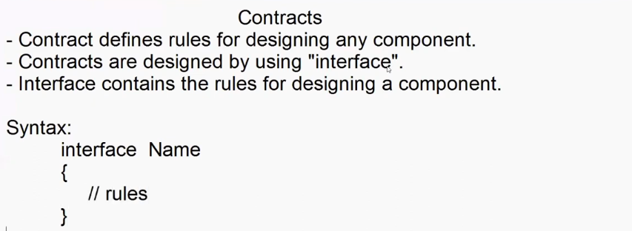

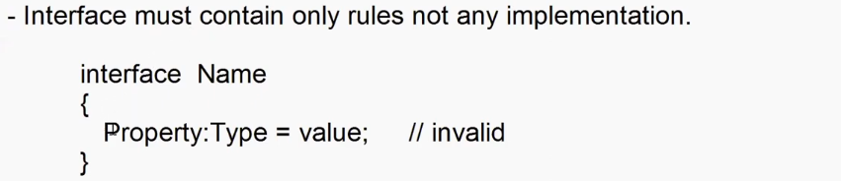

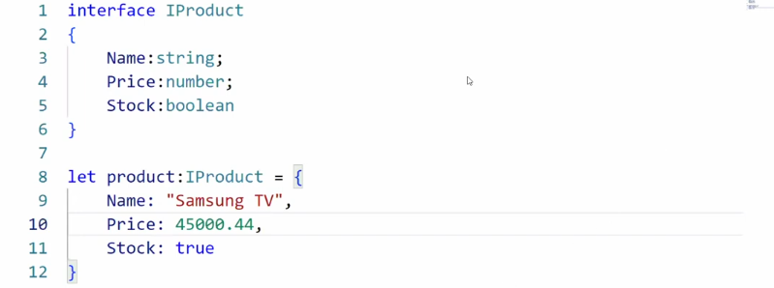

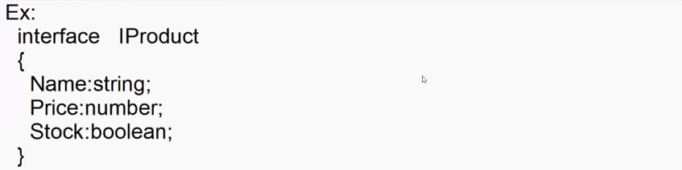

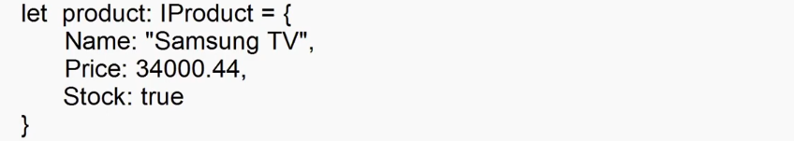

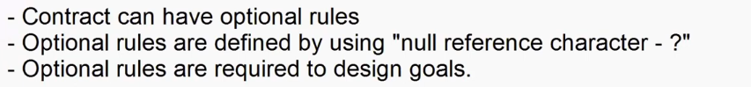

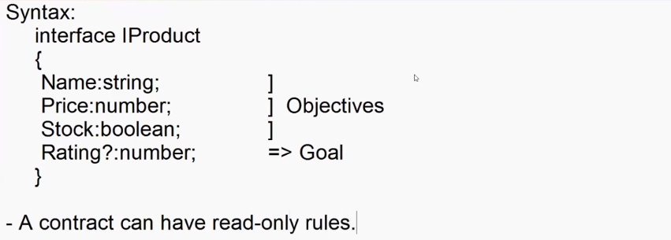

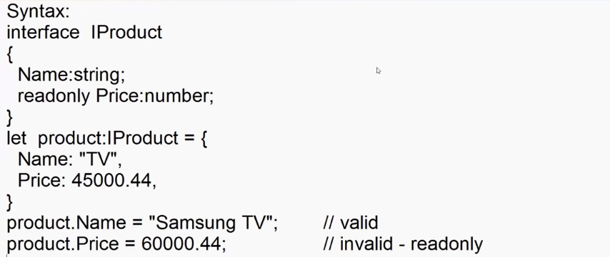

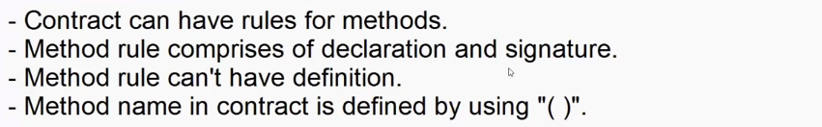

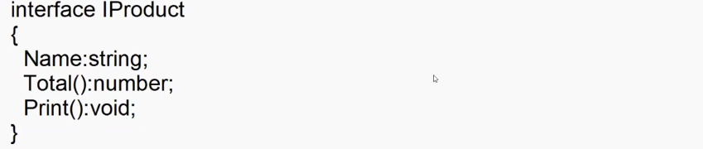

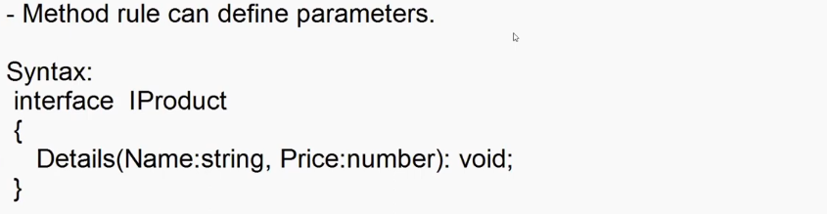

interface IProduct{

    Name:string;

    Price:number;

    Qty:number;

    Total():number;

    Print():void;

}

var product:IProduct = {

    Name:"Adesh",

    Price:45555.44,

    Qty:2,

    Total: function(){

        return this.Price*this.Qty;

    },

    Print:function(){

        console.log(`Name= ${this.Name}\nPrice= ${this.Price}\nQty=  ${this.Qty}\nTotal= ${this.Total()}`)

    }

}

product.Print();

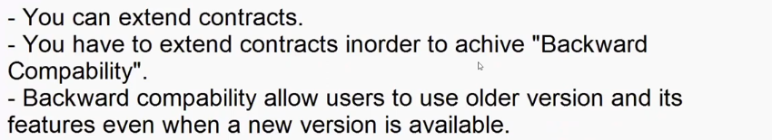

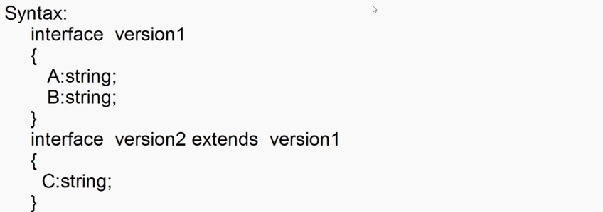

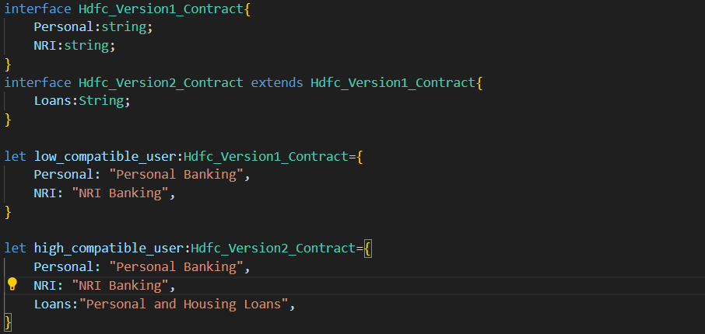

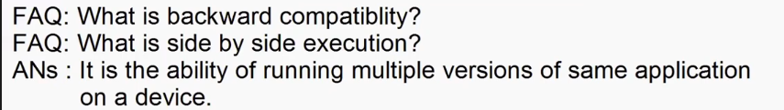

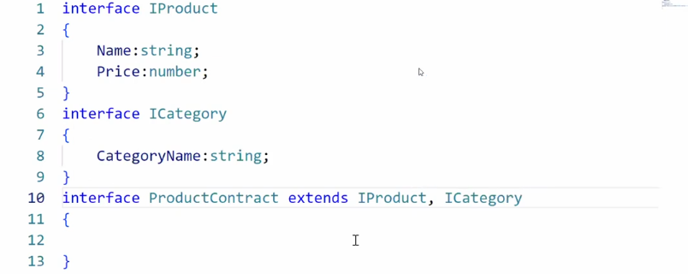

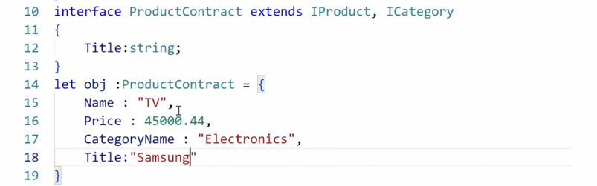

**-**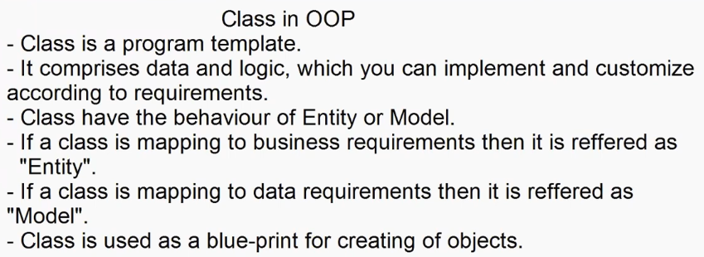

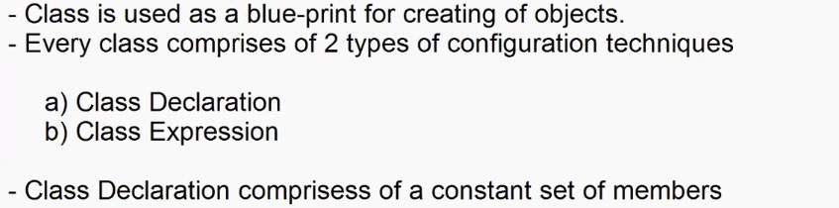

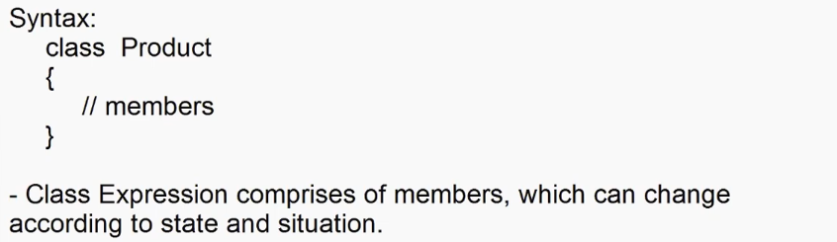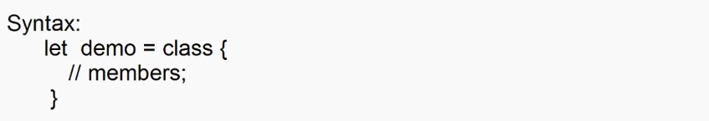

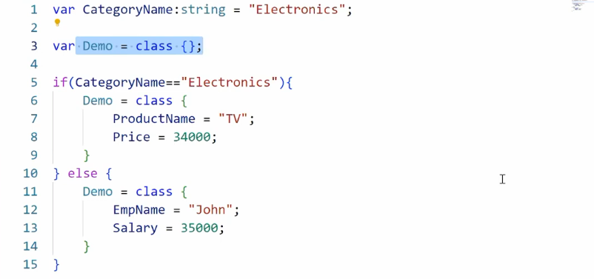

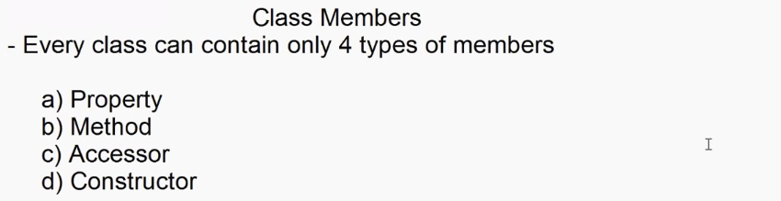

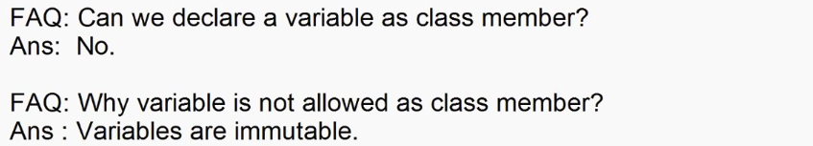

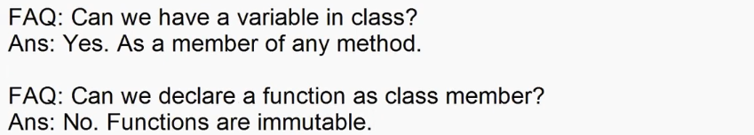



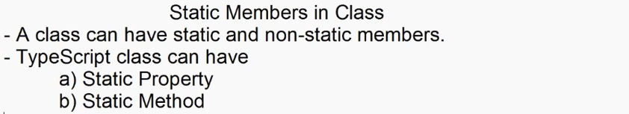

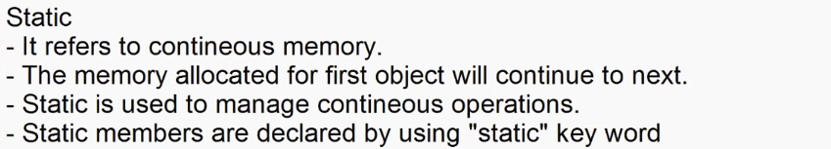

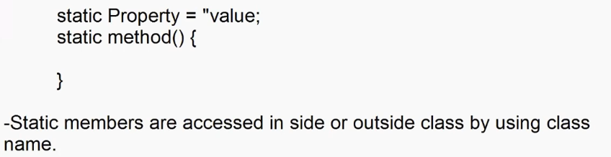

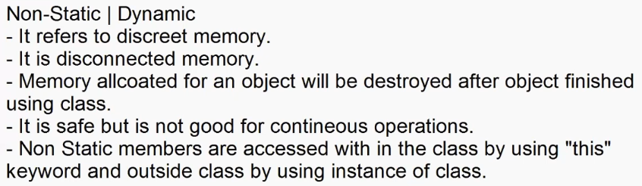

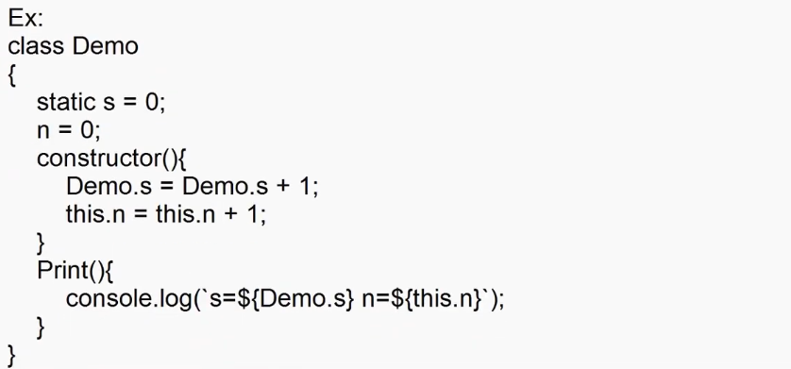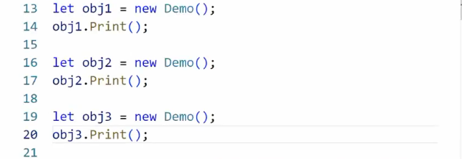

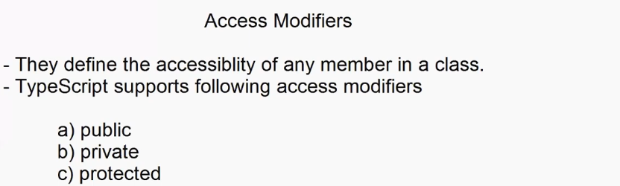

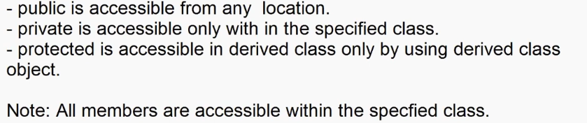

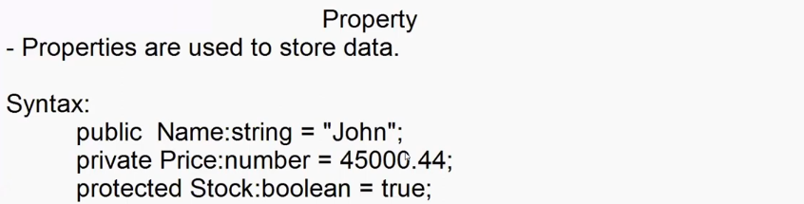

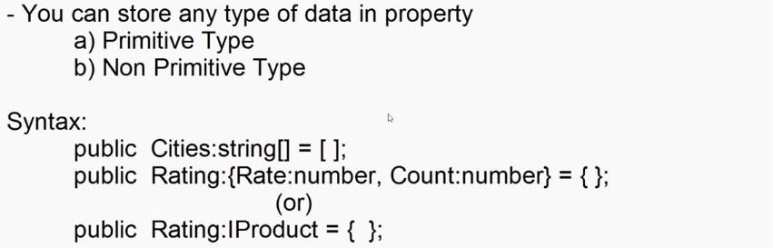



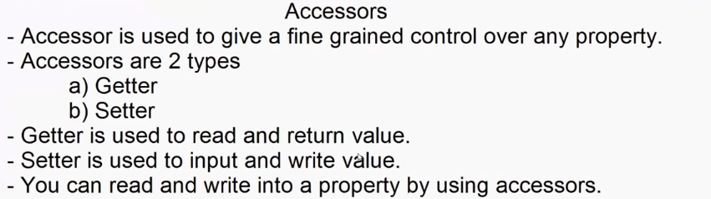

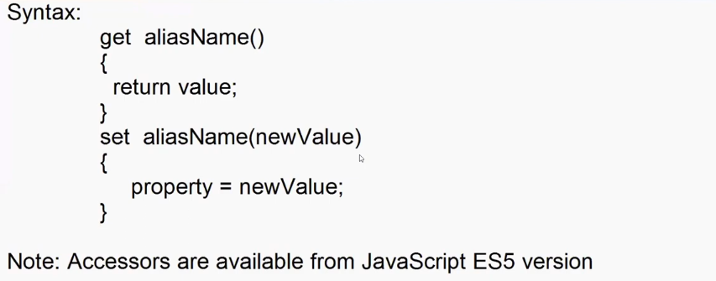

**Index.ts file > tsc index.ts**

var username:string|null = prompt("Enter Name :");

var role:string|null = prompt("Enter your role","admin|manager|customer");

var productname:string|null = prompt("Enter Product Name ");

class Product{

    public _productname:string|null = null;

    get productname(){

        return this._productname;

    }

    set productname(newName:string|null){

        if(role=="admin")

            {

                this._productname=newName;

            }

        else{

            document.write(`Hello ${username} your role ${role} is not authorized`);

        }

    }

}

let tv = new Product();

tv.productname = productname;

if(tv.productname){

    document.write("Product Name: " + tv.productname);

}



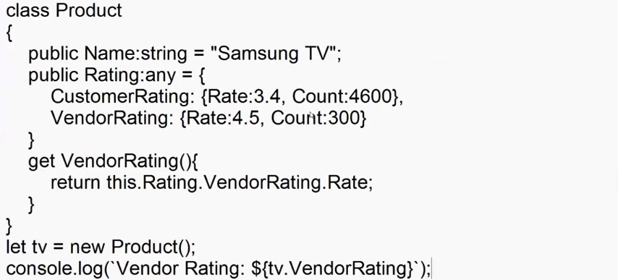

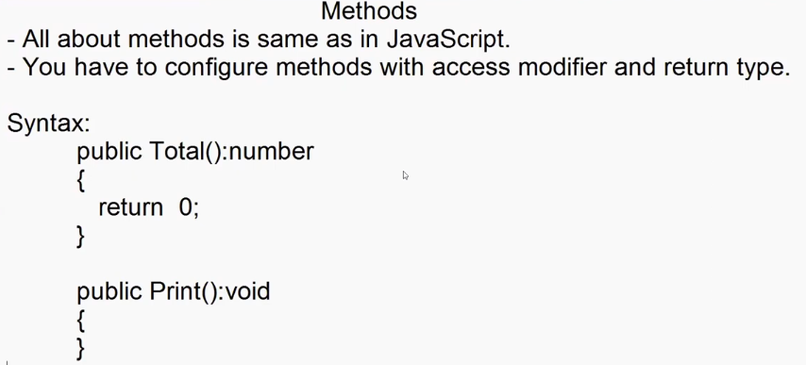 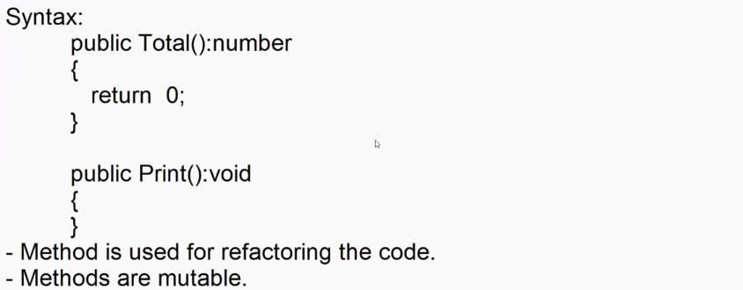

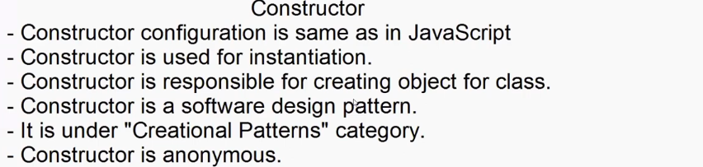

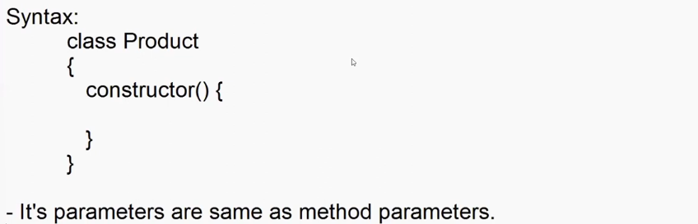

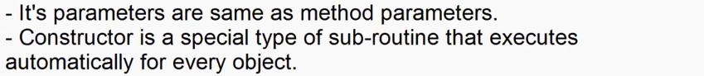

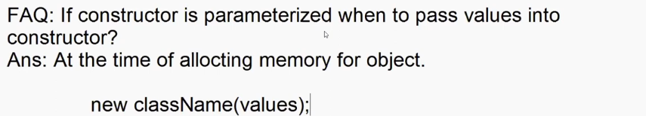

**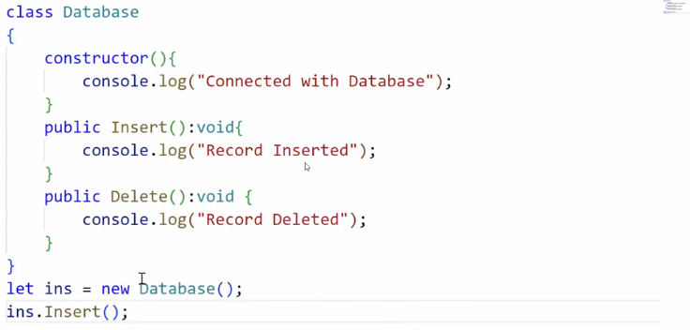  
Let ins = new Database(); -> parenthesis are not mandatory**



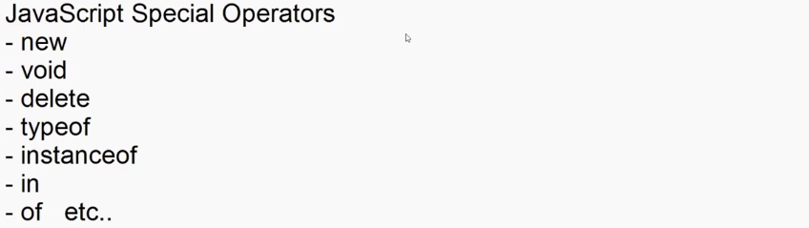

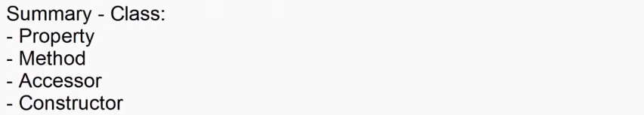

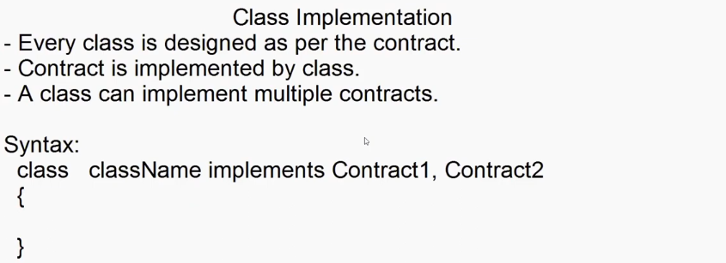

interface IProduct{

    Name:string;

    Price:number;

    Qty:number;

    Total():number;

    Print():void;

}

interface ICategory{

    CategoryName:string;

}

class Product implements IProduct, ICategory

{

    public Name: string = "";

    public Price: number = 0;

    public Qty: number = 0;

    public CategoryName: string = "";

    public Stock:boolean = true;

    public Total(): number {

        return this.Price * this.Qty;

    }

    public Print(): void {

        console.log(`Name= ${this.Name}\nPrice= ${this.Price}\nQty=  ${this.Qty}\nCategory=${this.CategoryName}\nTotal= ${this.Total()}\nStock=${this.Stock}`)

    }

}

let p1 = new Product();

p1.Name = "Samsung TV";

p1.Price = 45000.44;

p1.Qty=2;

p1.CategoryName="Electronics";

p1.Print();

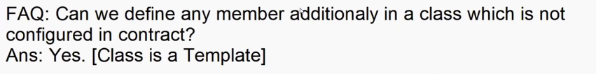

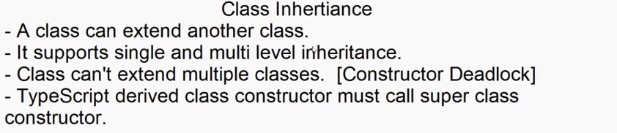 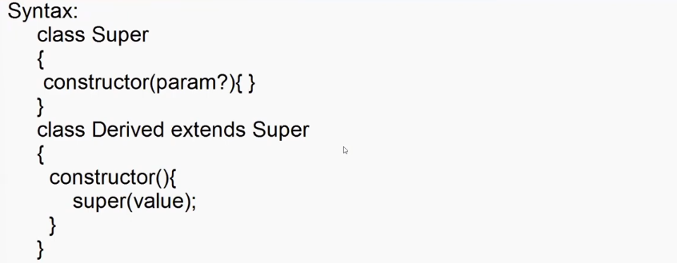

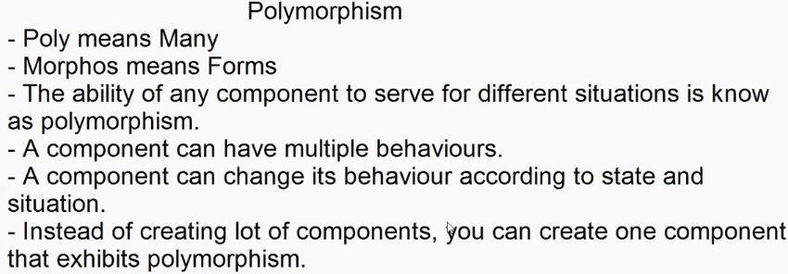 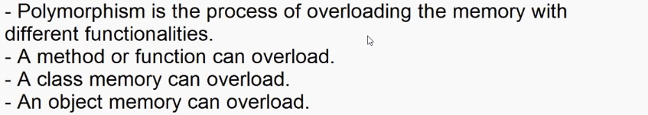 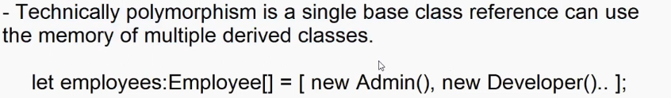

Ex:

1. **Index.ts**

class Employee{

    public FirstName:string = "";

    public LastName:string = "";

    public Designation:string = "";

    public Print():void

    {

        document.write(`${this.FirstName} ${this.LastName} - ${this.Designation}\n`)

    }

}

class Developer extends Employee{

    FirstName = "Raj";

    LastName = "Kumar";

    Designation = "Developer";

    Role = "Developer Role : Built, Debug, Test, Deploy";

    Print(){

        super.Print();

        document.write(this.Role);

    }

}

class Admin extends Employee{

    FirstName = "Kiran";

    LastName = "Kumar";

    Designation = "Admin";

    Role = "Admin Role : Authorization and Authentication";

    Print(){

        super.Print();

        document.write(this.Role);

    }

}

class Manager extends Employee{

    FirstName = "Tom";

    LastName = "Hanks";

    Designation = "Manager";

    Role = "Manager Role : Approvals";

    Print(){

        super.Print();

        document.write(this.Role);

    }

}

let employees: Employee[] = [new Developer(), new Admin(), new Manager()];

**>tsc index.ts**

**2) Index.html**

<!DOCTYPE html>

<html lang="en">

<head>

    <meta charset="UTF-8">

    <meta name="viewport"  content="width=device-width, initial-scale=1.0">

    <title>Document</title>

    <script src="src/index.js"></script>

    <script>

        var designation = prompt("Enter Designation : ");

        for(employee of employees)

        {

            if(employee.Designation == designation)

            {

                employee.Print();

            }

        }

    </script>

</head>

<body>

    <!-- <h1>Welcome Typescript</h1> -->

</body>

</html>

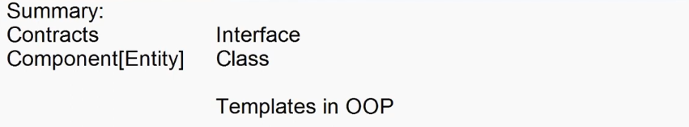

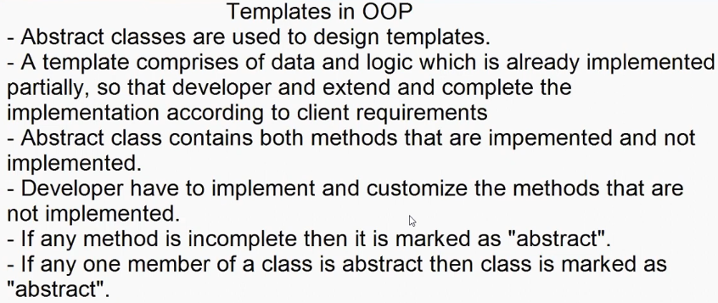 

interface ProductContracts {

    Name:string;

    Price:number;

    Qty:number;

    Total():number;

    Print():void;

}

abstract class ProductTemplete implements ProductContracts{

    public Name:string ="";

    public Price:number = 0;

    public Qty: number = 0;

    public abstract Total(): number;

    public abstract Print(): void;

}

class ProductComponent extends ProductTemplete{

    Name = "Samsung TV";

    Price = 45000.44;

    Qty = 2;

    public Total(): number {

        return this.Price*this.Qty;

    }

    public Print(): void {

        console.log(`Name= ${this.Name}\nPrice= ${this.Price}\nQty=  ${this.Qty}\nTotal= ${this.Total()}\n`)

    }

}

let tv = new ProductComponent();

tv.Print();

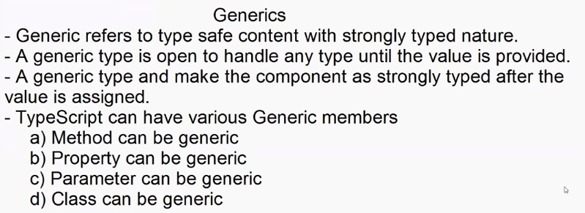

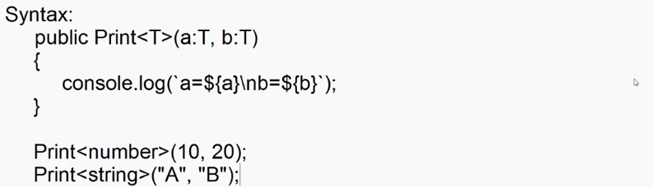

class Demo{

    public Print<T>(a:T,b:T){

        console.log(`A=${a}\nB=${b}`);

    }

}

let obj = new Demo();

obj.Print<number>(10,20);

obj.Print<string>("Adesh","Ritesh");

------------------------------------------------------------------------------

interface IProduct {

    Name : string;

    Price : number;

}

interface IEmployee{

    FirstName:string;

    Designation:string;

    Salary:number;

}

class Service{

    public GetData<T>(data:T){

        for(var property in data)

            {

                console.log(`${property} : ${data[property]}`);

            }

    }

}

let obj = new Service();

console.log("-------Employee Details--------")

obj.GetData<IEmployee>({FirstName:"Adesh",Designation:"Admin",Salary:50000});

console.log("-------Product Details---------")

obj.GetData<IProduct>({Name:"Samsung TV",Price:50000});

interface IOrcale{

    Username:string;

    Password:string;

    Database:string;

}

interface IMySql{

    Host:string;

    User:string;

    Pwd:string;

    Db:string;

}

interface IMongoDb{

    Url:string;

}

------------------------------------------------------------------------------

class Database<T>

{

    public ConnectionString:T|null=null;

    public Connect():void{

        for(var property in this.ConnectionString){

            console.log(`${property} : ${this.ConnectionString[property]}`);

        }

    }

}

console.log(`-------Orcal Connection--------`)

let oracal = new Database<IOrcale>();

oracal.ConnectionString={

    Username:"Adesh",

    Password:"Pass",

    Database:"Oracal"

}

oracal.Connect();

console.log(`-------MySql Connection--------`)

let mysql = new Database<IMySql>();

mysql.ConnectionString={

    Host:"localhost",

    User:"root",

    Pwd:"12345",

    Db:"EmpDb"

}

mysql.Connect();

console.log(`-------MongoDb Connection--------`)

let mongoDb = new Database<IMongoDb>();

mongoDb.ConnectionString={

    Url : "mongodb://127.0.0.1:27017"

}

mongoDb.Connect();

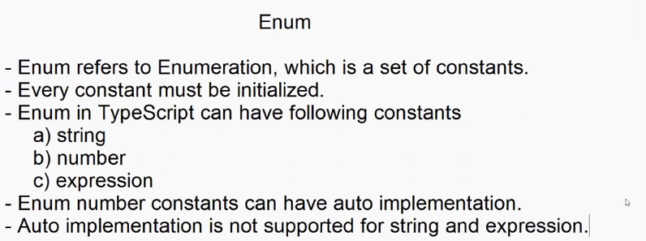

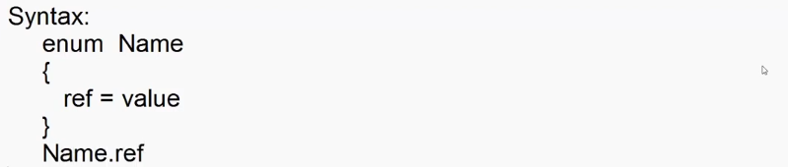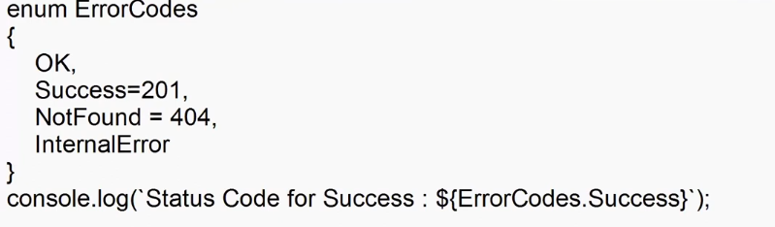

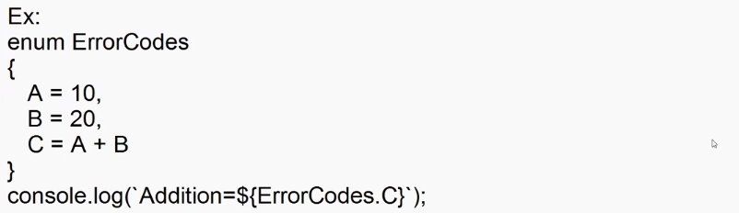



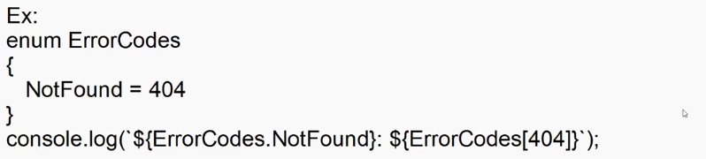

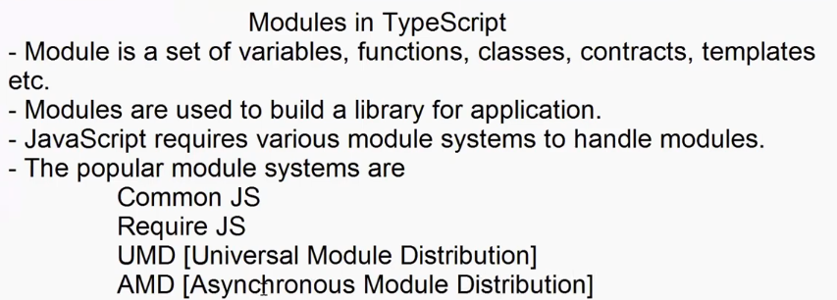

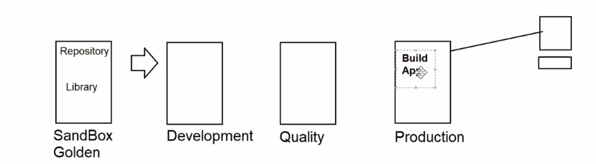



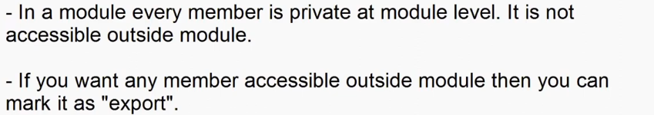

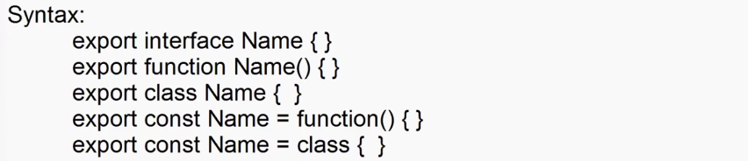

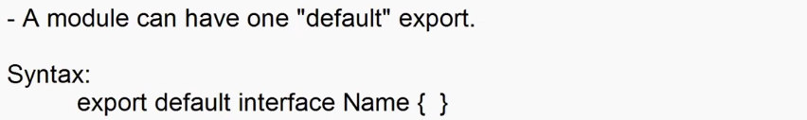



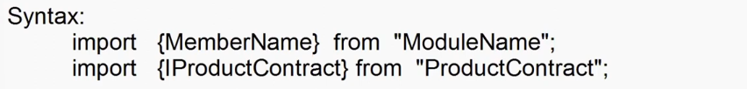

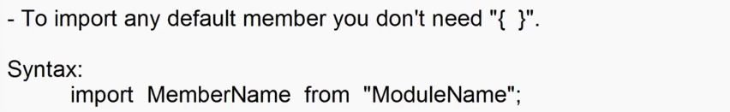





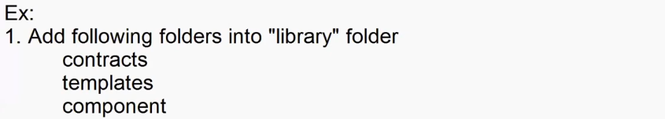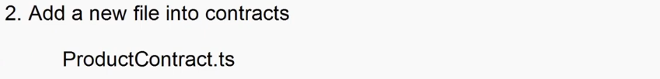

export interface IProductContract{

    Name:string;

    Price:number;

    Qty:number;

    Total():number;

    Print():void;

}

export default interface ICategory{

    CategoryName:String;

}

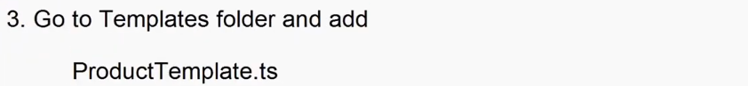

import ICategory,{ IProductContract }from "../contracts/ProductContract";

export abstract class ProductTempate implements ICategory,IProductContract{

    Name = "";

    Price = 0;

    Qty = 0;

    CategoryName="";

    public abstract Total(): number;

    public abstract Print(): void;

}

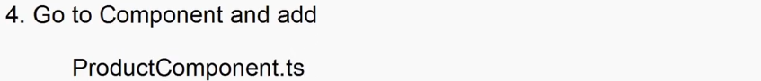

import { ProductTempate } from "../templates/ProductTemplate";

export class ProductComponent extends ProductTempate{

    Name = "Samsung TV";

    Price = 45000.44;

    Qty = 2;

    CategoryName = "Electronis";

    public Total(): number {

        return this.Price*this.Qty;

    }

    public Print(): void {

        console.log(`Name= ${this.Name}\nPrice= ${this.Price}\nQty=${this.Qty}\nTotal= ${this.Total()}\n`)

    }

}

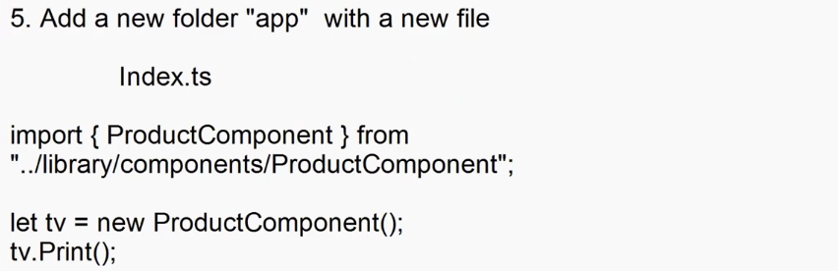

import { ProductComponent } from "../Library/components/ProductComponent";

let tv = new ProductComponent();

tv.Print();

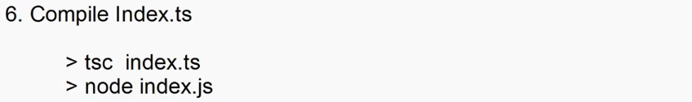

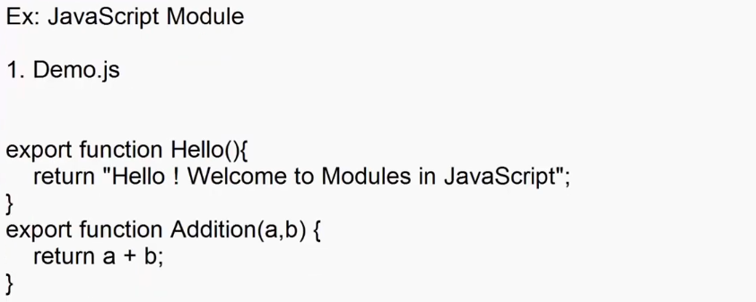



<!DOCTYPE html>

<html lang="en">

<head>

    <meta charset="UTF-8">

    <meta name="viewport" content="width=device-width, initial-scale=1.0">

    <title>Document</title>

    <script type="module">

        import { Hello,Addition } from "./Library/demo.js";

        document.querySelector("p").innerHTML = Hello() + "<br>" + "Addition = "+Addition(10,20);

    </script>

</head>

<body>

    <p></p>

</body>

</html>

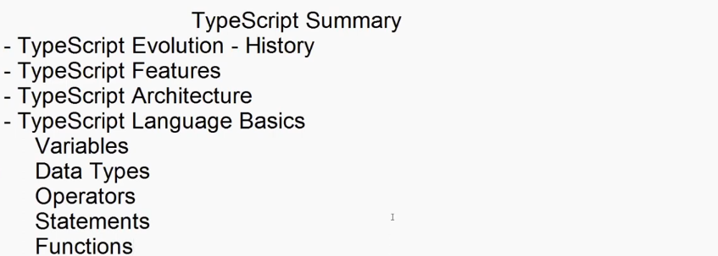

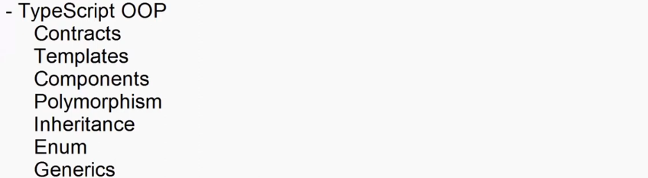

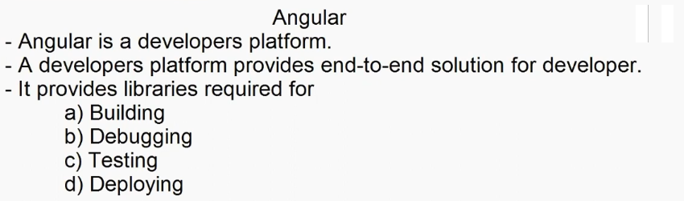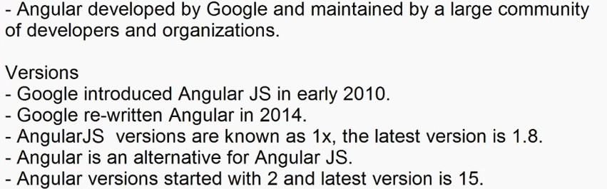

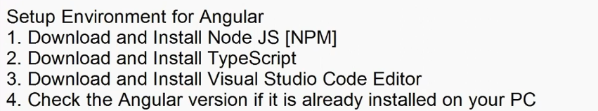

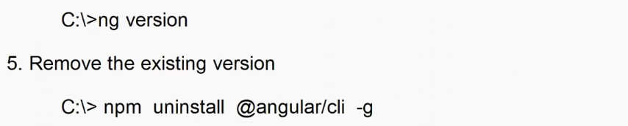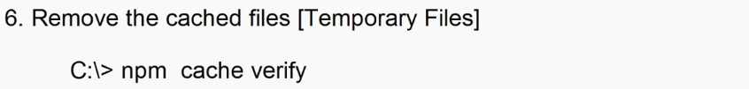

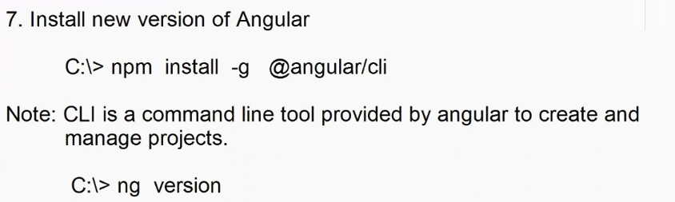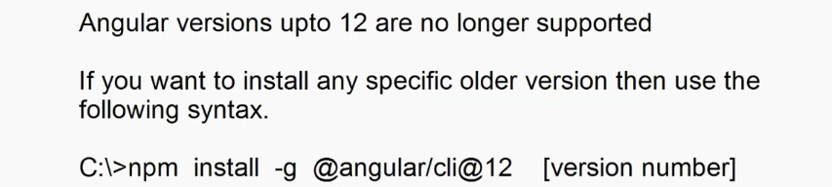

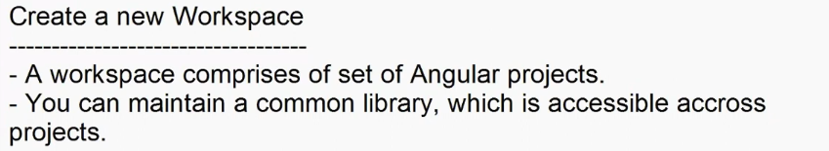

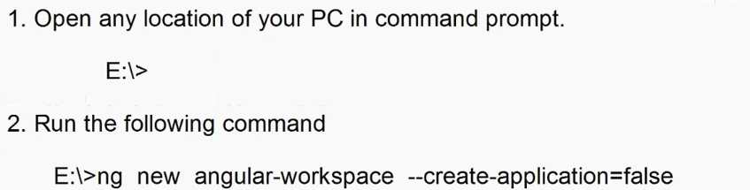

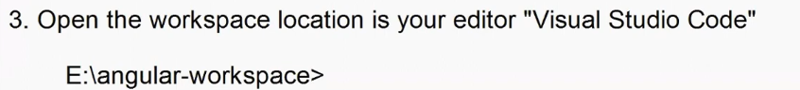



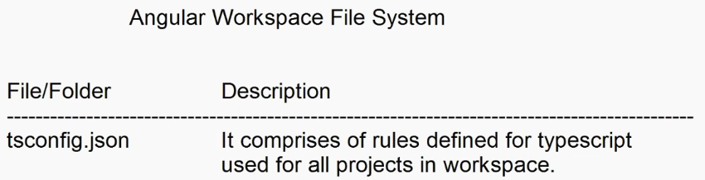

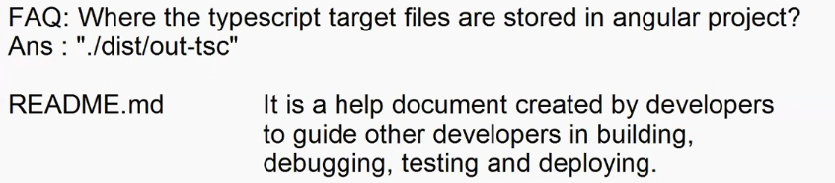

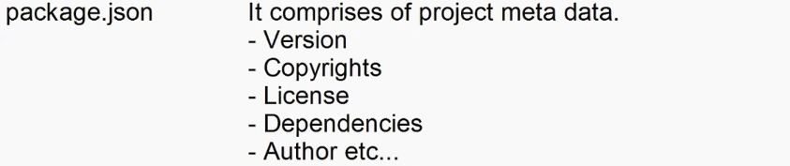







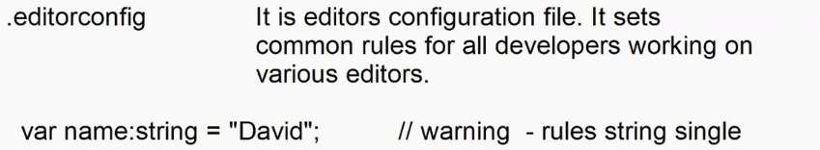





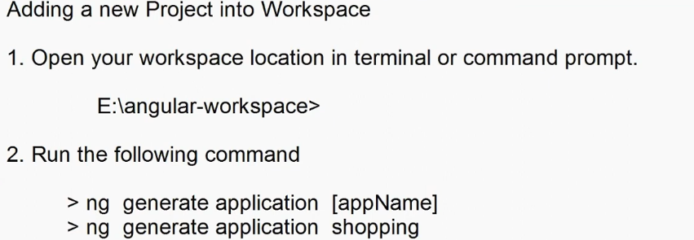

* **ng generate application shopping –standalone false**



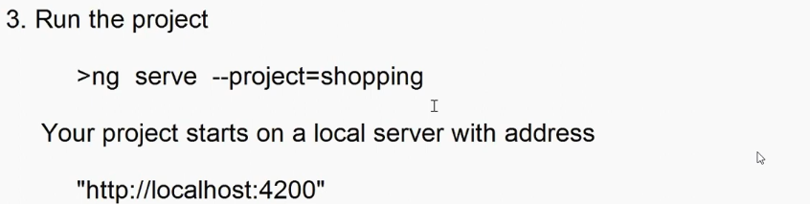

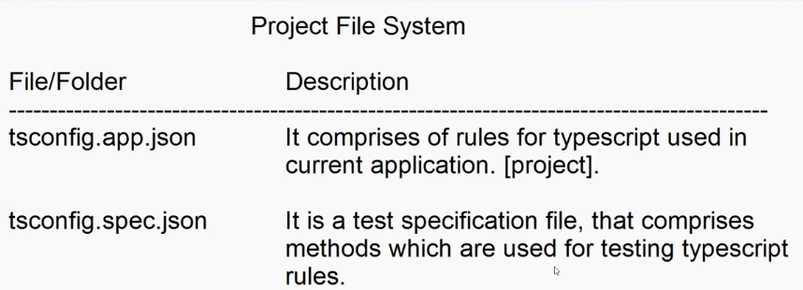

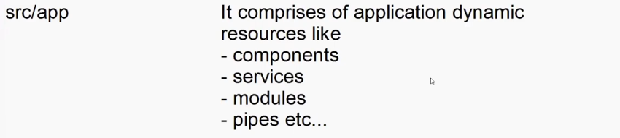

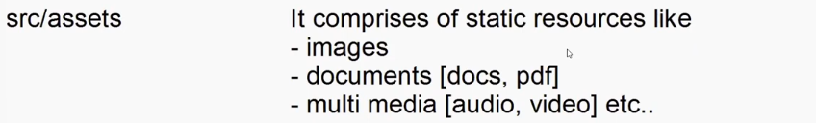









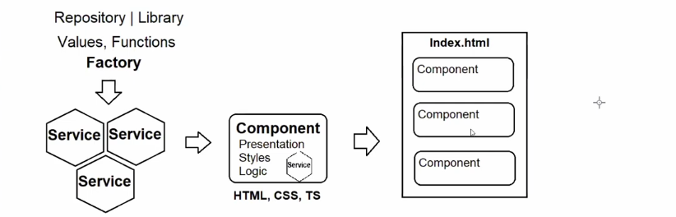

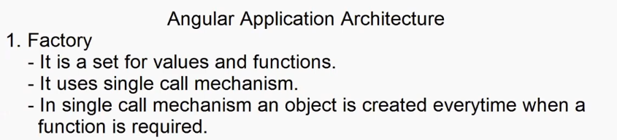

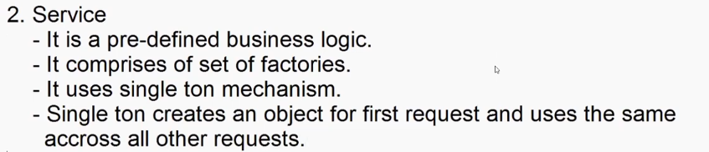

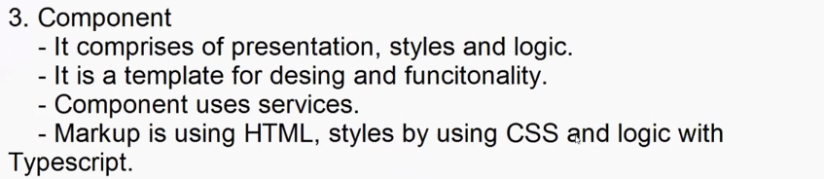

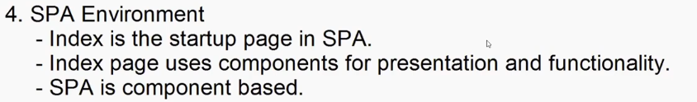

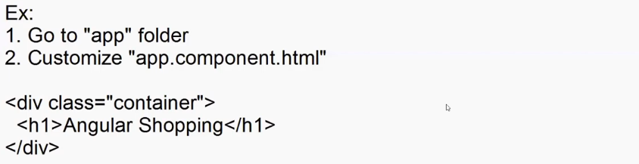

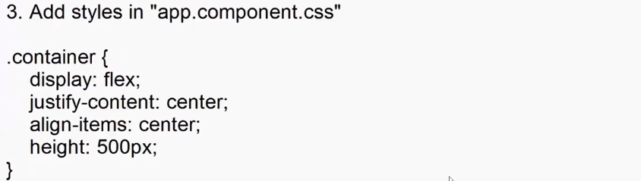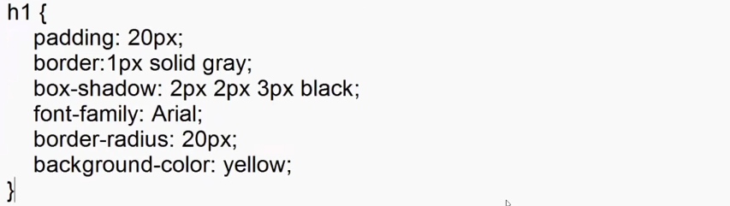

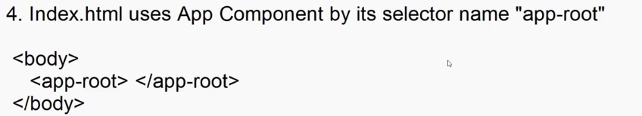

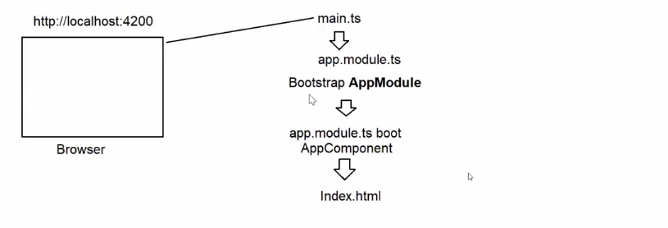

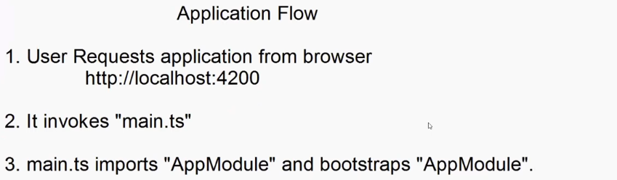

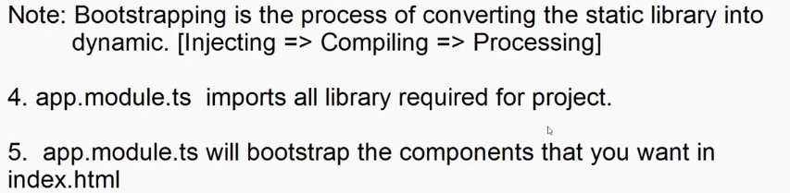

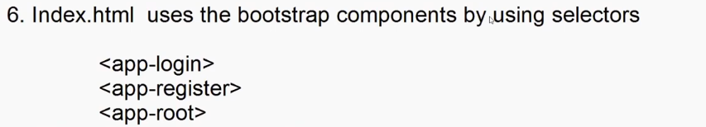

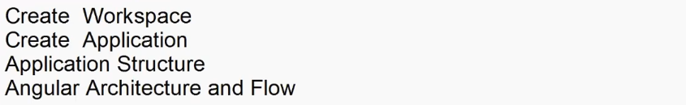

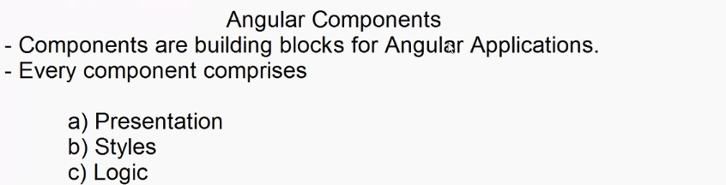

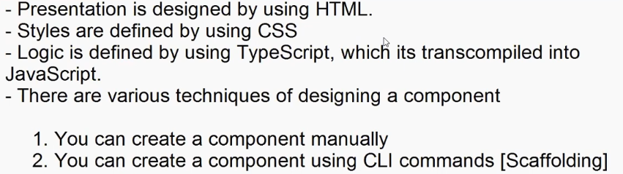

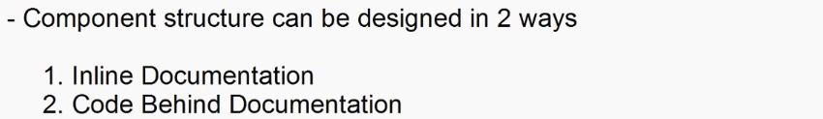

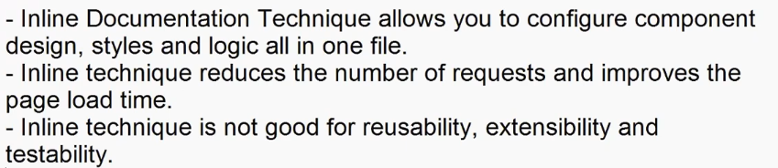

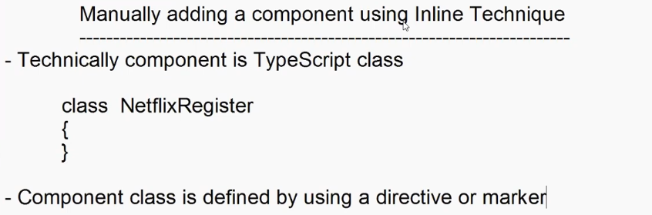



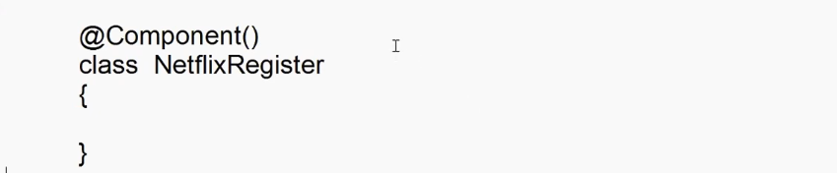

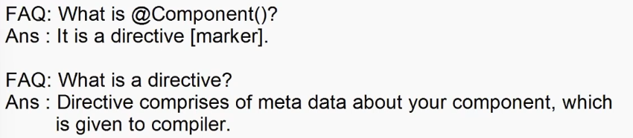

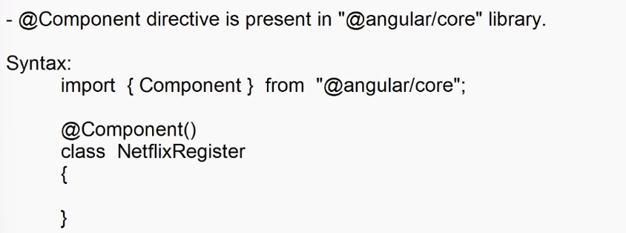

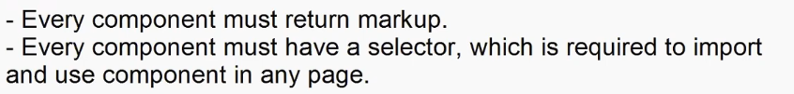

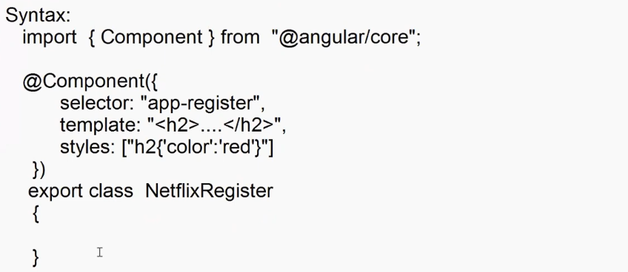



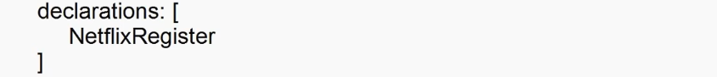

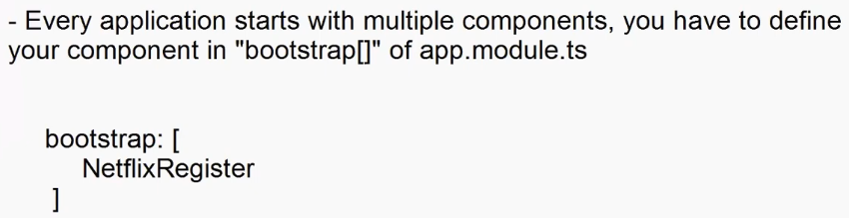

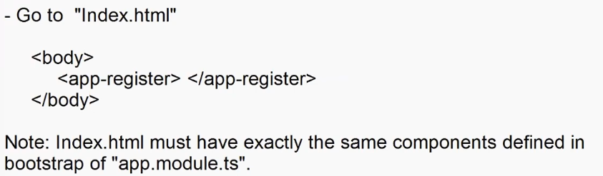

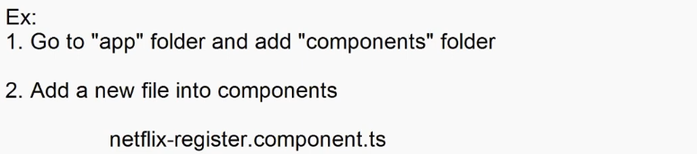

import { Component } from "@angular/core";

@Component({

    selector:'app-register',

    template:`

    <div class="register-container">

        <div>

            <p>Ready to watch? Enter your email to create or restart your membership</p>

            <input type="email" placeholder="Email Address">

            <button> Get Started></button>

        </div>

    </div> `,

    styles:[".register-container{display:flex;justify-content :center ; align-items:center;height:400px}"]

})

export class NetflixRegister{

}

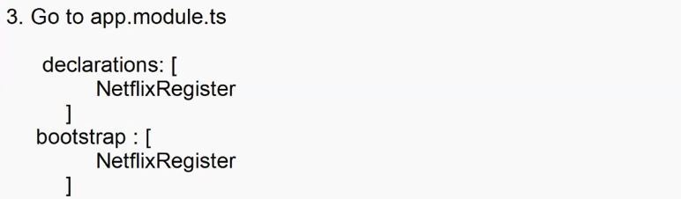

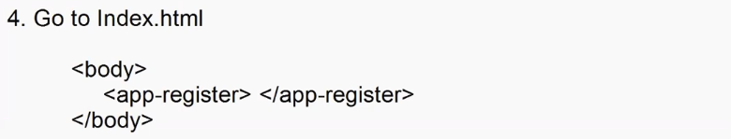

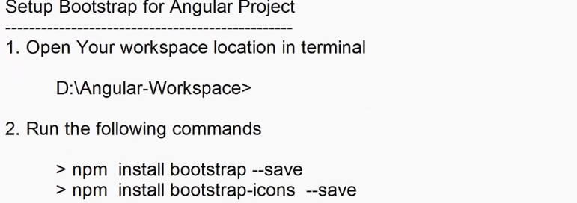

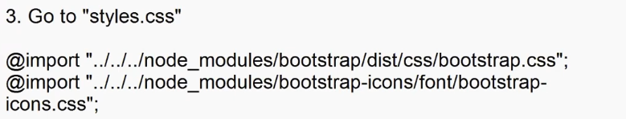

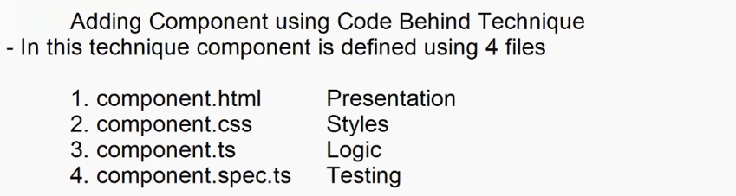

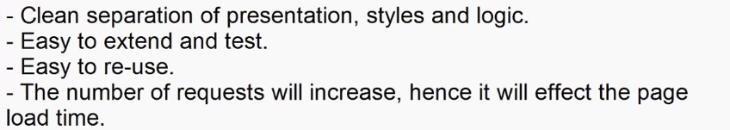

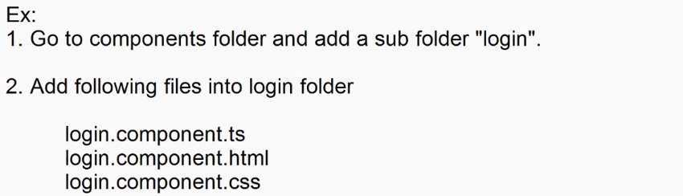

**login.component.ts**

import { Component } from "@angular/core";

@Component({

    selector:'app-login',

    templateUrl:'./login.component.html',

    styleUrls:['./login.component.css']

})

export class LoginComponent{

}

**login.component.html**

<div class="container-fluid">

  <div class="login-form">

    <form>

      <h2><span class="bi bi-person-fill"></span>User Login</h2>

      <dl>

        <dt>User Name</dt>

        <dd><input type="text" class="form-control" /></dd>

        <dt>Password</dt>

        <dd><input type="password" class="form-control" /></dd>

      </dl>

      <button class="btn btn-primary w-100">Login</button>

    </form>

  </div>

</div>

**login.component.css**

.login-form{

    display: flex;

    justify-content: center;

    align-items: center;

    height:600px;

}

form{

    border: 1px solid gray;

    box-shadow: 2px 2px 3px gray;

    padding: 20px;

    border-radius: 20px;

}

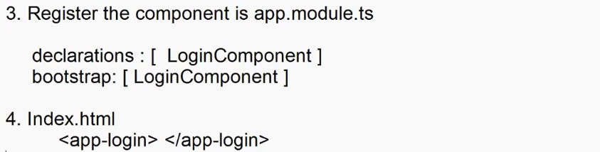

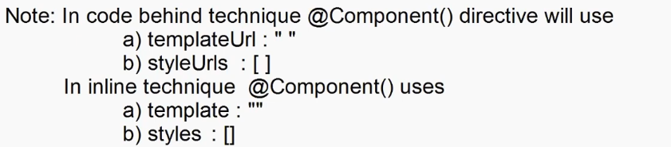

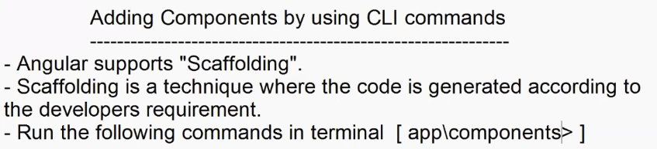

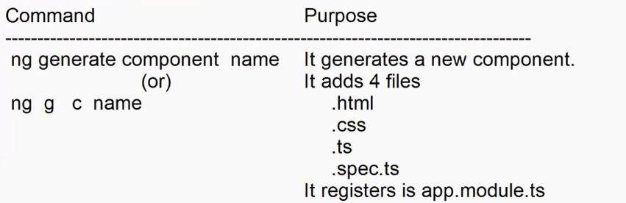

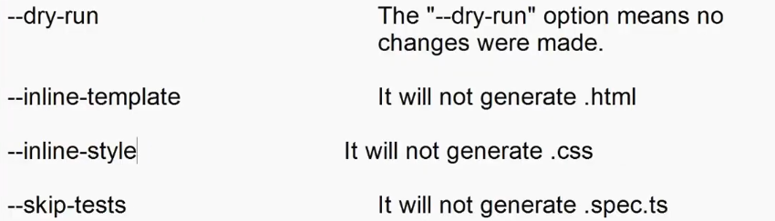

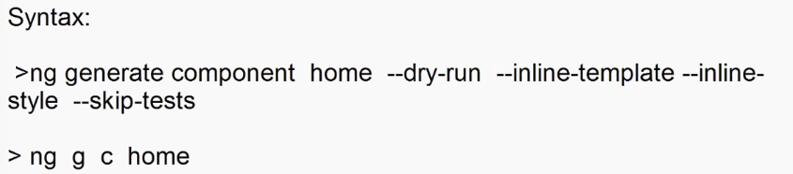

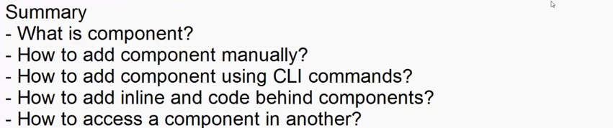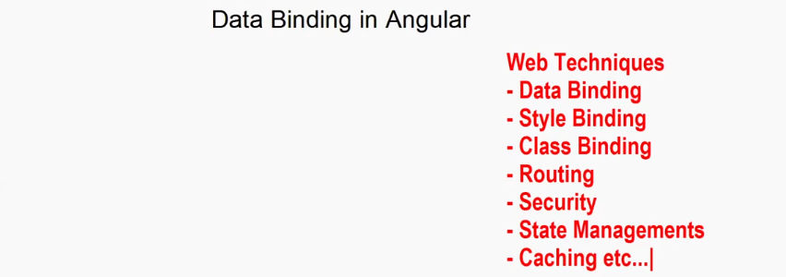

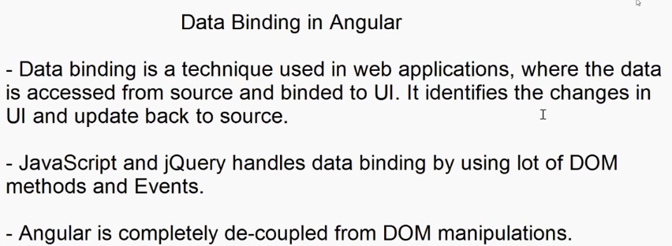

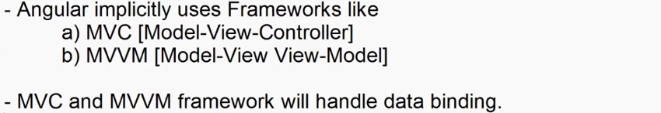

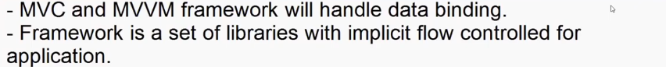

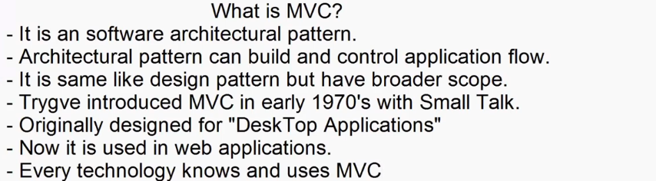

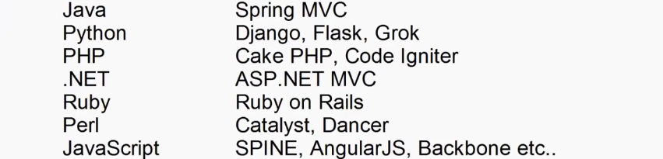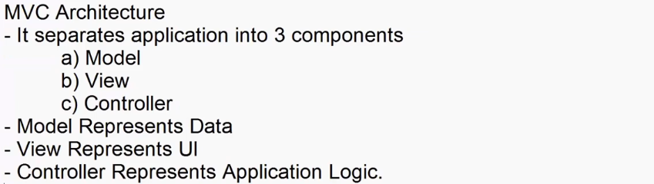

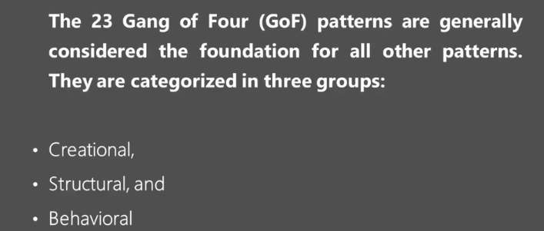



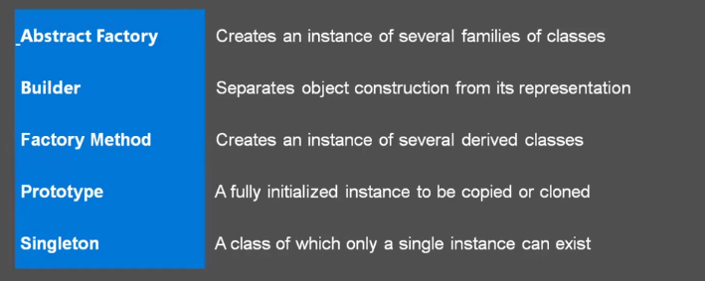



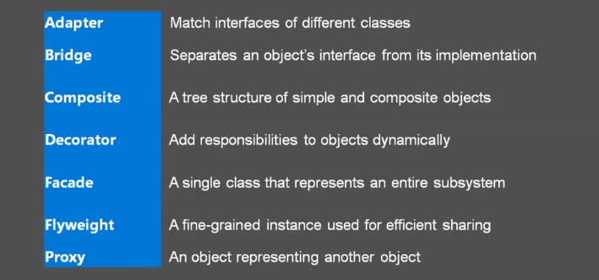



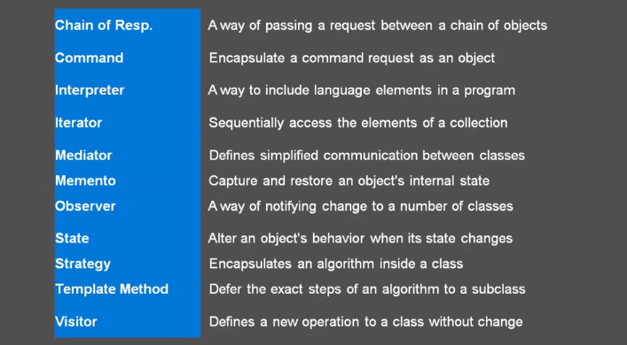



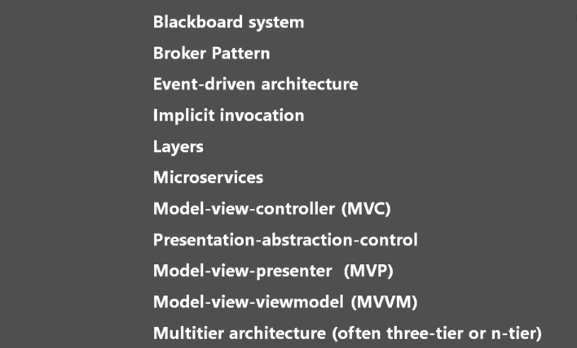

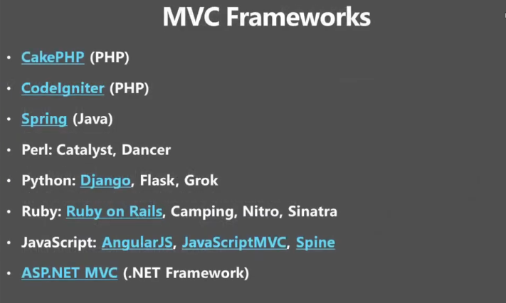

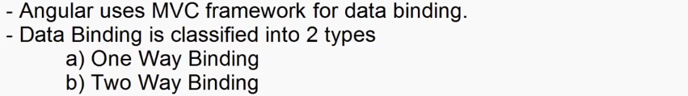

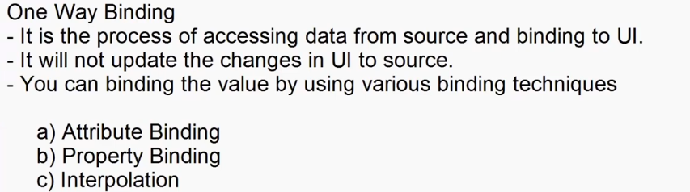

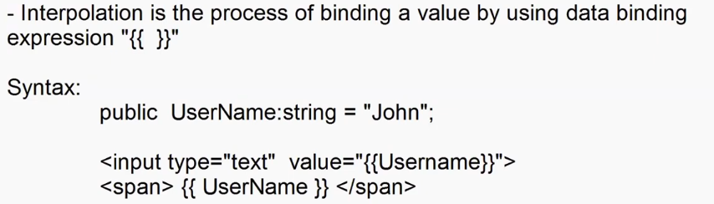



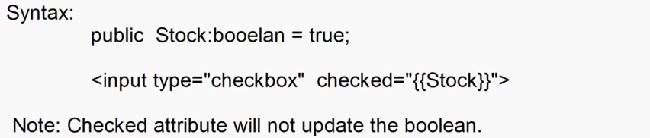

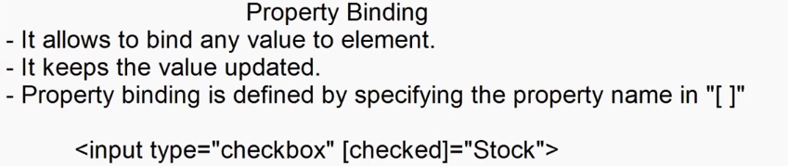



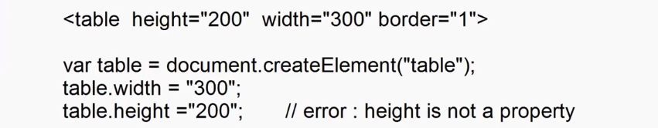

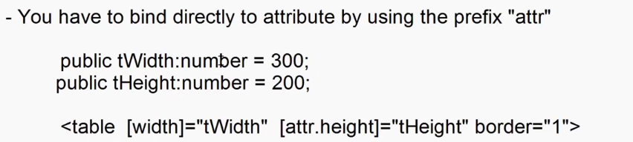

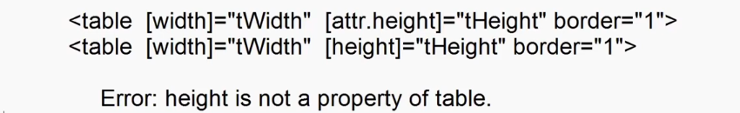



import { Component } from '@angular/core';

@Component({

  selector: 'app-data-binding',

  templateUrl: './data-binding.component.html',

  styleUrl: './data-binding.component.css'

})

export class DataBindingComponent {

  public Username:string = "Adesh";

  public Stock:boolean = false;

}



<div class="container-fluid">

    <h2>One way binding</h2>

    User Name: <input type="text" value="{{Username}}">

    <br><br>

    <h3>Hello ! <span>{{Username}}</span></h3>

</div>

<div class="container-fluid">

    <h2>Interpolation</h2>

    <dl>

        <dt>Stock</dt>

        <dd>

            <input type="checkbox" checked="{{Stock}}"> Available {{Stock}}

        </dd>

    </dl>

</div>

<div class="container-fluid">

    <h2>Property Binding</h2>

    <dl>

        <dt>Stock</dt>

        <dd>

            <input type="checkbox" [checked]="Stock"> Available {{Stock}}

        </dd>

    </dl>

</div>

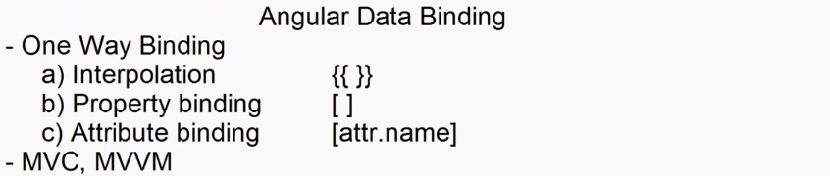

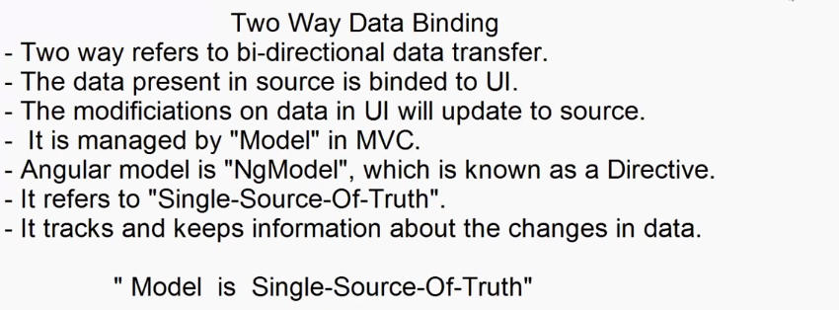

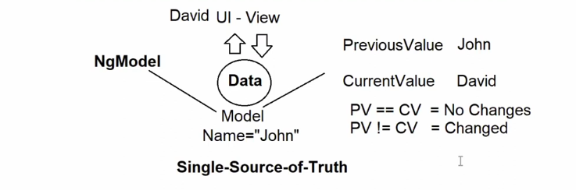



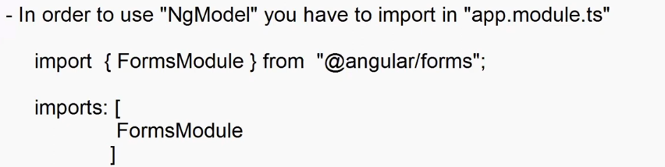

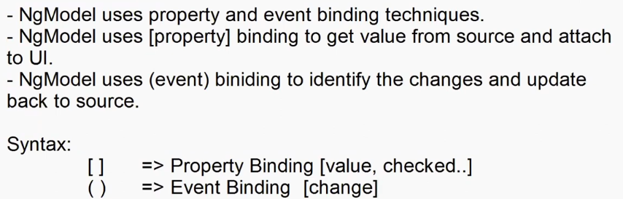



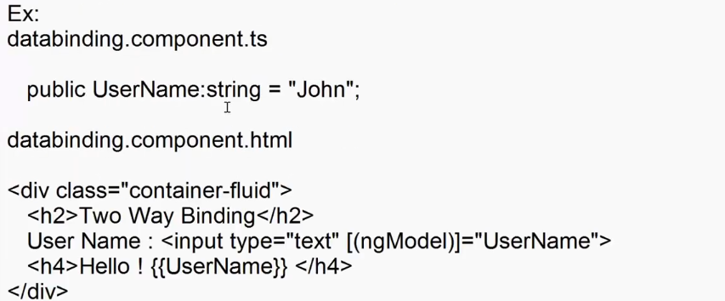

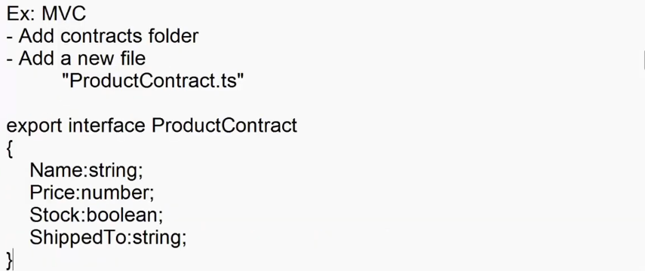

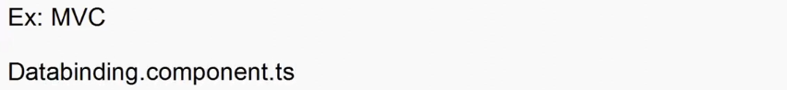

import { Component } from '@angular/core';

import { ProductContract } from '../../contracts/ProductContract';

@Component({

  selector: 'app-data-binding',

  templateUrl: './data-binding.component.html',

  styleUrl: './data-binding.component.css'

})

export class DataBindingComponent {

  public Product:ProductContract={

    Name: "",

    Price: 0,

    Stock: false,

    ShippedTO: ""

  }

  public UpdatedProduct:ProductContract={

    Name: "",

    Price: 0,

    Stock: false,

    ShippedTO: ""

  }

  public RegisterClick():void{

    this.UpdatedProduct=this.Product;

  }

}



<div class="container-fluid">

    <div class="row">

        <div class="col-3">

             <h2>Register Product</h2>

             <dl>

                <dt>Name</dt>

                <dd><input type="text" [(ngModel)]="Product.Name" class="from-control"></dd>

                <dt>Price</dt>

                <dd><input type="text" [(ngModel)]="Product.Price" class="from-control"></dd>

                <dt>Stock</dt>

                <dd class="form-switch"><input type="checkbox" [(ngModel)]="Product.Stock" class="form-check-input">Available</dd>

                <dt>Shipped to</dt>

                <dd >

                    <select [(ngModel)]="Product.ShippedTO" class="form-select">

                        <option>Delhi</option>

                        <option>Pune</option>

                        <option>Mumbai</option>

                    </select>

                </dd>

             </dl>

             <button (click)="RegisterClick()" class="btn btn-primary w-100">Register</button>

        </div>

        <div class="col-9 ">

            <h2>Details</h2>

            <dl>

                <dt>Name</dt>

                <dd [innerText]="UpdatedProduct.Name"></dd>

                <dt>Price</dt>

                <dd> {{UpdatedProduct.Price}}</dd>

                <dt>Stock</dt>

                <dd>{{(UpdatedProduct.Stock)==true?"Available":"Out of Stock"}}</dd>

                <dt>Shipped to</dt>

                <dd [innerText]="UpdatedProduct.ShippedTO"></dd>

             </dl>

        </div>

    </div>

</div>

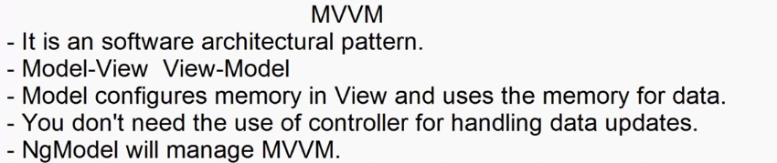

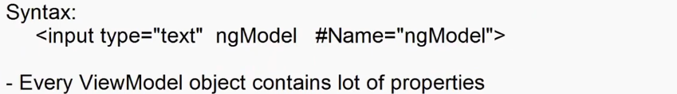

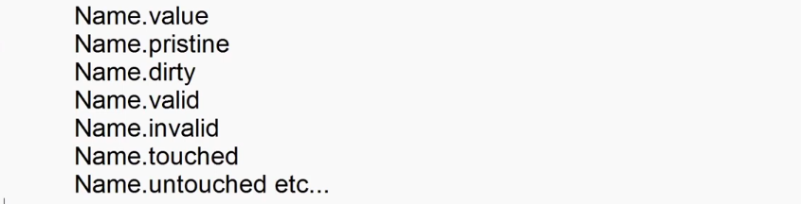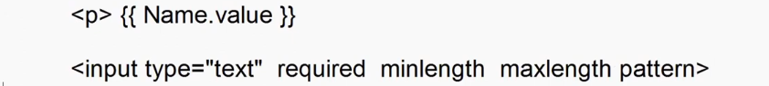

<div class="container-fluid">

    <div class="row">

        <div class="col-3">

             <h2>Register Product</h2>

             <dl>

                <dt>Name</dt>

                <dd><input type="text" ngModel #Name="ngModel" class="from-control"></dd>

                <dt>Price</dt>

                <dd><input type="text" ngModel #Price="ngModel" class="from-control"></dd>

                <dt>Stock</dt>

                <dd class="form-switch"><input ngModel #Stock="ngModel" type="checkbox"  class="form-check-input">Available</dd>

                <dt>Shipped to</dt>

                <dd >

                    <select ngModel #ShippedTO="ngModel" class="form-select">

                        <option>Delhi</option>

                        <option>Pune</option>

                        <option>Mumbai</option>

                    </select>

                </dd>

             </dl>

        </div>

        <div class="col-9 ">

            <h2>Details</h2>

            <dl>

                <dt>Name</dt>

                <dd>{{Name.value}}</dd>

                <dt>Price</dt>

                <dd>{{Price.value}}</dd>

                <dt>Stock</dt>

                <dd>{{(Stock.value==true)?"Available":"Out of Stock"}}</dd>

                <dt>Shipped to</dt>

                <dd>{{ShippedTO.value}}</dd>

             </dl>

        </div>

    </div>

</div>

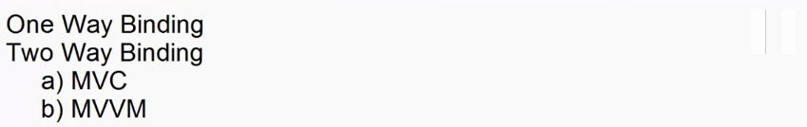

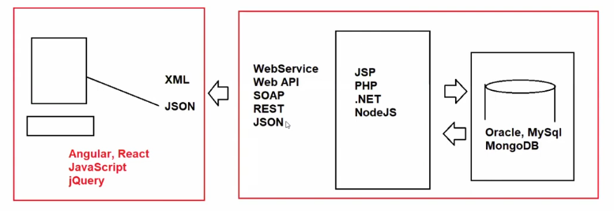

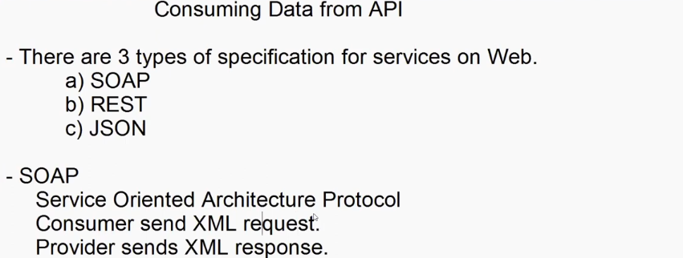

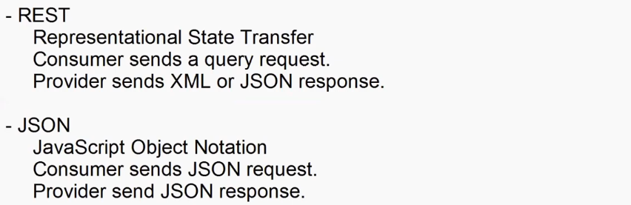

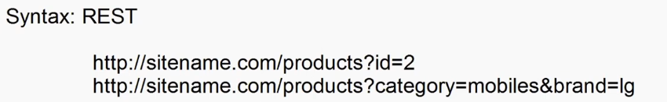



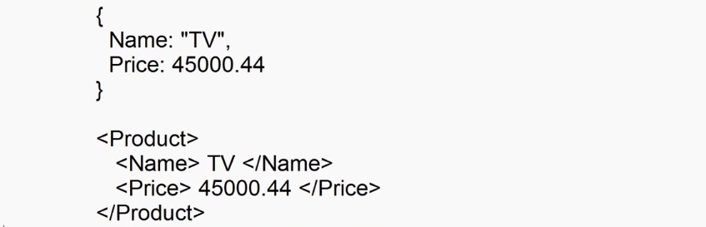

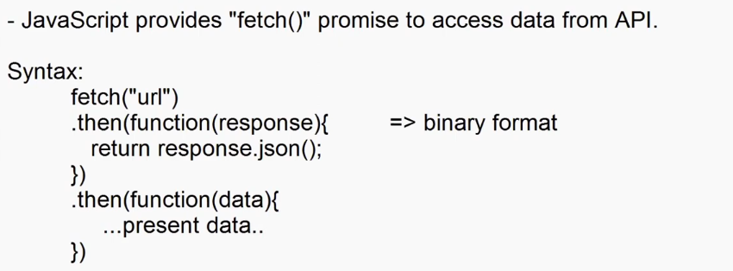

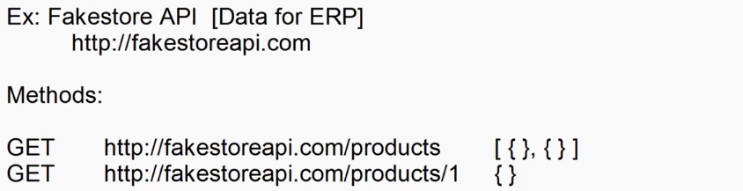

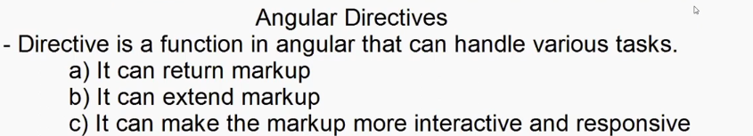

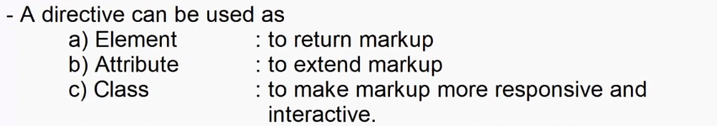

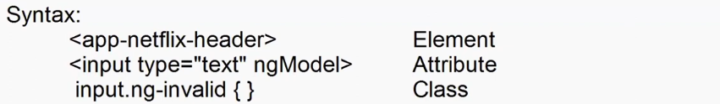

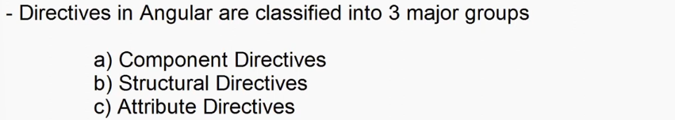

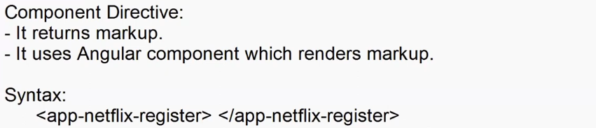

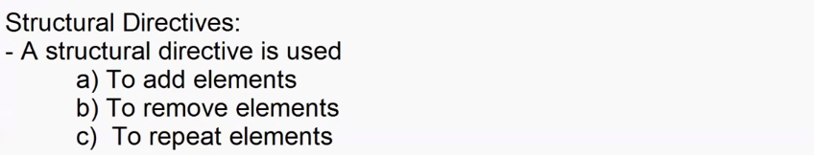

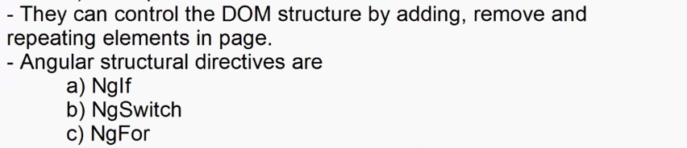

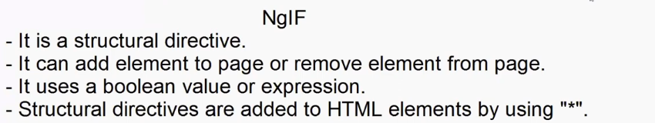

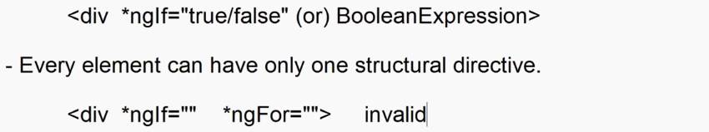

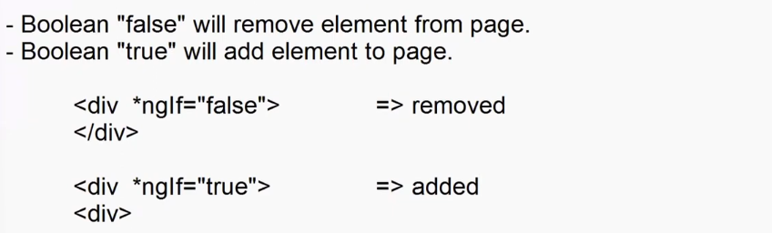



export interface FakeStoreProductContract{

    id:number;

    title:string;

    price:number;

    description:string;

    category:string;

    image:string;

    rating:{rate:number,count:number}

}

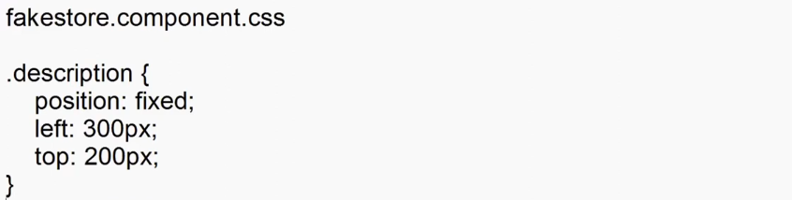

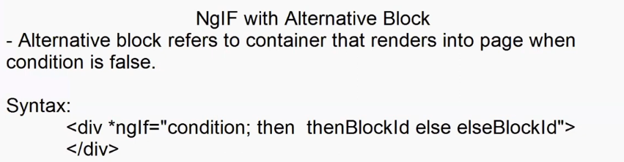

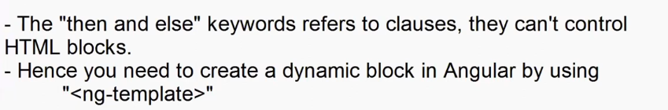

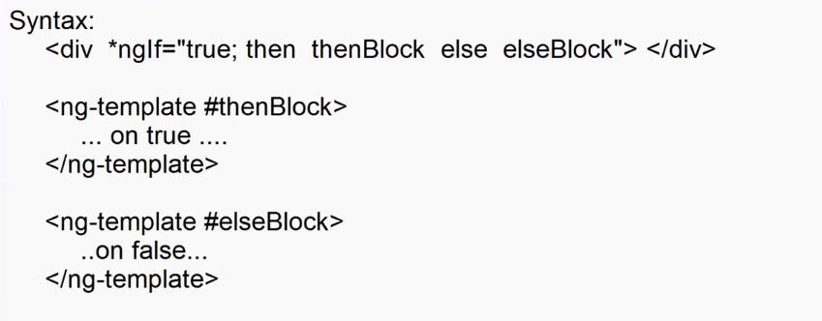



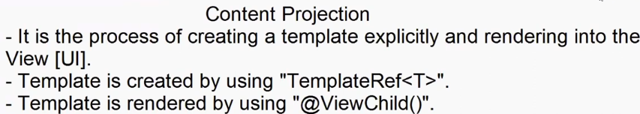

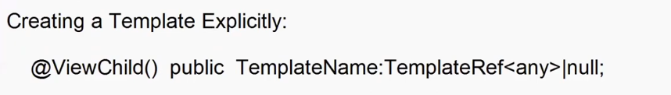



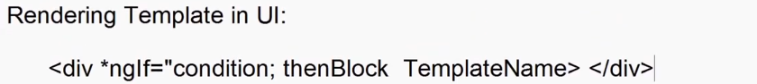

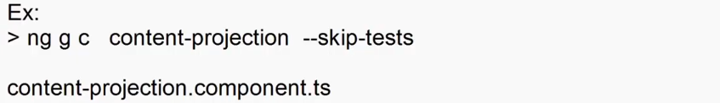

import { Component,OnInit,TemplateRef,ViewChild,viewChild } from '@angular/core';

@Component({

  selector: 'app-content-projection',

  templateUrl: './content-projection.component.html',

  styleUrl: './content-projection.component.css'

})

export class ContentProjectionComponent implements OnInit {

  constructor(){}

  public ThenBlock: TemplateRef<any> | null = null;

  public TemplateName : string = "choose Template";

  @ViewChild('Template1',{static:true}) public Template1:TemplateRef<any>|null =null;

  @ViewChild('Template2',{static:true}) public Template2:TemplateRef<any>|null =null;

  @ViewChild('Template3',{static:true}) public Template3:TemplateRef<any>|null =null;

  ngOnInit(): void {

    this.ThenBlock = this.Template1;

  }

  public TemplateChange():void{

    switch(this.TemplateName){

      case "Template1":

        this.ThenBlock = this.Template1;

        break;

      case "Template2":

        this.ThenBlock = this.Template2;

        break;

      case "Template3":

        this.ThenBlock = this.Template3;

        break;

    }

  }

}



<div class="container-fluid">

  <h2>Content Projection</h2>

  <div>

      <select (change)="TemplateChange()" [(ngModel)]="TemplateName">

        <option selected>Choose Option</option>

        <option value="Template1">Template1</option>

        <option value="Template2">Template2</option>

        <option value="Template3">Template3</option>

      </select>

  </div>

  <div *ngIf="true; then ThenBlock"></div>

  <ng-template #Template1> Template-1 </ng-template>

  <ng-template #Template2> Template-2 </ng-template>

  <ng-template #Template3> Template-3 </ng-template>

</div>

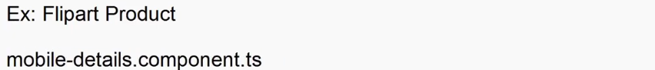

import { Component,OnInit,TemplateRef,ViewChild } from '@angular/core';

import { tick } from '@angular/core/testing';

@Component({

  selector: 'app-mobile-details',

  templateUrl: './mobile-details.component.html',

  styleUrl: './mobile-details.component.css'

})

export class MobileDetailsComponent implements OnInit {

  constructor(){}

  public ThenBlock : TemplateRef<any>|null = null;

  @ViewChild('View1',{static : true}) public View1 : TemplateRef<any>|null = null;

  @ViewChild('View2',{static : true}) public View2 : TemplateRef<any>|null = null;

  @ViewChild('View3',{static : true}) public View3 : TemplateRef<any>|null = null;

  @ViewChild('View4',{static : true}) public View4 : TemplateRef<any>|null = null;

  @ViewChild('View5',{static : true}) public View5 : TemplateRef<any>|null = null;

  @ViewChild('View6',{static : true}) public View6 : TemplateRef<any>|null = null;

  ngOnInit(): void {

    this.ThenBlock=this.View1;

  }

  public ChangeView(View:String)

  {

    switch(View){

      case "View1":

        this.ThenBlock = this.View1;

        break;

      case "View2":

        this.ThenBlock = this.View2;

        break;

      case "View3":

        this.ThenBlock = this.View3;

        break;

      case "View4":

        this.ThenBlock = this.View4;

        break;

      case "View5":

        this.ThenBlock = this.View5;

        break;

      case "View6":

        this.ThenBlock = this.View6;

        break;

    }

  }

}



nav div{

    border: 2px solid blue;

    margin-bottom: 20px;

    padding:5px;

    width: 65px;

    height: 65px;

}

nav{

    border: 1px solid black;

    width: 85px;

    padding: 10px;

}

nav div:hover{

    cursor: pointer;

}



<div class="container-fluid">

  <div class="row mt-3">

    <div class="col-2">

      <nav>

        <div (mouseover)="ChangeView('View1')">

          <img src="assets/View1.png" width="50" height="50" />

        </div>

        <div (mouseover)="ChangeView('View2')">

          <img src="assets/View2.png" width="50" height="50" />

        </div>

        <div (mouseover)="ChangeView('View3')">

          <img src="assets/View3.png" width="50" height="50" />

        </div>

        <div (mouseover)="ChangeView('View4')">

          <img src="assets/View4.png" width="50" height="50" />

        </div>

        <div (mouseover)="ChangeView('View5')">

          <img src="assets/View5.png" width="50" height="50" />

        </div>

        <div (mouseover)="ChangeView('View6')">

          <img src="assets/View6.png" width="50" height="50" />

        </div>

      </nav>

    </div>

    <div class="col-4">

      <div *ngIf="true; then ThenBlock"></div>

      <ng-template #View1>

        <img src="assets/View1.png" width="500" height="500" />

      </ng-template>

      <ng-template #View2>

        <img src="assets/View2.png" width="500" height="500" />

      </ng-template>

      <ng-template #View3>

        <img src="assets/View3.png" width="500" height="500" />

      </ng-template>

      <ng-template #View4>

        <img src="assets/View4.png" width="500" height="500" />

      </ng-template>

      <ng-template #View5>

        <img src="assets/View5.png" width="500" height="500" />

      </ng-template>

      <ng-template #View6>

        <img src="assets/View6.png" width="500" height="500" />

      </ng-template>

    </div>

    <div class="col-6">

      <div>

        <div>

          <h3>Apple iPhone 15 (Black, 128 GB)</h3>

        </div>

        <div class="mt-3">

          <span class="bg-success p-2 rounded rounded-2"

            ><span class="bi bi-star-fill text-success text-white">4.633</span>

          </span>

          <span class="ms-3">826 Ratings & 1,987 Reviews</span>

        </div>

        <div>

          <div class="mt-3">

            <span

              ><h3>₹70,999</h3>

              <del>₹79900 </del>11% off

            </span>

          </div>

          <div>

            <ul class="list-unstyled">

              <li>

                <span class="bi bi-tag-fill text-success"> </span> Bank OfferGet

                ₹50 instant discount on first Flipkart UPI txn on order of ₹200

                and above

              </li>

              <li>

                <span class="bi bi-tag-fill text-success"></span>

                Bank Offer5% Cashback on Flipkart Axis Bank CardT&C

              </li>

              <li>

                <span class="bi bi-tag-fill text-success"></span>

                Bank Offer₹4000 Off On ICICI Bank Credit Non EMI, Credit and

                Debit Card EMI TransactionsT&C

              </li>

              <li>

                <span class="bi bi-tag-fill text-success"> </span>Special

                PriceGet extra ₹6901 off (price inclusive of cashback/coupon)T&C

              </li>

            </ul>

          </div>

        </div>

      </div>

    </div>

  </div>

</div>

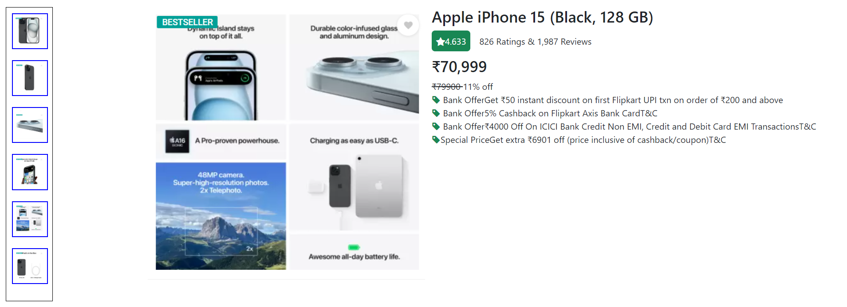

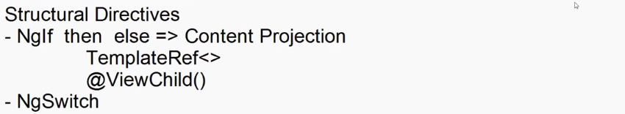

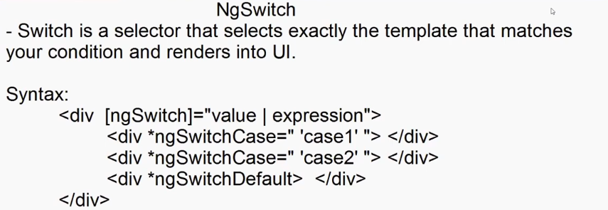



import { Component } from '@angular/core';

@Component({

  selector: 'app-product-details',

  templateUrl: './product-details.component.html',

  styleUrl: './product-details.component.css'

})

export class ProductDetailsComponent {

  public ViewName : string = 'View1';

  ViewClick(Viewname: string) {

    this.ViewName = Viewname;

    }

}



<div class="container-fluid">

  <div class="row mt-4">

    <div class="col-2">

      <div class="btn-group-vertical">

        <button (click)="ViewClick('View1')" class="btn btn-primary w-100 mb-2">

          Basic Details

        </button>

        <button (click)="ViewClick('View2')" class="btn btn-primary w-100 mb-2">

          Preview

        </button>

        <button (click)="ViewClick('View3')" class="btn btn-primary w-100">

          Description

        </button>

      </div>

      <div class="mt-4">

        <select [(ngModel)]="ViewName" class="form-select">

          <option value="Info">Select Info</option>

          <option value="View1">Basic Details</option>

          <option value="View2">Preview</option>

          <option value="View3">Description</option>

        </select>

      </div>

    </div>

    <div class="col-10">

      <div [ngSwitch]="ViewName">

        <div *ngSwitchCase="'View1'">

          <div>

            <h3>Apple iPhone 15 (Black, 128 GB)</h3>

          </div>

          <div class="mt-3">

            <span class="bg-success p-2 rounded rounded-2"

              ><span class="bi bi-star-fill text-success text-white"

                >4.633</span

              >

            </span>

            <span class="ms-3">826 Ratings & 1,987 Reviews</span>

          </div>

          <div>

            <div class="mt-3">

              <span

                ><h3>₹70,999</h3>

                <del>₹79900 </del>11% off

              </span>

            </div>

            <div>

              <ul class="list-unstyled">

                <li>

                  <span class="bi bi-tag-fill text-success"> </span> Bank

                  OfferGet ₹50 instant discount on first Flipkart UPI txn on

                  order of ₹200 and above

                </li>

                <li>

                  <span class="bi bi-tag-fill text-success"></span>

                  Bank Offer5% Cashback on Flipkart Axis Bank CardT&C

                </li>

                <li>

                  <span class="bi bi-tag-fill text-success"></span>

                  Bank Offer₹4000 Off On ICICI Bank Credit Non EMI, Credit and

                  Debit Card EMI TransactionsT&C

                </li>

                <li>

                  <span class="bi bi-tag-fill text-success"> </span>Special

                  PriceGet extra ₹6901 off (price inclusive of

                  cashback/coupon)T&C

                </li>

              </ul>

            </div>

          </div>

        </div>

        <div *ngSwitchCase="'View2'">

          <img src="assets/View1.png" width="500" height="500" />

        </div>

        <div *ngSwitchCase="'View3'">

          <div>

            <h3>Key Features</h3>

            <ul>

              <li>Display: 6.1 inches (15.54 cm), Super Retina XDR Display</li>

              <li>Memory: 128GB ROM</li>

              <li>Processor: Apple A16 Bionic Chip, Hexa Core</li>

              <li>Camera: 48 MP + 12 MP Dual Rear & 12 MP Front Camera</li>

              <li>Battery: 15W MagSafe Wireless Charging</li>

              <li>USP: Dynamic Island, IP68 Water Resistant</li>

            </ul>

          </div>

        </div>

        <div *ngSwitchDefault>

          <h4>Please Select View</h4>

        </div>

      </div>

    </div>

  </div>

</div>

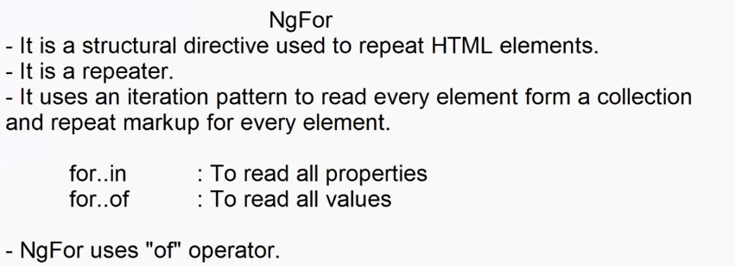





import { Component } from '@angular/core';

@Component({

  selector: 'app-for-demo',

  templateUrl: './for-demo.component.html',

  styleUrl: './for-demo.component.css'

})

export class ForDemoComponent {

  public Categories:string[] = ["All","Electronics","Footwear","Fashion"]

}



<div class="container-fluid">

  <div class="mt-4 row">

    <div class="col">

      <ol>

        <li *ngFor="let item of Categories">{{ item }}</li>

      </ol>

    </div>

    <div class="col">

      <select>

        <option *ngFor="let item of Categories">{{ item }}</option>

      </select>

    </div>

    <div class="col">

      <ul class="list-unstyled">

        <li *ngFor="let item of Categories"><input type="checkbox">{{item}}</li>

      </ul>

    </div>

    <div class="col">

      <div class="btn-group-vertical">

        <button class="btn btn-primary mt-2" *ngFor="let item of Categories">

            {{item}}

        </button>

      </div>

    </div>

    <div class="col">

        <div *ngFor="let item of Categories" >

            <a href="#">{{item}}</a>

        </div>

    </div>

    <div class="col">

        <table class="table table-hover table-dark">

            <thead>

                <tr>

                    <th>Categories</th>

                </tr>

            </thead>

            <tbody>

                <tr *ngFor="let item of Categories">

                    <td>{{item}}</td>

                </tr>

            </tbody>

        </table>

    </div>

  </div>

</div>



import { Component } from '@angular/core';

@Component({

  selector: 'app-for-demo',

  templateUrl: './for-demo.component.html',

  styleUrl: './for-demo.component.css'

})

export class ForDemoComponent {

  // public Categories:string[] = ["All","Electronics","Footwear","Fashion"]

  public Menu: { Category: string, Product: String[] }[] = [

    {

      Category: "Electronis",

      Product: ["Television", "Mobile"]

    },

    {

      Category: "Footwear",

      Product: ["Sneakers", "Boots", "Casulas"]

    }

  ]

  public Products:{Name:string, Price:number}[]=[

    {Name:"Samsung TV",Price: 45000.00},

    {Name:"Mobile",Price: 20000.00},

    {Name:"Nike Casuals",Price: 5300.00},

]

}



<div class="container-fluid">

    <div class="mt-4">

        <table class="table table-hover">

            <thead>

                <tr>

                    <th>Name</th>

                    <th>Price</th>

                </tr>

            </thead>

            <tbody>

                <tr *ngFor="let item of Products">

                    <th>{{item.Name}}</th>

                    <th>{{item.Price}}</th>

                </tr>

            </tbody>

        </table>

    </div>

  <div class="mt-4 row">

    <div class="col">

      <ol>

        <li *ngFor="let item of Menu">

          {{ item.Category }}

          <ul>

            <li *ngFor="let Product of item.Product">

              {{ Product }}

            </li>

          </ul>

        </li>

      </ol>

    </div>

    <div class="col">

      <select>

        <optgroup *ngFor="let item of Menu" [label]="item.Category">

          <option *ngFor="let product of item.Product">

            {{ product }}

          </option>

        </optgroup>

      </select>

    </div>

    <div class="col">

      <details *ngFor="let item of Menu">

            <summary>{{item.Category}}</summary>

            <ul>

                <li *ngFor="let product of item.Product">

                {{product}}</li>

            </ul>

      </details>

    </div>

  </div>

</div>

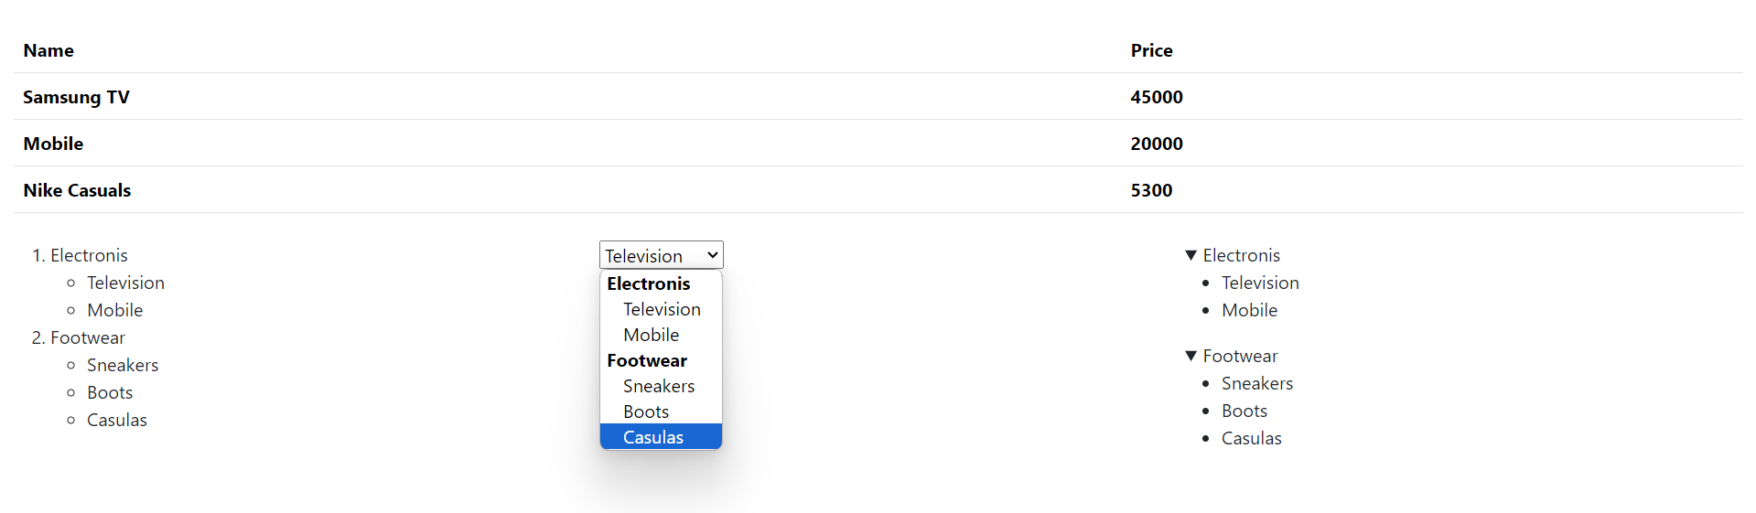



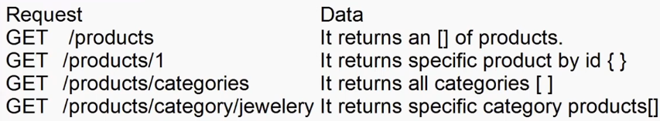

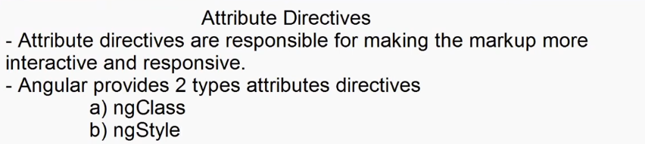

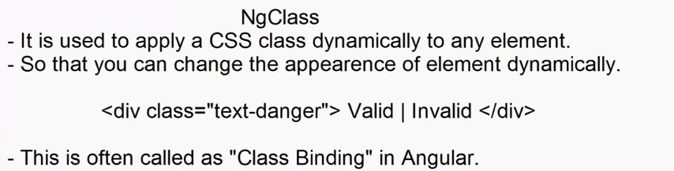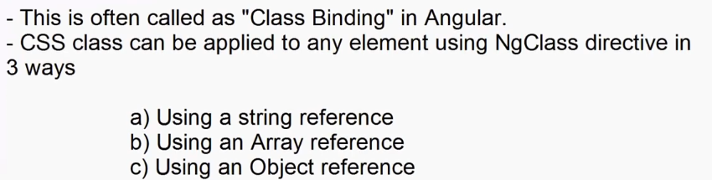

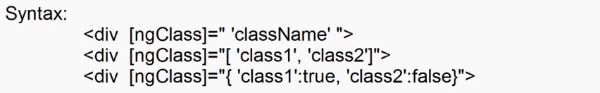

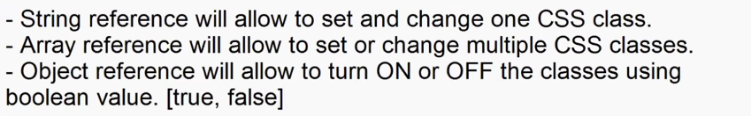



.bg-style{

    background-color: yellow;

}

.text-style{

    color: red;

    text-align: center;

    padding: 10px;

}

.border-style{

    border:2px solid red;

}



<div class="container-fluid">

    <h2>Class Binding</h2>

    <ul class="list-unstyled">

        <li><input ngModel #border="ngModel" type="checkbox">Border</li>

        <li><input ngModel #background="ngModel" type="checkbox">Background</li>

        <li><input ngModel #textEffect="ngModel" type="checkbox">Text Effect</li>

    </ul>

    <h1 [ngClass]="'bg-style'">Sample Text</h1>

    <h1 [ngClass]="['bg-style','text-style','border-style']">Sample Text</h1>

    <h1 [ngClass]="{'bg-style':background.value ,'text-style':textEffect.value, 'border-style':border.value}">Sample Text</h1>

</div>

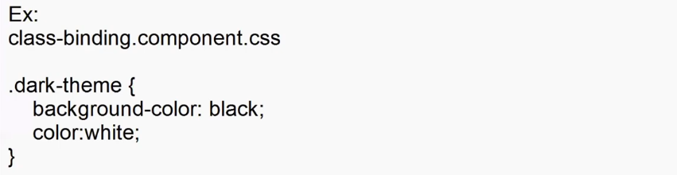

<div  class="container-fluid d-flex justify-content-center align-items-center" style="height: 500px" >

  <div>

    <div class="form-switch">

      <input type="checkbox" ngModel #darkTheme="ngModel" class="form-check-input"/>

    </div>

    <form class="border border-2 p-2" [ngClass]="{ 'dark-theme': darkTheme.value }">

      <h2><span class="bi bi-person-fill"></span>User Login</h2>

      <dl>

        <dt>User Name</dt>

        <dd><input type="text" class="form-control" /></dd>

        <dt>Password</dt>

        <dd><input type="password" class="form-control" /></dd>

      </dl>

      <button type="button" class="btn btn-dark w-100 e" [ngClass]="{ 'bg-white': darkTheme.value, 'text-dark': darkTheme.value}">Login</button>

    </form>

  </div>

</div>

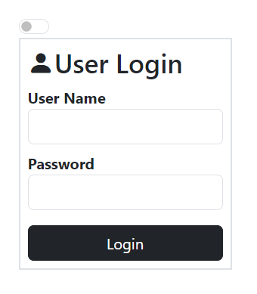

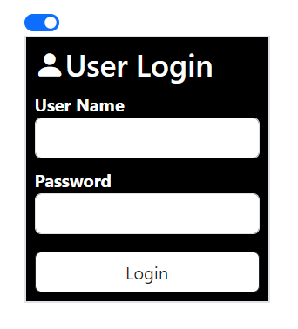

      <dl>

        <dt>User Name</dt>

        <dd><input [ngClass]="{'bg-danger':Username.invalid}" ngModel #Username="ngModel" name="Username" type="text" class="form-control"  required minlength="4"/></dd>

        <dt>Password</dt>

        <dd><input type="password" ngModel #Password="ngModel" class="form-control" /></dd>

      </dl>

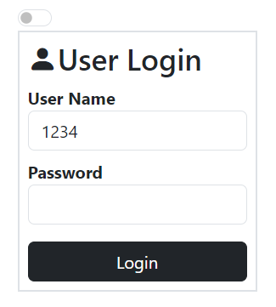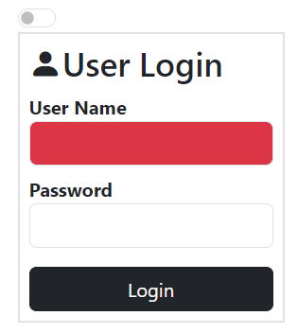

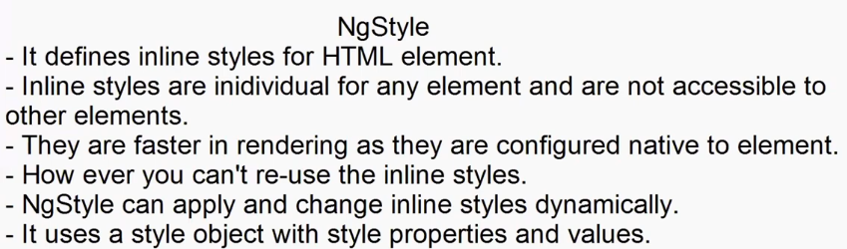

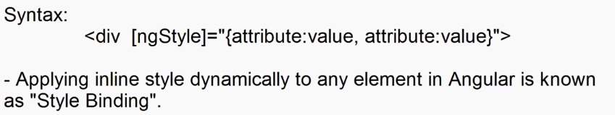



import { Component } from '@angular/core';

@Component({

  selector: 'app-class-binding',

  templateUrl: './class-binding.component.html',

  styleUrl: './class-binding.component.css'

})

export class ClassBindingComponent {

  public bgStyle:string = 'red';

  public textStyle:string = 'white';

  public padding:string="0px";

  public fontSize:string="0px";

  public ApplyClick(){

    this.styleObject = {

      "background-color":this.bgStyle,

      "color":this.textStyle,

      "padding":this.padding+ "px",

      "fontSize":this.fontSize+"px"

    }

  }

  public FontChange(){

    this.styleObject = {

      "background-color":this.bgStyle,

      "color":this.textStyle,

      "padding":this.padding+ "px",

      "fontSize":this.fontSize+"px"

    }

  }

  public styleObject:{'background-color':string , 'color': string, 'padding':string, 'fontSize':string }={

    "background-color":"red",

    "color":"white",

    "padding":"10px",

    "fontSize":"11px"

  }

}



<div class="container">

    <h1>Select Styles</h1>

    <dl>

        <dt>Background</dt>

        <dd>

            <select [(ngModel)]="bgStyle" >

                <option value="red">Red</option>

                <option value="black">black</option>

                <option value="white">white</option>

                <option value="yellow">Yellow</option>

            </select>

        </dd>

    </dl>

    <dl>

        <dt>Text Color</dt>

        <dd>

            <select [(ngModel)]="textStyle">

                <option value="red">Red</option>

                <option value="green">Green</option>

                <option value="blue">Blue</option>

                <option value="yellow">Yellow</option>

            </select>

        </dd>

        <dt>Padding</dt>

        <dd>

           1px <input [(ngModel)]="padding" type="range" value="1" min="1" max="50"> 50px

        </dd>

        <dd>

           10px <input (change)="FontChange()" [(ngModel)]="fontSize" type="range" value="10" min="10" max="50"> 50px

        </dd>

    </dl>

    <dd><button (click)="ApplyClick()" class="btn btn-primary">Apply</button></dd>

    <div  class="container-fluid d-flex justify-content-center align-items-center" style="height: 500px" >

        <h1 [ngStyle]="styleObject">Welcome to Angular</h1>

    </div>

</div>

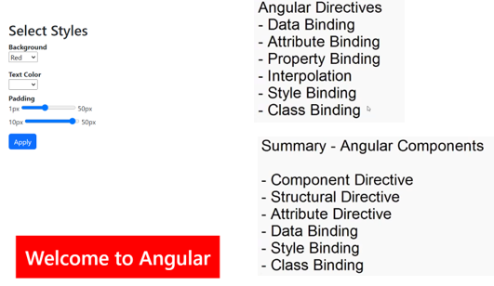

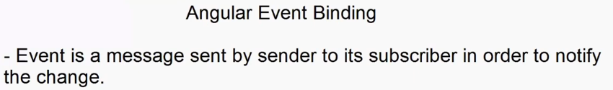

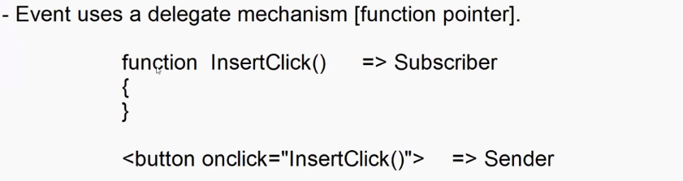

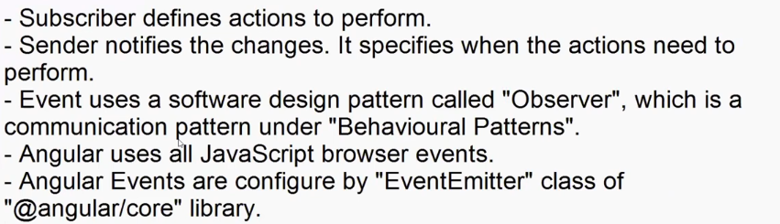

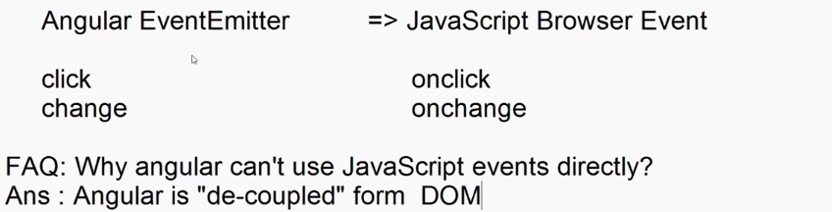

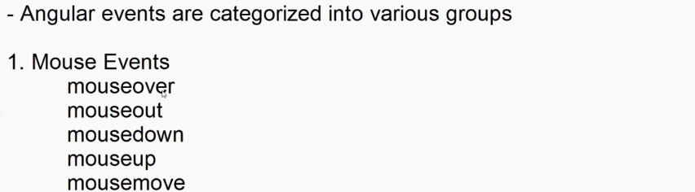

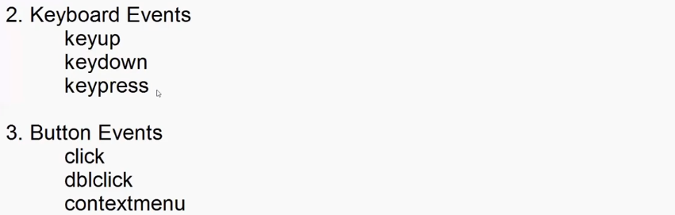

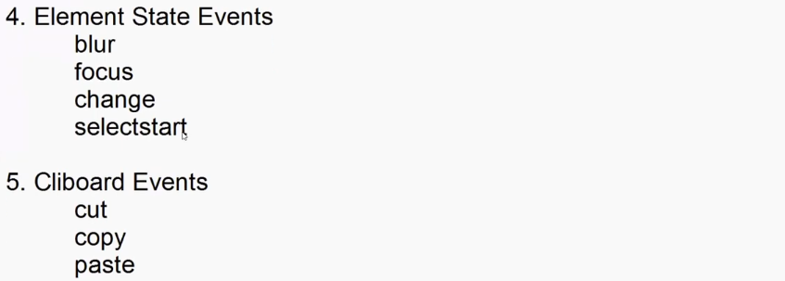

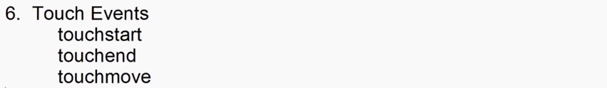

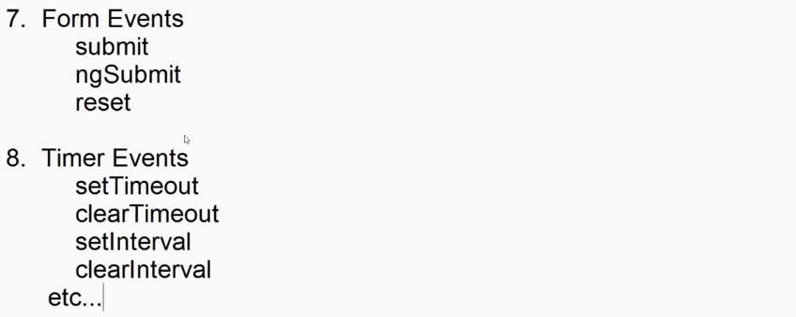

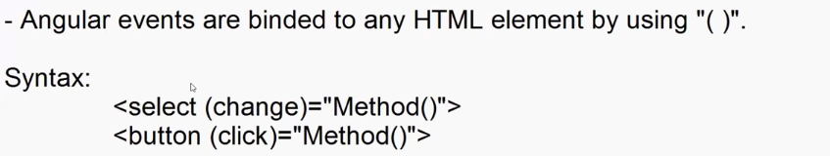

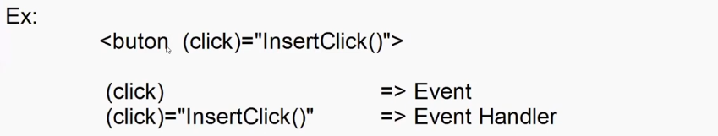

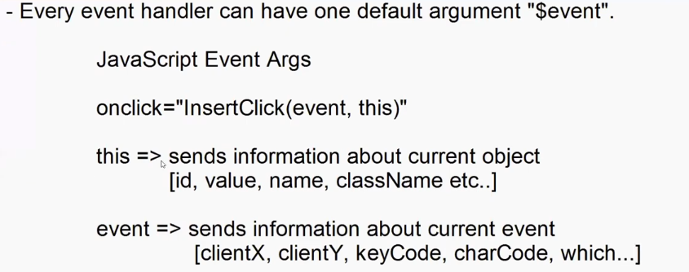



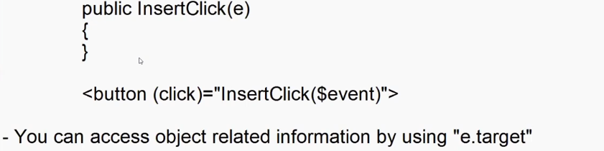



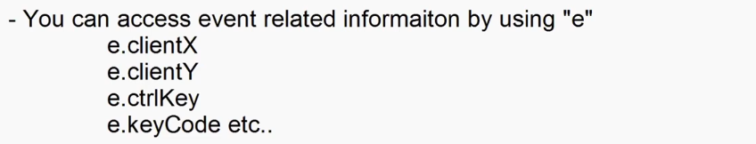



import { Component } from '@angular/core';

@Component({

  selector: 'app-event-binding',

  templateUrl: './event-binding.component.html',

  styleUrl: './event-binding.component.css'

})

export class EventBindingComponent {

 public InsertClick(e: any):void {

    document.write(`

      Button Id    : ${e.target.id} <br>

      Button Name  : ${e.target.name} <br>

      Button Class : ${e.target.className} <br>

      X Position   : ${e.clientX} <br>

      Ctrl Key     : ${e.ctrlKey}

    `);

    }

}



 <div class="container-fluid">

    <h2>Event Binding</h2>

    <button (click)="InsertClick($event)" id="btnInsert" name="InsertButton" class="btn btn-primary">Insert</button>

 </div>

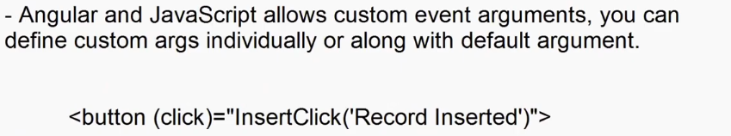

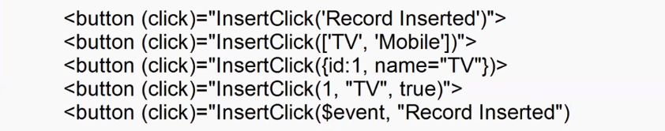

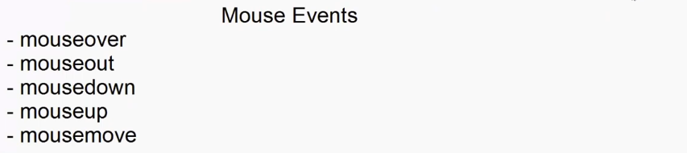



import { Component } from '@angular/core';

@Component({

  selector: 'app-event-binding',

  templateUrl: './event-binding.component.html',

  styleUrl: './event-binding.component.css'

})

export class EventBindingComponent {

    public img_src = "assets/shoe.png";

    public styleObject:{position:string,left:string,top:string}={

      position:'',

      left:'',

      top:''

    }

    public changeColor(e:any){

      this.img_src = `assets/shoe${e.target.name}.png`

    }

    public MouseMove(e:any)

    {

      this.styleObject={

        position:'fixed',

        left:e.clientX+'px',

        top:e.clientY+'px'

      }

    }

}



 <div class="container-fluid" (mousemove)="MouseMove($event)">

   <h2>Shoe</h2>

   <img width="200" [src]="img_src" height="100">

      <div class="mt-2">

         <div class="btn-group">

         <button (mouseover)="changeColor($event)" name="" class="text-dark" style="background-color: white;">White</button>

         <button (mouseover)="changeColor($event)" name="Red" class="text-white" style="background-color: red;">Red</button>

         <button (mouseover)="changeColor($event)" name="Green" class="text-white" style="background-color: green;">Green</button>

         <button (mouseover)="changeColor($event)" name="Blue" class="text-white" style="background-color: blue;">Blue</button>

      </div>

   </div>

   <div style="height: 1000px;"></div>

      <img src="assets/flag.gif" [ngStyle]="styleObject" width="50" height="50">

 </div>

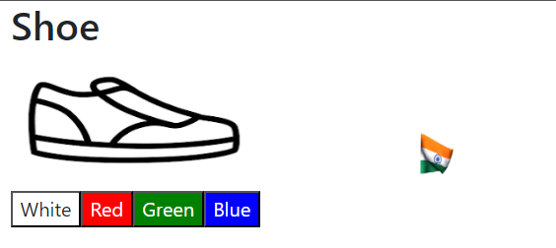

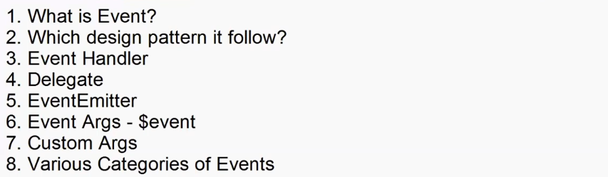

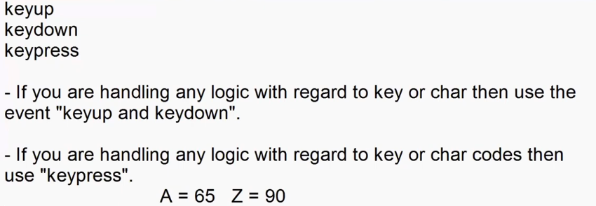





public user:any[]=[

    {Username:'adesh'},

    {Username:'adesh12'},

    {Username:'ad_mh'},

    {Username:'david'}

  ];

  public UserError:string = '';

  public isInValid:boolean = false;

  public capsOn:boolean = false;

  public VerifyUser(e:any){

    for(var user of this.user)

      {

        if(user.Username==e.target.value)

          {

            this.UserError = 'User Name Taken';

            this.isInValid=true;

            break;

          }

          else{

            this.UserError="Username available";

            this.isInValid=false;

          }

      }

  }

  public CapsOn(e:any) {

    if(e.keyCode>=65 && e.keyCode<=95)

      {

        this.capsOn=true;

      }

      else{

        this.capsOn=false;

      }

  }



    <div class="container-fluid">

      <h2>Register User</h2>

      <dl>

         <dt>User Name</dt>

         <dd><input type="text" [ngClass]="{ 'text-danger':isInValid,'text-success':true,}"  (keyup)="VerifyUser($event)"></dd>

         <dd [ngClass]="{ 'text-danger':isInValid,'text-success':true,}" >{{UserError}}</dd>

         <dt>Password</dt>

         <dd><input (keypress)="CapsOn($event)"  type="password"></dd>

         <dd *ngIf="capsOn" class="text-warning">

            <span class="bi bi-exclamation-triangle-fill"></span>Caps ON

         </dd>

      </dl>

    </div>

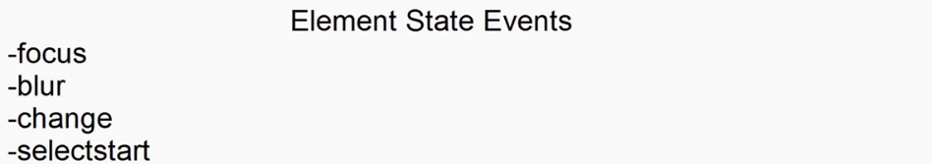



  verifyRequired(e:any) {

    if(e.target.value==""){

      this.UserError="Username Required";

      this.isInValid=true;

    }

    else{

      if(this.isInValid==false)

        {

          this.UserError="";

        }

    }

  }



<dd><input type="text" (blur)="verifyRequired($event)" [ngClass]="{ 'text-danger':isInValid,'text-success':true,}"  (keyup)="VerifyUser($event)"></dd>

**Emi-component.html**

<div class="container-fluid">

    <h2 class="text-center">Personal Loan EMI Calculator</h2>

    <div class="border border-2 border-dark p-3">

        <div class="row">

            <div class="col">

                Amount you need &#8377; <input type="text" [value]="p" >

            </div>

            <div class="col">

                For <input type="text" size="4" [value]="n" > years

            </div>

            <div class="col">

                Interest rate <input type="text" size="4" [value]="r" > %

            </div>

        </div>

        <div class="row mt-4">

            <div class="col">

                &#8377; 10,000 <input (change)="AmountChange($event)" type="range" value="10000" min="10000" max="1000000" > &#8377; 10,00,000

            </div>

            <div class="col">

                1 <input (change)="YearChange($event)" type="range" value="1" min="1" max="5"> 5

            </div>

            <div class="col">

                10.25% <input (change)="RateChange($event)" type="range" value="10.25" step="0.1" min="10.25" max="18.45"> 18.45 %

            </div>

        </div>

        <div class="row mt-4">

            <div class="col text-center">

                <button (click)="CalculateClick()" class="btn btn-primary">Calculate</button>

            </div>

        </div>

        <h1 class="text-center mt-4">

            Your monthly installment is <span class="text-primary">{{emi | currency:'INR'}}</span> for {{n}} years.

        </h1>

    </div>

</div>

Emi-component.ts

import { Component } from '@angular/core';

@Component({

  selector: 'app-emi',

  templateUrl: './emi.component.html',

  styleUrl: './emi.component.css'

})

export class EmiComponent {

  public p:number = 10000;

  public r:number = 10.25;

  public n:number = 1;

  public emi:number = 0;

  public AmountChange(e:any) {

    this.p = e.target.value;

  }

 public YearChange(e:any) {

    this.n = e.target.value;

  }

  public RateChange(e:any) {

    this.r = e.target.value;

  }

  public CalculateClick(){

    var n = this.n*12;

    var r = this.r/12/100;

    this.emi = this.p * r * Math.pow(1+r,n)/Math.pow(1+r,n)-1;

    // this.emi = Math.round(this.emi);

  }  
}

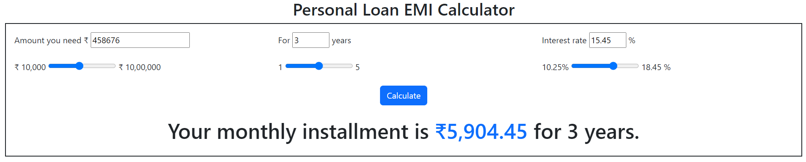

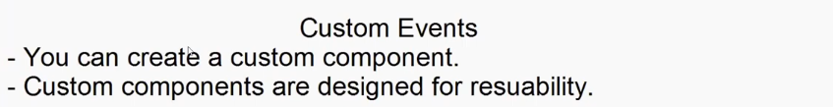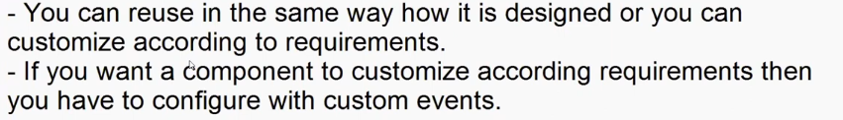

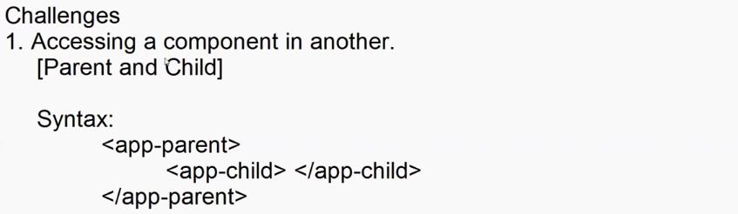



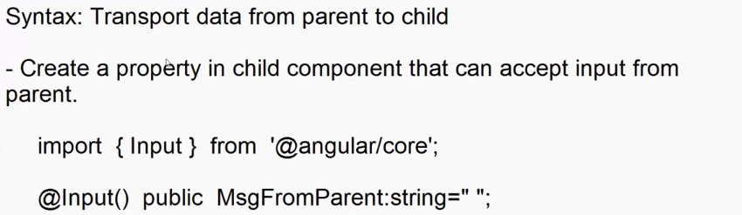









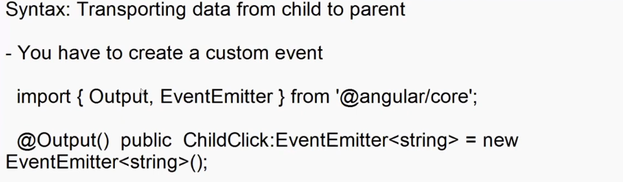

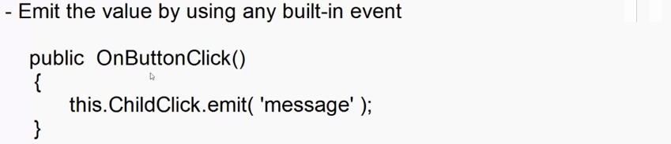

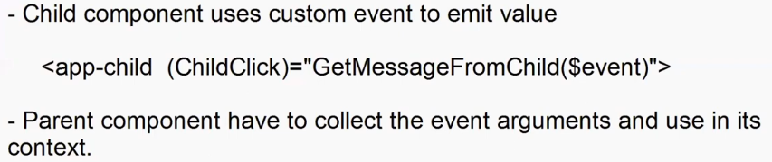

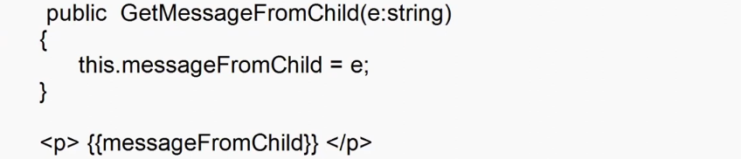

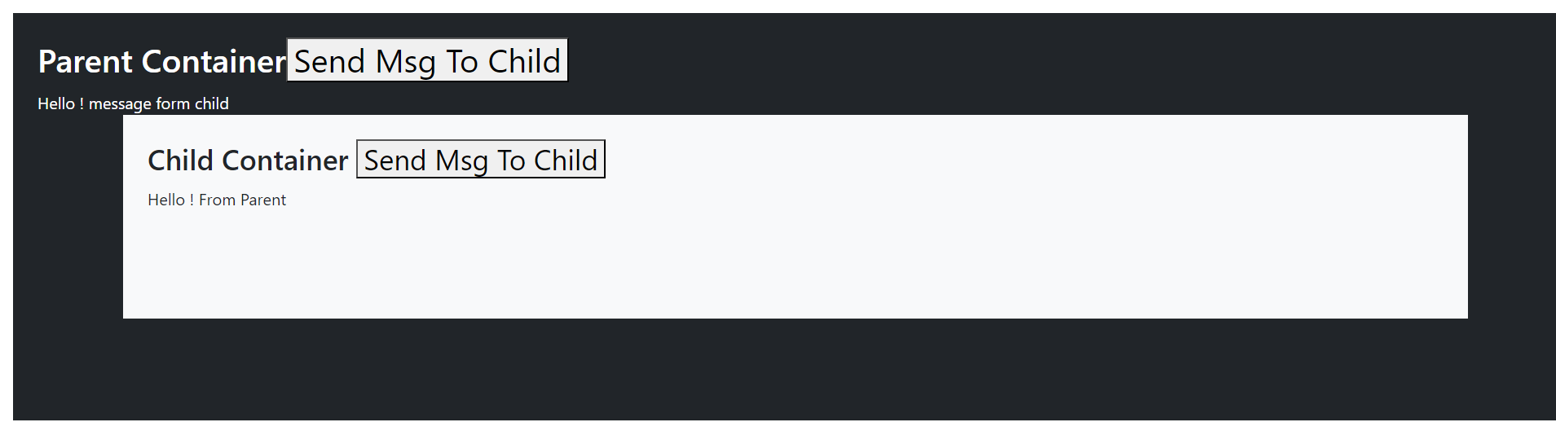



import { Component, Input, EventEmitter, Output  } from '@angular/core';

@Component({

  selector: 'app-child',

  templateUrl: './child.component.html',

  styleUrl: './child.component.css'

})

export class ChildComponent {

  @Input() public MSGFromParent:string = '';

  @Output() public ChildClick:EventEmitter<string> = new EventEmitter<string>();

  public ChildButtomClick(){

    this.ChildClick.emit('Hello ! message form child');

  }

}



<div class="container p-4 bg-light text-dark" style="height: 200px;">

    <h3>Child Container <button (click)="ChildButtomClick()">Send Msg To Child</button></h3>

    {{MSGFromParent}}

</div>



<div class="container-fluid m-3 p-4 bg-dark text-white" style="height: 400px;">

    <h2>Parent Container<button (click)="SendClick()">Send Msg To Child</button></h2>

    {{msgFromChild}}

    <app-child [MSGFromParent]="msg" (ChildClick)="GetMessageFromChild($event)"></app-child>

</div>



import { Component } from '@angular/core';

@Component({

  selector: 'app-parent',

  templateUrl: './parent.component.html',

  styleUrl: './parent.component.css'

})

export class ParentComponent {

  public msg = '';

  public msgFromChild:string = '';

  public SendClick(){

    this.msg = "Hello ! From Parent";

  }

  public GetMessageFromChild(e:string){

    this.msgFromChild=e;

  }

}

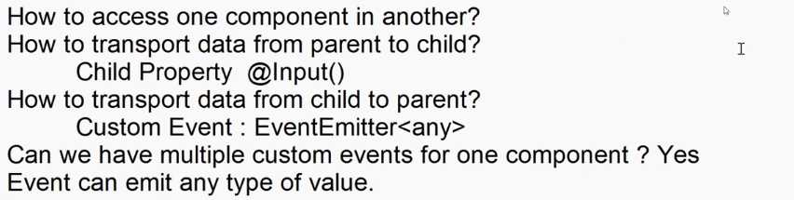

**filter.component.ts**

import { Component, EventEmitter, Input, Output } from '@angular/core';

@Component({

  selector: 'app-filter',

  templateUrl: './filter.component.html',

  styleUrl: './filter.component.css'

})

export class FilterComponent {

  @Input() public AllCount:number = 0;

  @Input() public ElectronicCount:number = 0;

  @Input() public JewelleryCount:number = 0;

  @Input() public MensCount:number = 0;

  @Input() public WomensCount:number = 0;

  public CategoryName:string = 'all';

  @Output() public CategoryChanged:EventEmitter<string> = new EventEmitter<string>();

  @Output() public SendClick:EventEmitter<any> = new EventEmitter<any>();

  public SendCategoryName(e:any) {

    this.CategoryChanged.emit(e.target.value);

  }

  public SendClickButton(e:any) {

    this.SendClick.emit({name:'samsung tv', price:'10000'});

  }

}

**Filter.component.html**<h3>Filter Products</h3>

<ul class="list-unstyled">

    <li class="d-flex justify-content-between mb-2"> <span><input type="radio" value="all" (change)="SendCategoryName($event)" class="form-check-input" name="category">All</span> <span class="badge bg-primary">{{AllCount}}</span></li>

    <li class="d-flex justify-content-between mb-2"> <span><input type="radio"  value="electronics" (change)="SendCategoryName($event)"  class="form-check-input" name="category">Electronics</span> <span class="badge bg-primary">{{ElectronicCount}}</span></li>

    <li class="d-flex justify-content-between mb-2"> <span><input type="radio"  value="jewelery" (change)="SendCategoryName($event)" class="form-check-input" name="category">Jewellery</span> <span class="badge bg-primary">{{JewelleryCount}}</span></li>

    <li class="d-flex justify-content-between mb-2"> <span><input type="radio"  value="men's clothing" (change)="SendCategoryName($event)" class="form-check-input" name="category">Men's Clothing</span> <span class="badge bg-primary">{{MensCount}}</span></li>

    <li class="d-flex justify-content-between"> <span><input type="radio"  value="women's clothing" (change)="SendCategoryName($event)" class="form-check-input" name="category">Women's Clothing</span> <span class="badge bg-primary">{{WomensCount}}</span></li>

</ul>

<button (click)="SendClickButton($event)">Send</button>

**Products-data.component.html**

<div class="container-fluid">

    <header class="bg-dark text-white p-1 text-center">

        <h2> <span class="bi bi-cart3"></span> Shopping - Online</h2>

    </header>

    <section class="row">

        <nav class="col-3">

            <app-filter [AllCount]="AllCount" [ElectronicCount]="ElectronicCount" [JewelleryCount]="JewelleryCount" [MensCount]="MensCount" [WomensCount]="WomensCount" (CategoryChanged)="GetCategoryName($event)" (SendClick)="GetProductData($event)"></app-filter>

        </nav>

        <main class="col-9 d-flex flex-wrap overflow-auto" style="height: 600px;">

            <div *ngFor="let item of Products" class="card m-2 p-2" style="width: 200px;">

                <img [src]="item.image" class="card-img-top" height="150">

                <div class="card-header" style="height: 150px;">

                    <p>{{item.title}}</p>

                </div>

            </div>

        </main>

    </section>

</div>

**Products-data.component.html**

import { Component, OnInit } from '@angular/core';

import { FakeStoreProductContract } from '../../contracts/FakeStore';

@Component({

  selector: 'app-products-data',

  templateUrl: './products-data.component.html',

  styleUrl: './products-data.component.css'

})

export class ProductsDataComponent implements OnInit{

  public Products:FakeStoreProductContract[] = [];

  public AllCount:number = 0;

  public ElectronicCount:number = 0;

  public JewelleryCount:number = 0;

  public MensCount:number = 0;

  public WomensCount:number = 0;

  ngOnInit(): void {

    fetch('http://fakestoreapi.com/products')

    .then(responce=>responce.json())

    .then(data=>{

      this.Products=data;

      this.AllCount=data.length;

      this.ElectronicCount = data.filter((product:any) => product.category=='electronics').length;

      this.JewelleryCount = data.filter((product:any) => product.category=='jewelery').length;

      this.MensCount = data.filter((product:any) => product.category=="men's clothing").length;

      this.WomensCount = data.filter((product:any) => product.category=="women's clothing").length;

    });

  }

  public GetCategoryName(e:any) {

    if(e=='all'){

      fetch(`http://fakestoreapi.com/products`)

      .then(responce=>responce.json())

      .then(data=>{

        this.Products=data;

      });

    }

    else{

      fetch(`http://fakestoreapi.com/products/category/${e}`)

      .then(responce=>responce.json())

      .then(data=>{

        this.Products=data;

      });

    }

  }

  public GetProductData(e:any)

  {

    alert(JSON.stringify(e))

  }

}

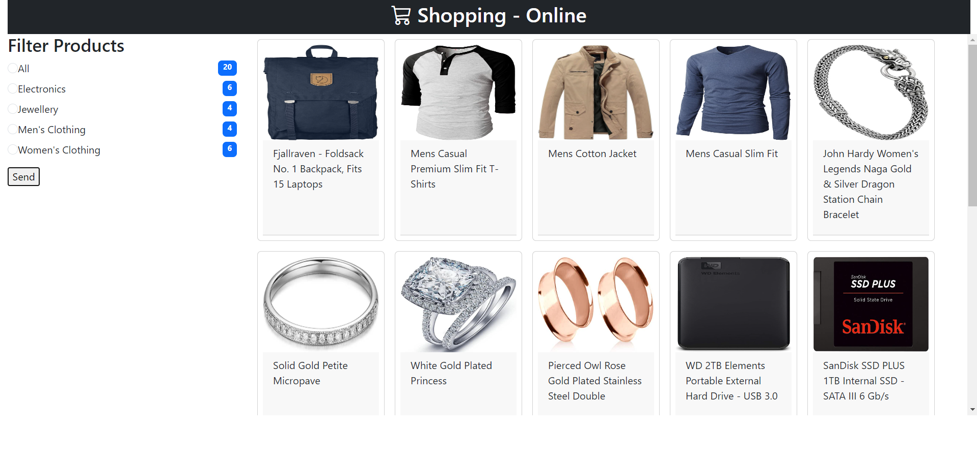

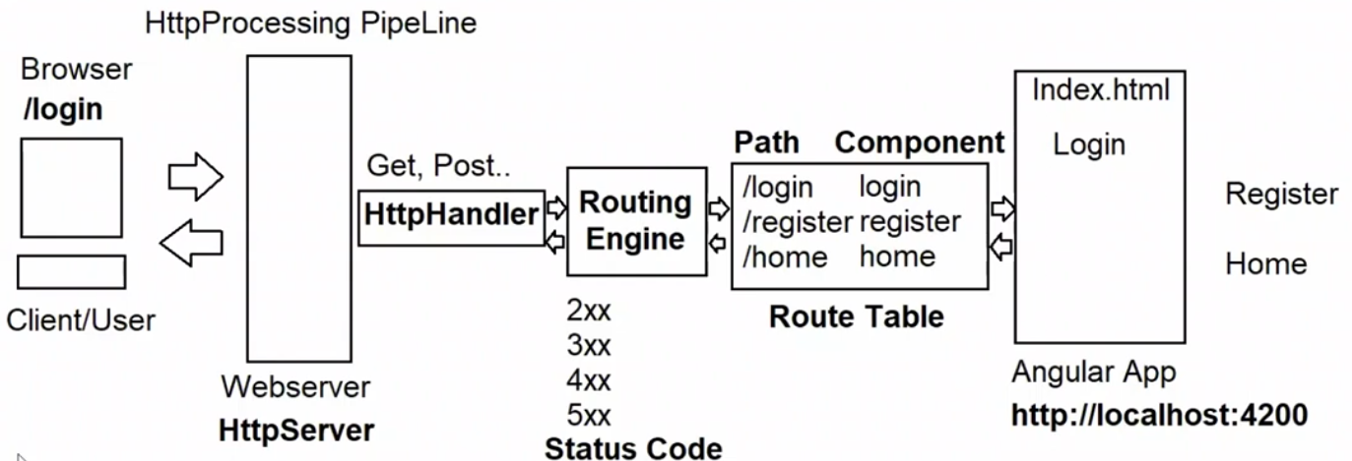

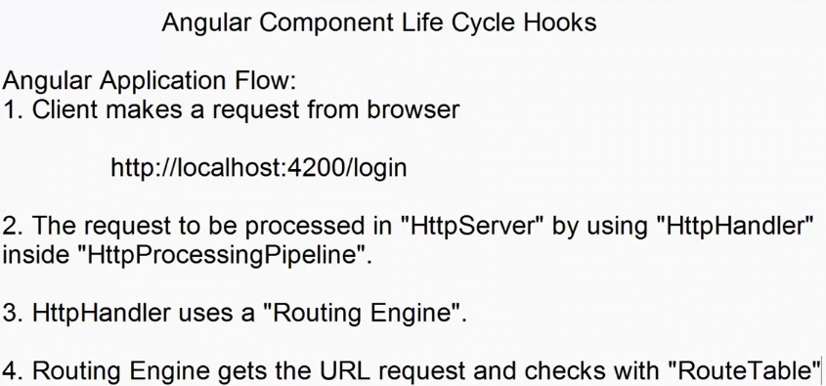

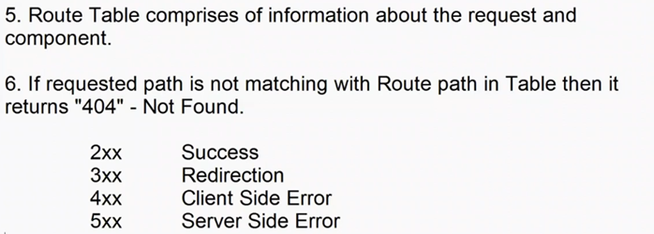

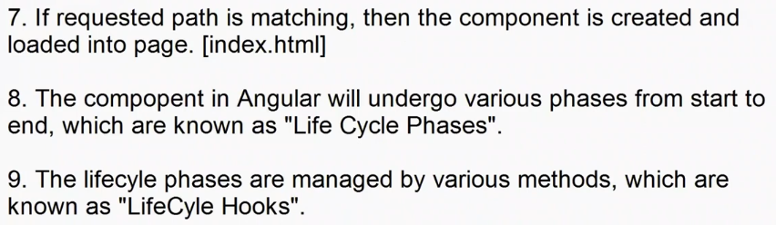



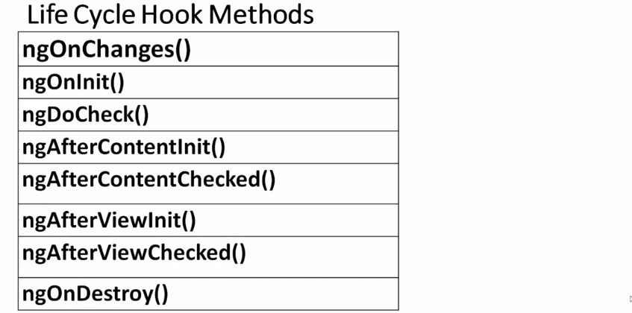

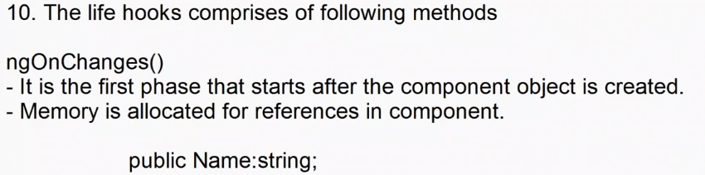

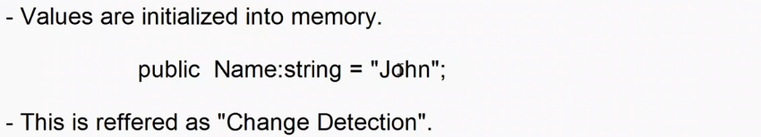

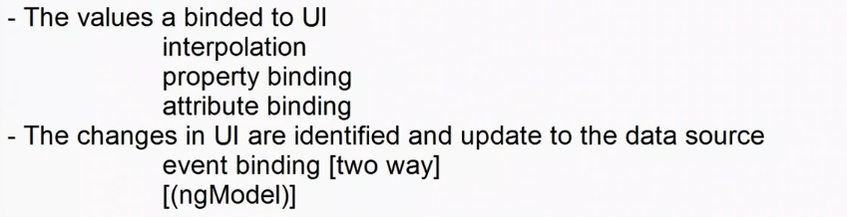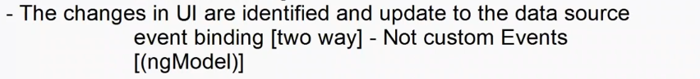

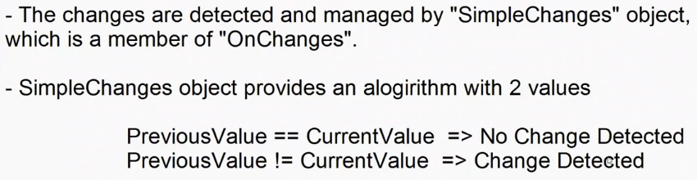

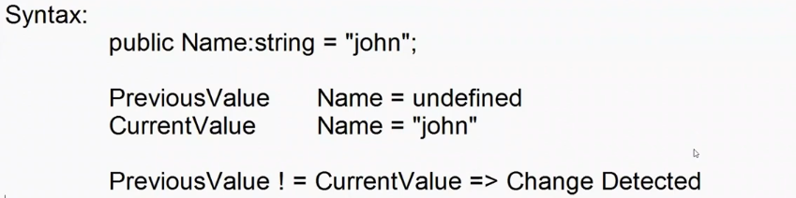

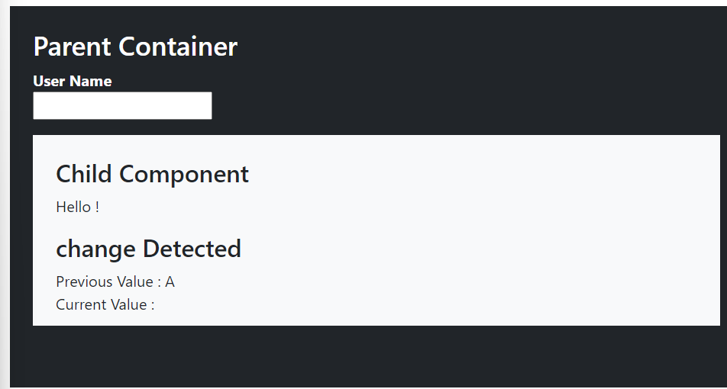

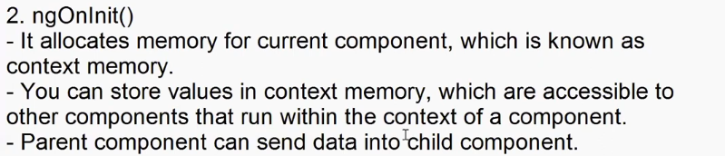

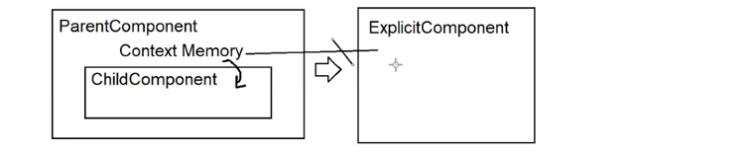

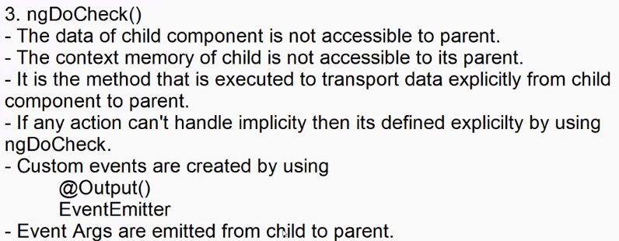

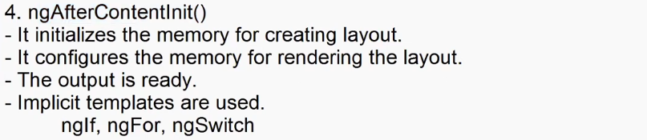

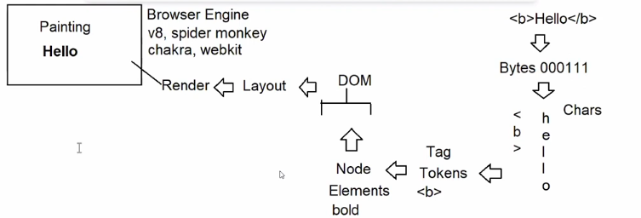

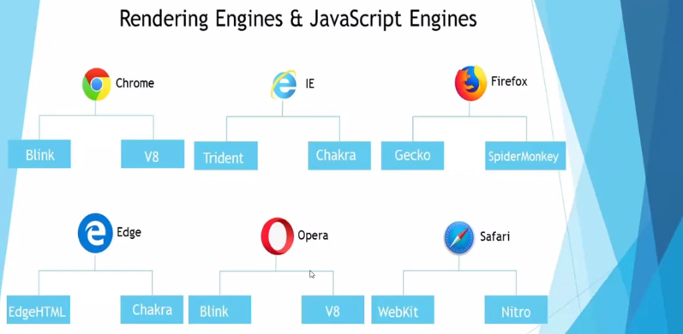

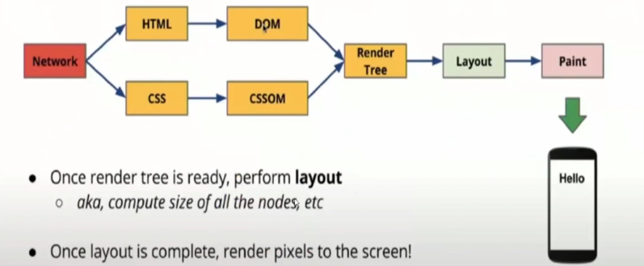

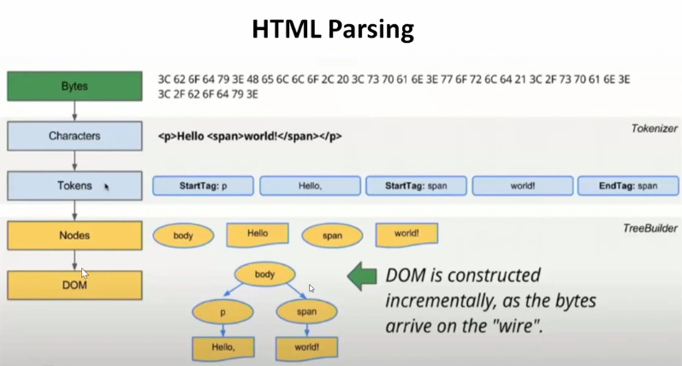

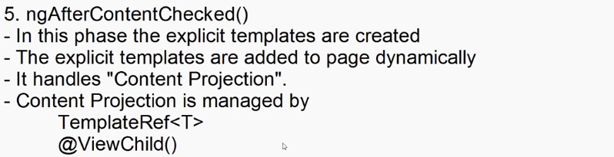

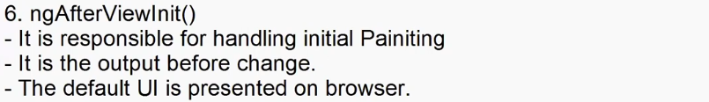

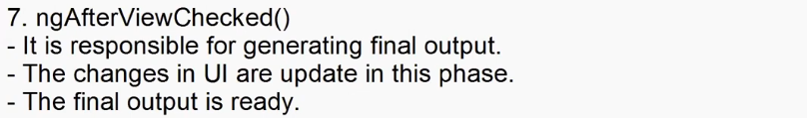

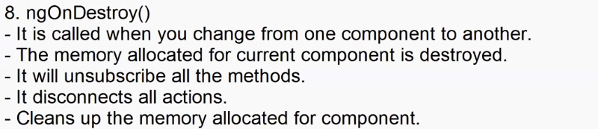

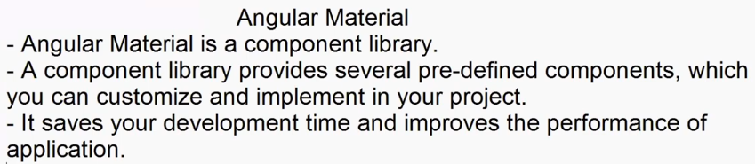

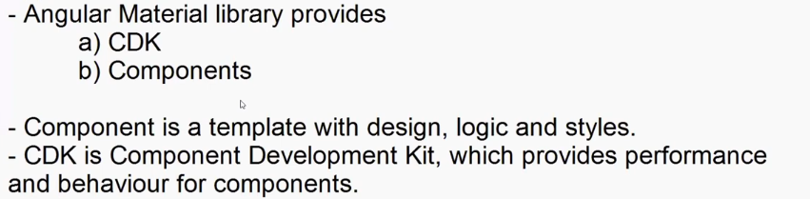

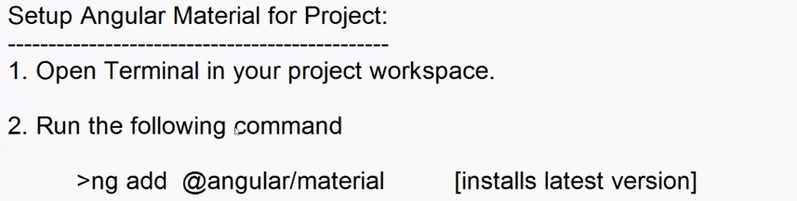

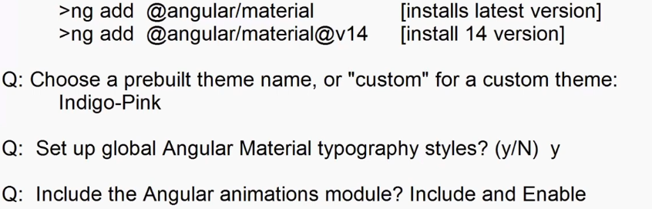

The package @angular/material@17.3.10 will be installed and executed.

Would you like to proceed? Yes

✔ Packages successfully installed.

? Choose a prebuilt theme name, or "custom" for a custom

theme: Indigo/Pink[ Preview: https://material.angular.io?theme=indigo-pink ]

? Set up global Angular Material typography styles? Yes

? Include the Angular animations module? Include and enable

animations

UPDATE package.json (1177 bytes)

✔ Packages installed successfully.

UPDATE projects/shopping/src/app/app.module.ts (3022 bytes)

UPDATE angular.json (3311 bytes)

UPDATE projects/shopping/src/index.html (540 bytes)

UPDATE projects/shopping/src/styles.css (324 bytes)

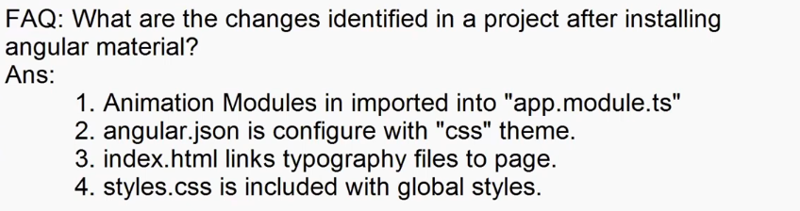

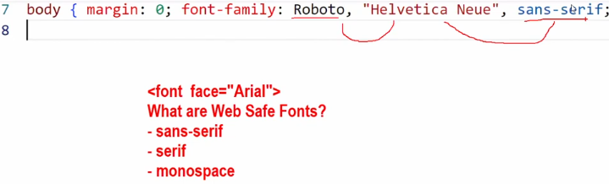

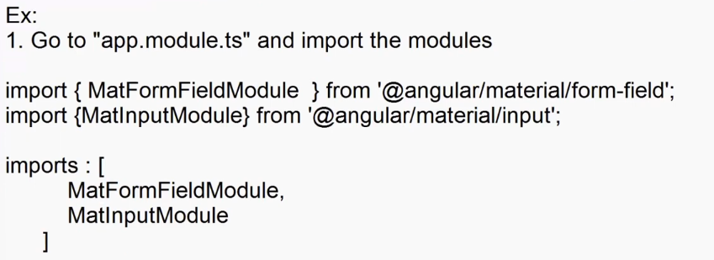

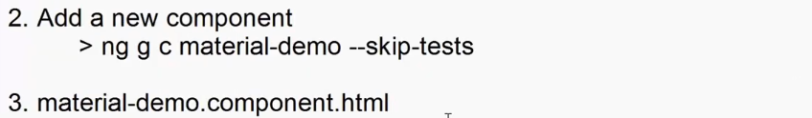

<div class="container-fluid">

    <h2>BootStrap Input</h2>

    <div class="w-25">

        <label class="form-label">User Name</label>

        <div>

            <input type="text" placeholder="Enter Name" class="form-control">

        </div>

    </div>

    <hr>

    <h2>Material Input</h2>

    <mat-form-field appearance="outline">

        <mat-label>User Name</mat-label>

        <input type="text" matInput placeholder="Enter Name">

    </mat-form-field>

</div>

**Ex. Date Pickers**

**material-demo.component.html**

<div class="container-fluid">

    <h2>Date Picker</h2>

    <mat-form-field appearance="outline">

        <mat-label >Choose a date</mat-label>

        <mat-datepicker-toggle matSuffix [for]="deprarture"></mat-datepicker-toggle>

        <input [matDatepicker]="deprarture" type="text" matInput>

        <mat-datepicker #deprarture></mat-datepicker>

    </mat-form-field>

</div>

**App.module.ts**

import { MatFormFieldModule } from '@angular/material/form-field';

import { MatInputModule } from '@angular/material/input';

import { MatDatepickerModule } from '@angular/material/datepicker';

import { MatNativeDateModule } from '@angular/material/core';

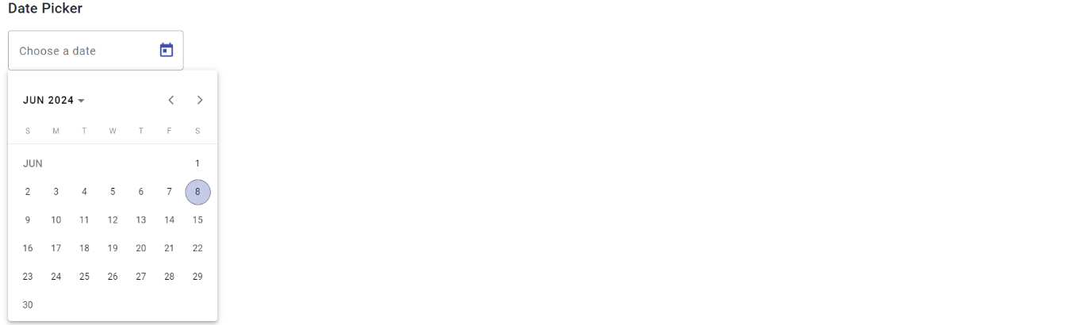  imports: [

    BrowserModule,

    AppRoutingModule,

    FormsModule,

    MatFormFieldModule,

    MatInputModule,

    MatDatepickerModule,

    MatNativeDateModule

  ],

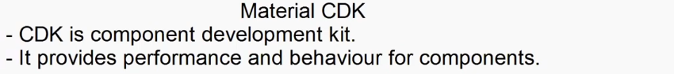

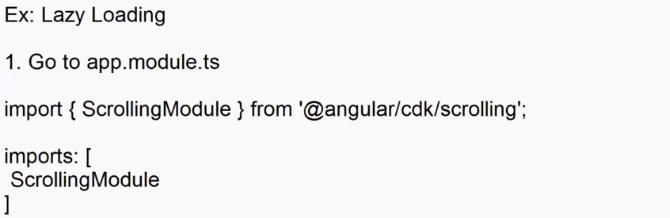

 import { Component, OnInit } from '@angular/core';

import { provideNativeDateAdapter } from '@angular/material/core';

import { FakeStoreProductContract } from '../../contracts/FakeStore';

@Component({

  selector: 'app-material-demo',

  templateUrl: './material-demo.component.html',

  styleUrl: './material-demo.component.css',

})

export class MaterialDemoComponent implements OnInit{

  // component development kit

  public Products:FakeStoreProductContract[]=[];

  ngOnInit(){

      fetch('http://fakestoreapi.com/products')

      .then(res => res.json())

      .then(data=>{

        this.Products=data;

      })

  }

}



<!----- component development kit ----->

<div class="container-fluid">

    <h2>Without Lazy Loading</h2>

    <div class="overflow-auto" style="height: 300px; width: 250px; border: 1px solid black; padding: 5px;">

        <div *ngFor="let item of Products">

            <img [src]="item.image" width="150" height="150">

        </div>

    </div>

    <h2>With Lazy Loading</h2>

    <cdk-virtual-scroll-viewport itemSize="100" style="height: 300px; width: 250px; border: 1px solid black; padding: 5px;">

        <div *cdkVirtualFor="let item of Products">

            <img [src]="item.image" height="150" width="15 0">

        </div>

    </cdk-virtual-scroll-viewport>

</div>

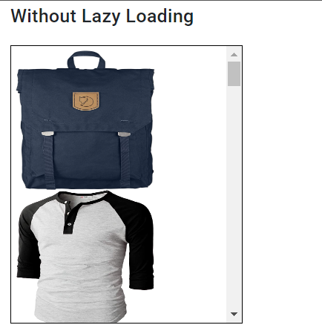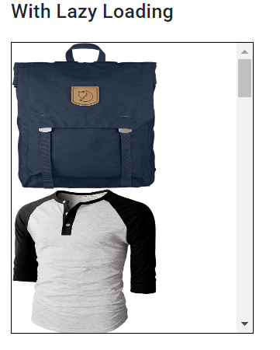

**Angular Pipes**

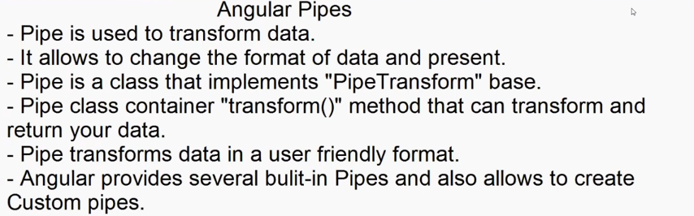

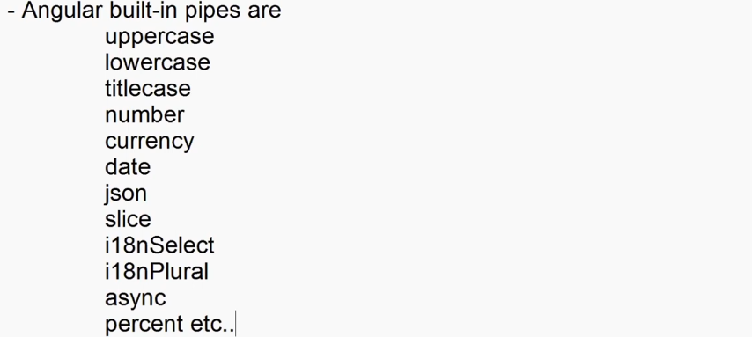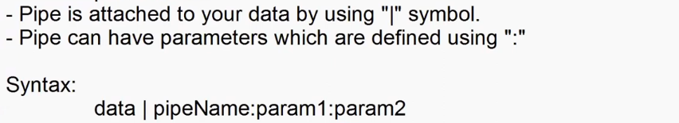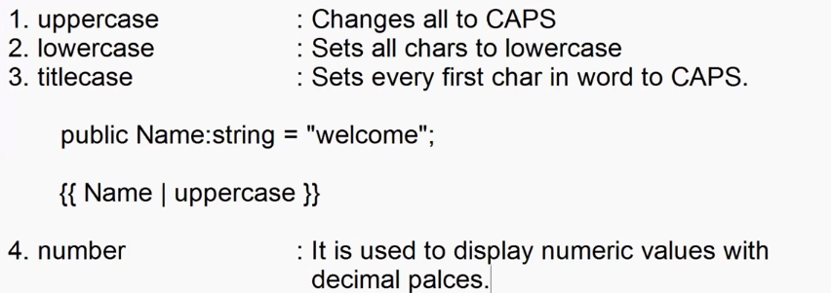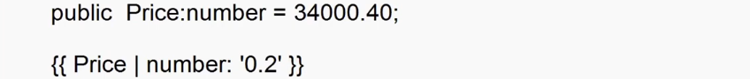

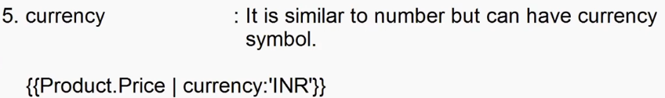

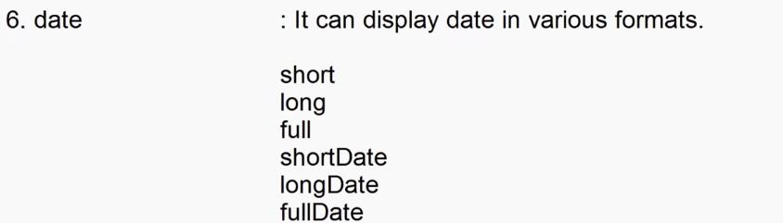



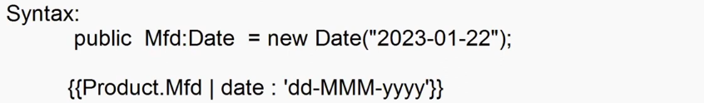

**Pipe-demo.component.ts**

import { Component } from '@angular/core';

@Component({

  selector: 'app-pipe-demo',

  templateUrl: './pipe-demo.component.html',

  styleUrl: './pipe-demo.component.css'

})

export class PipeDemoComponent {

  public Product:{Name:string, Price:number, Mfd:Date}={

    Name: 'Samsung Tv',

    Price: 34000.30,

    Mfd: new Date("2023-01-22")

  }

}

**Pipe-demo.component.html**

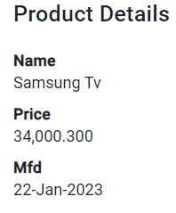<div class="container-fluid">

    <h2>Product Details</h2>

    <dl>

        <dt>Name</dt>

        <dd>{{Product.Name | titlecase}}</dd>

        <dt>Price</dt>

        <dd>{{Product.Price | number:'5.3'}}</dd>

        <dt>Mfd</dt>

        <dd>{{Product.Mfd | date : 'dd-MMM-yyyy'}}</dd>

    </dl>

</div>

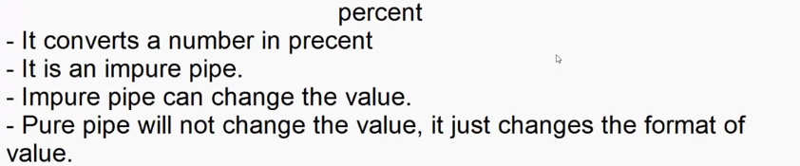

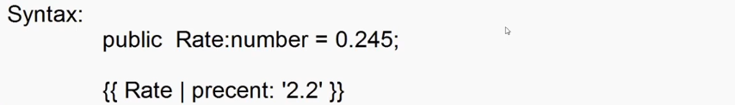

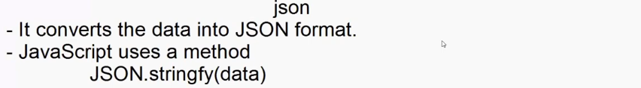

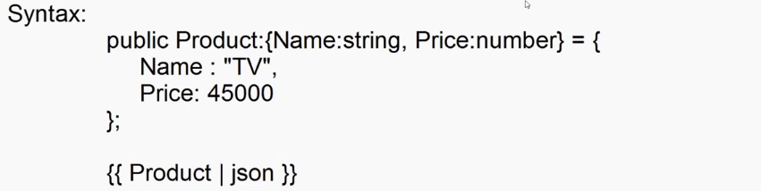

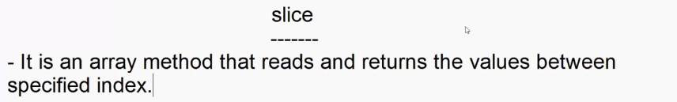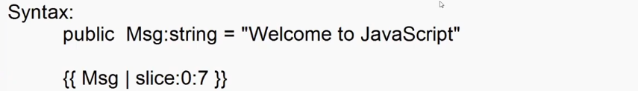

<!-- Slice -->

 <div class="container-fluid">

    <h2>Product Details</h2>

    <ol>

        <li *ngFor="let item of categories | slice:2:4">

            {{item | slice:0:6}}

        </li>

    </ol>

 </div>

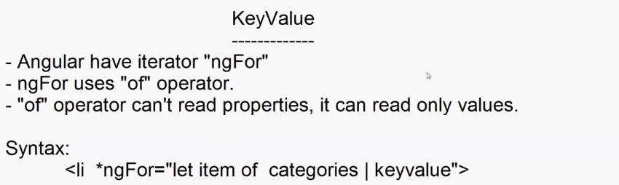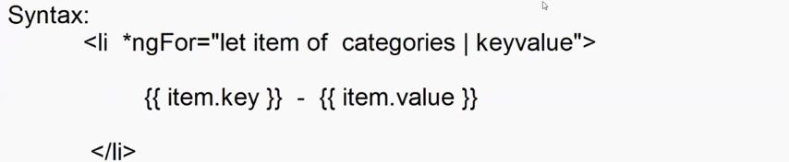

<div class="container-fluid">

    <h2>Product Details</h2>

    <ol class="list-unstyled">

        <li *ngFor="let item of categories | keyvalue">

            {{item.key}} - {{item.value}}

        </li>

    </ol>

 </div>

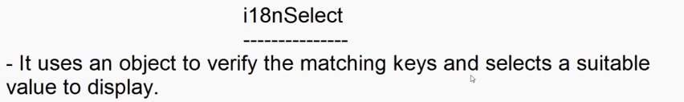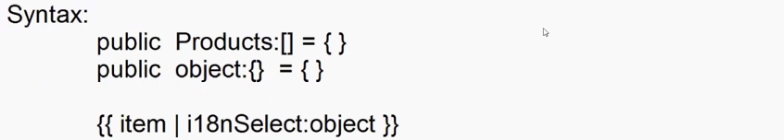



public  Products :{Name:string,ShippedTo:string}[] = [

      {Name:"Samsung TV",ShippedTo:"Delhi"},

      {Name:"Mobile",ShippedTo:"Hyd"},

      {Name:"Watch",ShippedTo:"Goa"},

      {Name:"Shirt",ShippedTo:"Mumbai"},

    ];

    public Status:any = {

      'Delhi':'Delivery in 2 Days',

      'Hyd':'Same Day Delivery',

      'Mumbai' : 'One Day Delivery',

      'other' : 'Usually dispatched in 3/4 working days'

    };



 <!-- i18nSelect -->

<div class="container-fluid">

    <h2>Your Cart</h2>

    <table class="table table-hover">

        <thead>

            <tr>

                <th>Name</th>

                <th>City</th>

                <th>Delivery Status</th>

            </tr>

        </thead>

        <tbody>

            <tr *ngFor = "let product of Products">

                    <td>{{product.Name}}</td>

                    <td>{{product.ShippedTo}}</td>

                    <td>

                        {{product.ShippedTo | i18nSelect:Status}}

                    </td>

            </tr>

        </tbody>

    </table>

</div>

**i18nPlural**

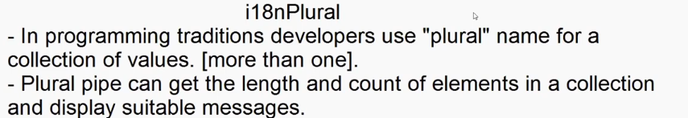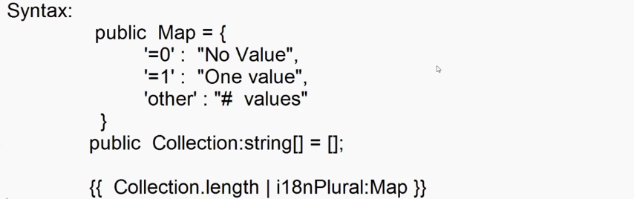

**Ex pipe-demo.component.ts**

public Messages : string[] = [];

    public Message : string = '';

    public Count : number = 0;

    public ShowMessagaes:boolean = false;

    public NotifivationMap = {

      '=0' : 'No New Messages',

      '=1' : 'One New Messages',

      'other' : '# New Messages'

    }

    public SendClick(){

      var now = new Date();

      this.Messages.push(this.Message + " - "+ now.toLocaleTimeString());

      this.Count = this.Messages.length;

      alert("Message Sent");

      this.Message="";

    }

    public ShowClick(){

      this.ShowMessagaes = (this.ShowMessagaes==true)?false:true;

    }

**Ex. Pipe-demo.component.html**

<!-- i18nPlural -->

<div class="container-fluid">

    <h2>Plural Demo</h2>

    <div class="mb-3 input-group w-25">

        <input class="form-control" type="text" [(ngModel)]="Message"><button (click)="SendClick()" class="btn btn-primary"><span class="bi bi-send"></span></button>

    </div>

    <button (click)="ShowClick()"   class="btn btn-primary position-relative" >

        <span class="bi bi-bell"></span>{{Messages.length | i18nPlural:NotifivationMap }}

        <span class="badge bg-dark position-absolute end-0 top-0 rounded rounded-circle">{{Count}}</span>

    </button>

    <div class="mt-4" *ngIf="ShowMessagaes">

            <ul class="list-unstyled">

                <li *ngFor="let msg of Messages">

                    {{msg}}

                </li>

            </ul>

    </div>

</div>

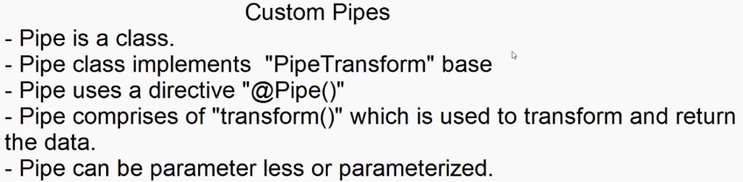

import { PipeTransform, Pipe } from "@angular/core";

@Pipe({

    name:"sentence"

})

export class SentencePipe implements PipeTransform{

    transform(sentence:string) {

        var firstChar = sentence.charAt(0);

        var restChar  = sentence.substring(1);

        var sentence = firstChar.toUpperCase() + restChar.toLowerCase();

        return sentence;

    }

}

**Add SentencePipe to angular.module.tc > declatations**

    <h1>{{title|sentence}}</h1>

    public title : string = "weLComE tO AnGuLaR";

**Angular Services**  
  
What is a Service?  
- Service is a pre-defined business logic, which you can inject and implement in any component.  
- Service enables Reusability, Maintainability and Testability.  
- Service is a set of factories.  
- Factory is a set of functions and values.  
- Factory uses "Single Call" mechanism.  
- Single call is a design pattern where an object is created every time when a method is requested.  
- Service uses "Single Ton" pattern.  
- Single ton creates an object for first request and it will use the same object across requests.  
- Service uses "DI Mechanism" for implementation.  
  [Dependency Injection]  
- DI Comprises of 2 components  
  
        a) Provider  
        b) Injector  
  
Provider:  
- It is used to locate a service in memory.  
- It looks into  
        a) root  
        b) child  
        c) platform  
- root is memory allocated for project.  
- child is memory allocated for module in project.  
- platform is memory allocated for workspace.  
  
Injector  
- It is used to inject a service into component.  
- Service is injected into the constructor of component.  
- It uses single ton pattern.  
  
Configuring a Service in Angular:  
- Angular Service is a class.  
- Service class comprises of methods known as service methods.  
- The directive for service is "@Injectable()"  
  
Syntax:  
    import  { Injectable } from  "@angular/core";  
  
    @Injectable()  
     export class  ServiceName  
    {  
          public ServiceMethod() {  
             return somedata;  
          }  
    }  
  
- Every service requires a scope to be defined, which is used by "Provider".  
  
     @Injectable(  
         {  
           providedIn: "root | child | platform"  
        }  
     )  
                (or)  
  
     app.module.ts  
  
       providers: [ ServiceName ]  
  
- Service is injected into any component  
  
   export class ComponentClass  
   {  
        constructor(private refName: ServiceName) { }  
   }  
  
- Angular provide several pre-defined services  
  
        a) Routing Service  
        b) Form Builder Service  
        c) Validation Service  
        d) Cookie Service (3rd Party)  
        e) HttpService [GET, POST...] API  
  
Ex:  
1. Add a new folder  
    "services" into app  
  
2. Add a new file  
    "captcha.service.ts"  
  
import { Injectable } from "@angular/core";  
  
@Injectable({  
    providedIn:"root"  
})  
export class CaptchaService  
{  
    public GenerateCode(){  
        let a = Math.random() * 10;  
        let b = Math.random() * 10;  
        let c = Math.random() * 10;  
        let d = Math.random() * 10;  
        let e = Math.random() * 10;  
        let f = Math.random() * 10;  
        let code = `${Math.round(a)} ${Math.round(b)} ${Math.round(c)} ${Math.round(d)} ${Math.round(e)} ${Math.round(f)}`;  
        return code;  
    }  
}  
  
3. Go to component  
  
    login.component.ts  
  
import { Component, OnInit } from "@angular/core";  
import { CaptchaService } from "../../services/captcha.service";  
  
@Component({  
    selector: "app-login",  
    templateUrl: "./login.component.html",  
    styleUrls: ["./login.component.css"]  
})  
export class LoginComponent implements OnInit  
{  
    constructor(private captcha:CaptchaService){  
    }  
    public code:string = '';  
  
    ngOnInit(){  
        this.code = this.captcha.GenerateCode();  
    }  
  
    public NewCode():void{  
        this.code = this.captcha.GenerateCode();  
    }  
    public title:string = "User Login";  
}  
  
4. login.component.html  
  
<div class="container-fluid d-flex justify-content-center align-items-center" style="height:400px">  
  <form class="border border-2 rounded rounded-2 p-3 border-primary">  
    <h3> <span class="bi bi-person-fill"></span> {{title}}</h3>  
    <dl>  
        <dt>User Name</dt>  
        <dd><input type="text" class="form-control"></dd>  
        <dt>Password</dt>  
        <dd><input type="password" class="form-control"></dd>  
        <dt>Verify Code <button (click)="NewCode()" class="btn"> <span class="bi bi-arrow-clockwise"></span> </button> </dt>  
        <dd>{{code}}</dd>  
    </dl>  
    <button class="btn btn-primary w-100">Login</button>  
  </form>  
</div>

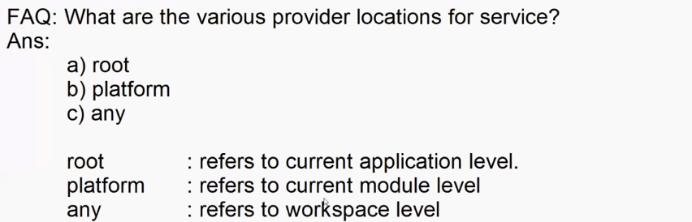 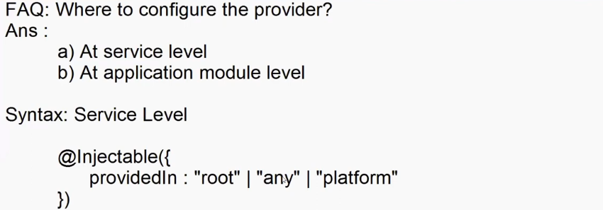 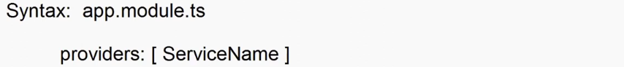

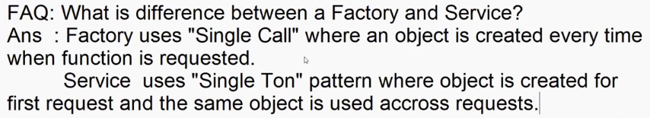

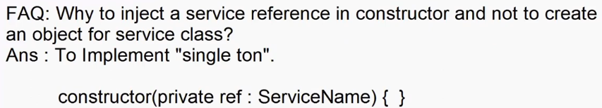 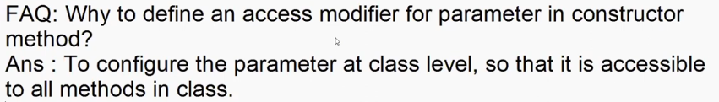

FAQ's  
Pipes  
1. What is a Pipe? What is the role of Pipe?  
A. It is a class, used to transform data.  
  
2. Why to transform data?  
A. To display is user friendly format. And to handle operations like sorting and filtering the data.  
  
3. What is the base for creating a custom Pipe?  
A. PipeTransform  
  
4. Which method returns a format?  
A. transform()  
  
5. What is a parameterized pipe?  
A. It is a pipe that allows parameters to modify its functionality.  
  
                {{ price | currency: 'INR' }}  
  
6. What is Chaining of Pipes?  
A. It is the process of configuring multiple pipes to any specific content.  
  
                {{ message | uppercase | slice:0:6 }}  
  
7. What is a Pure or Impure Pipe?  
A. Pure Pipe changes the value on change detection.  
        percent, slice, i18nselect, i18nplural  
    Impure Pipe will not change value on change detection.  
        uppercase, number, currency, etc..  
  
8. What are built-in pipes and custom pipes?  
  
9. Where to register a Pipe?  
A. Declarations[ ]  
  
10. What  is directive for Pipe?  
A.  @Pipe()  
  
11. What is "async" pipe?  
A. It handle async requests.  
  
Services  
1. What is a service?  
  
2. What a service enables?  
A. Reusability, Maintainability, Testablility.  
  
3. What is a factory?  
A. It is a set of functions and values.  
  
4. Why not a factory to use directly in application?  
A. It uses "single call"  
  
5. What is single call?  
A. An object is required every time in order to access any method.  
  
6. Which design pattern service follows?  
A. Single ton  
  
7. What is a Provider?  
A. It is a component of DI that locates a service in memory.  
  
8. What are the Provider Locations?  
A. root, child, platform, any  
  
9. What is difference between configuring a provider in service and configuring in app.module.ts?  
A. app.module uses Eager Loading.  
    Inside Service it is Lazy Loading.  
  
10. What is an Injector?  
A.  It is a component of DI that is responsible for injecting a service into  
     any component of another service.  
  
11. Who manages the Injector in service?  
A.  It is managed by the directive "@Injectable()"  
  
12. Why to Inject a service into constructor and not to create an object?  
A. To handle Single Ton.  
  
13. Name any built-in service of Angular?  
A.      HttpClient, Routing, Form Validation etc..  
  
14. Where the services are registered if not configured with provider?  
A.   In app.module.ts  
        providers : [ ]  
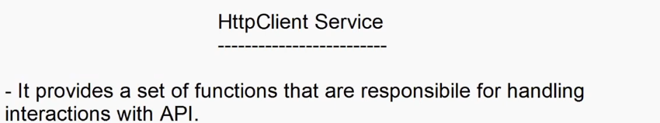

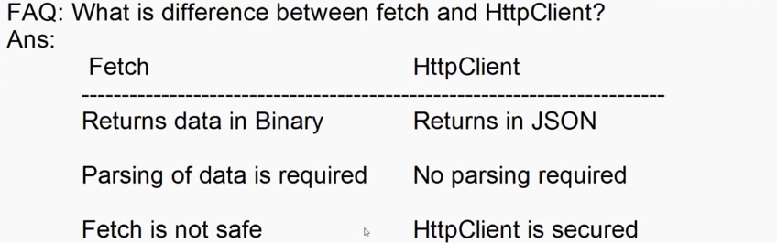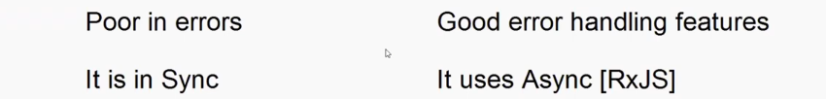

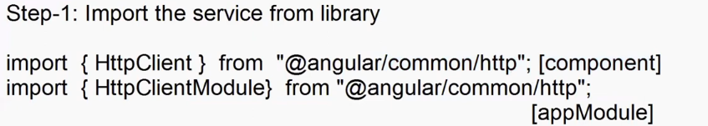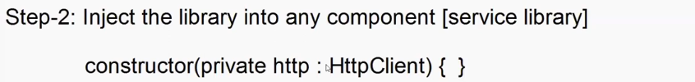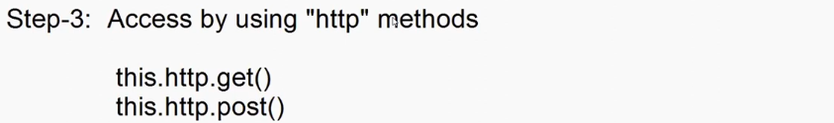 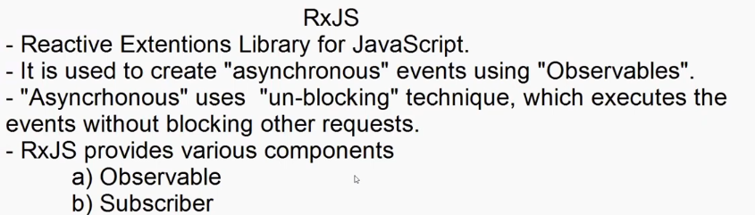

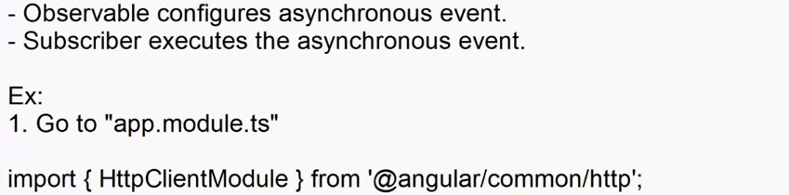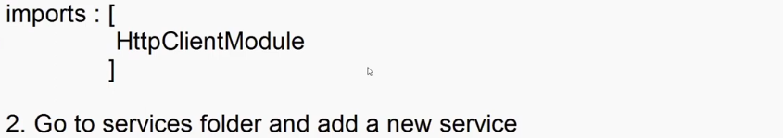 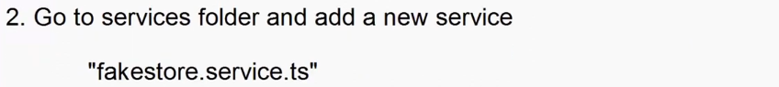

import { Injectable } from '@angular/core';

import { HttpClient } from '@angular/common/http';

import {Observable} from 'rxjs';

import { FakeStoreProductContract } from '../contracts/FakeStore';

@Injectable({

  providedIn: 'root'

})

export class FakestoreService {

  constructor(private http : HttpClient) { }

  public GetProducts():Observable<FakeStoreProductContract[]>{

    return this.http.get<FakeStoreProductContract[]>("http://fakestoreapi.com/products");

  }

  public GetCategories():Observable<string[]>{

    return this.http.get<string[]>("http://fakestoreapi.com/products/categories ")

  }

}



import { Component, OnInit } from '@angular/core';

import { FakestoreService } from '../../service/fakestore.service';

import { FakeStoreProductContract } from '../../contracts/FakeStore';

@Component({

  selector: 'app-service-demo',

  templateUrl: './service-demo.component.html',

  styleUrl: './service-demo.component.css'

})

export class ServiceDemoComponent implements OnInit {

  public Categories : string[]=[];

  public Products: FakeStoreProductContract[] = [];

  constructor(private fakeStore : FakestoreService){

  }

  ngOnInit(): void {

    this.fakeStore.GetCategories().subscribe(data=>this.Categories=data);

    this.fakeStore.GetProducts().subscribe(data=>this.Products = data);

  }

}



<div class="container-fluid">

    <h2 class="text-center">FakeStore API</h2>

    <select>

        <option *ngFor="let item of Categories">{{item}}</option>

    </select>

    <table class="table table-hover">

        <thead>

            <tr>

                <th>Title</th>

                <th>Preview</th>

            </tr>

        </thead>

        <tbody>

            <tr *ngFor="let product of Products">

                <td>{{product.title}}</td>

                <td><img src="{{product.image}}" height="100" width="100"></td>

            </tr>

        </tbody>

    </table>

</div>

**Angular Forms And Validation Services**

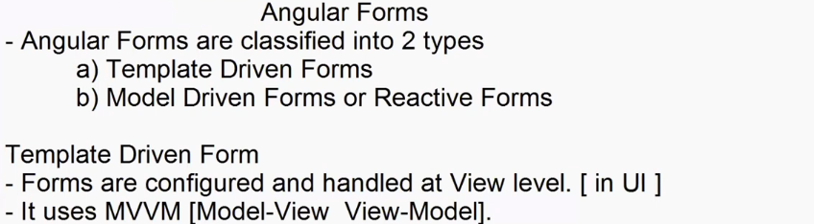

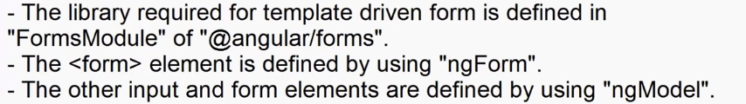

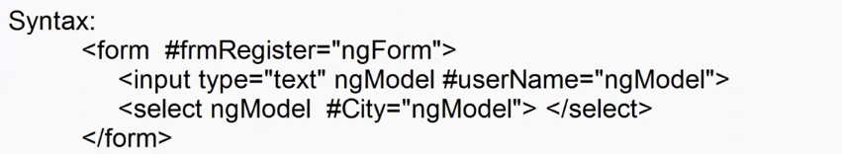

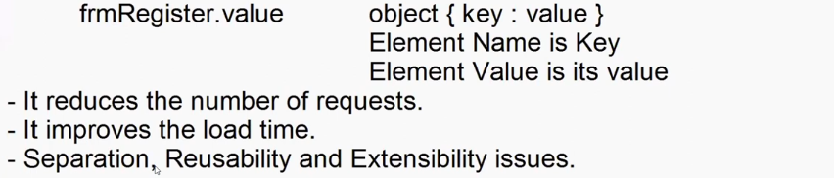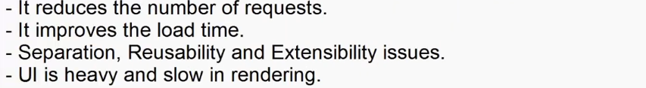



import { Component } from '@angular/core';

@Component({

  selector: 'app-template-form',

  templateUrl: './template-form.component.html',

  styleUrl: './template-form.component.css'

})

export class TemplateFormComponent {

  SubmitClick(data : any) {

    alert(JSON.stringify(data))

  }

}



<div class="container-fluid">

    <form #frmRegister="ngForm" (submit)="SubmitClick(frmRegister.value)">

        <h2>Registration Form</h2>

        <dl>

            <dt>User Name</dt>

            <dd><input type="text" name="UserName" ngModel #UserName="ngModel"></dd>

            <dt>Age</dt>

            <dd><input type="number" name="Age" ngModel #Age="ngModel"></dd>

            <dt>City</dt>

            <dd>

                <select name="City" ngModel #City="ngModel">

                    <option>Delhi</option>

                    <option>Hyd</option>

                    <option>Pune</option>

                </select>

            </dd>

        </dl>

        <button>Register</button>

    </form>

</div>

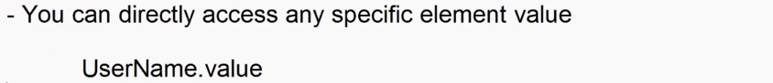

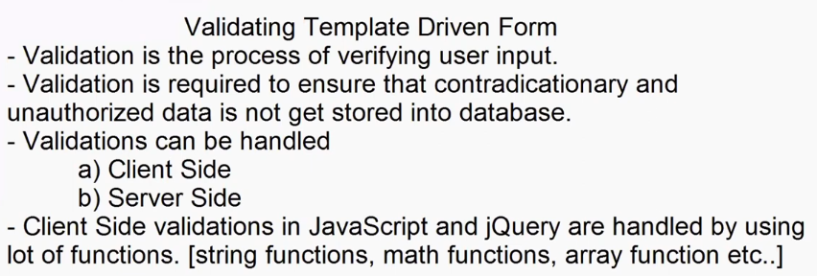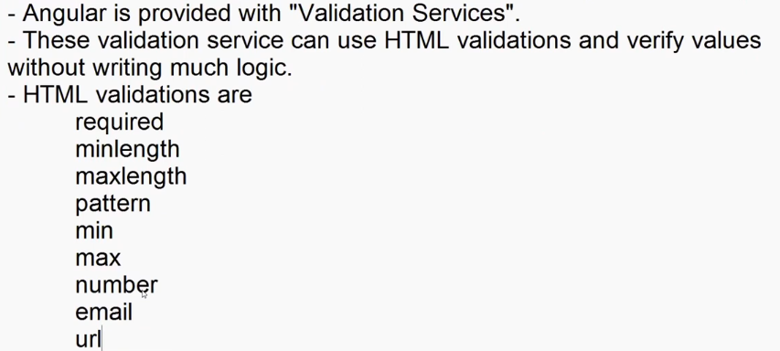

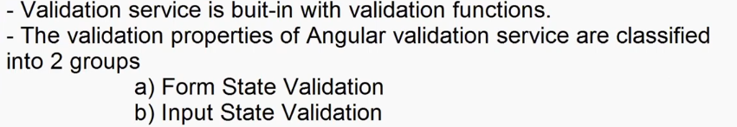

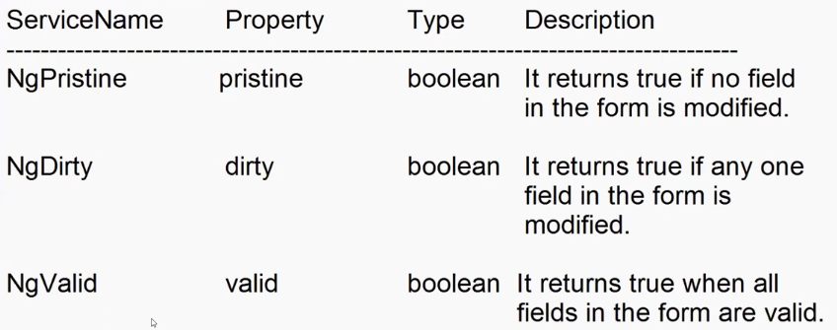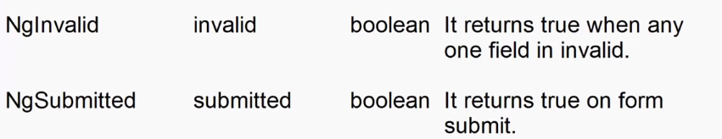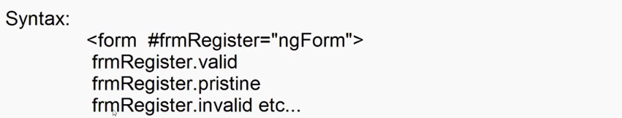

**Template-form.component.html**

<div class="container-fluid">

    <div class="row">

      <div class="col-3">

          <form #frmRegister="ngForm" (submit)="SubmitClick(frmRegister.value)">

              <h2>Register User</h2>

              <dl>

                  <dt>User Name</dt>

                  <dd><input name="UserName" required ngModel #UserName="ngModel" type="text"></dd>

                  <dt>Mobile</dt>

                  <dd><input name="Mobile" required  pattern="\+91\d{10}" ngModel #Mobile="ngModel" type="text"></dd>

                  <dt>City</dt>

                  <dd>

                      <select name="City" ngModel #City="ngModel">

                          <option>Delhi</option>

                          <option>Hyd</option>

                      </select>

                  </dd>

              </dl>

              <button [disabled]="frmRegister.invalid">Register</button>

              <button [disabled]="frmRegister.pristine">Save</button>

          </form>

      </div>

      <div class="col-9">

           <h3>Form State Services</h3>

           <dl>

              <dt>Pristine [Form is Untouched]</dt>

              <dd>{{frmRegister.pristine}}</dd>

              <dt>Dirty [Form Modified]</dt>

              <dd>{{frmRegister.dirty}}</dd>

              <dt>Valid [All Fields are valid]</dt>

              <dd>{{frmRegister.valid}}</dd>

              <dt>Invalid [Any one Field is not Valid]</dt>

              <dd>{{frmRegister.invalid}}</dd>

              <dt>Form Submitted</dt>

              <dd>{{frmRegister.submitted}}</dd>

           </dl>

      </div>

    </div>

  </div>

**template-form.component.css**

.invalid-style {

    background-color: rgb(255, 198, 198);

}

.valid-style {

    background-color: rgb(221, 255, 221);

}

form {

    padding: 20px;

}

**Input State Validation Services**

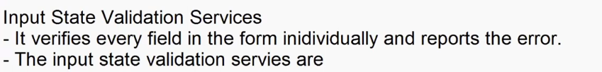

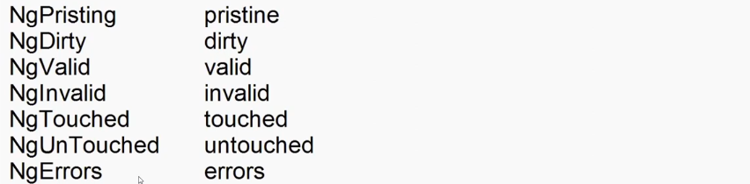

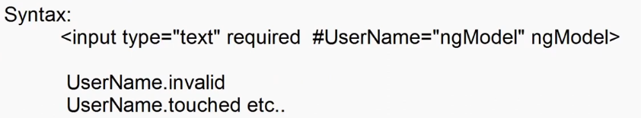

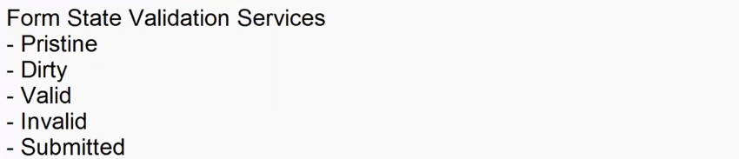

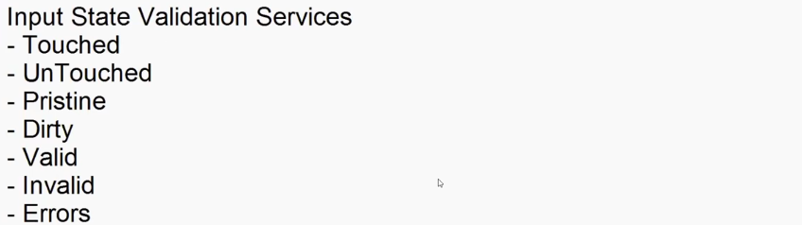

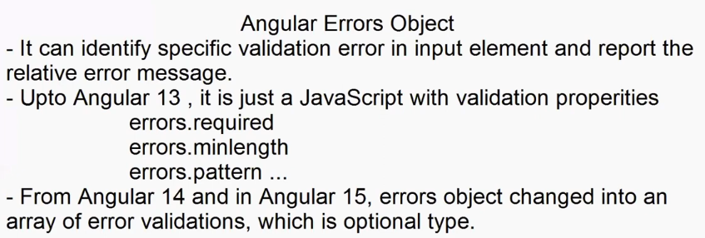 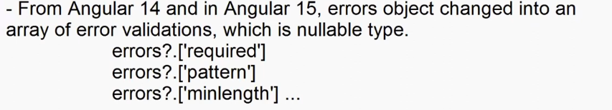





            <dt>City</dt>

            <dd>

                <select (change)="CityChannged($event)" ngModel #City="ngModel"  name="City">

                    <Option value="-1">Select Your City</Option>

                    <Option value="Hyd">Hyd</Option>

                    <Option value="Pune">Pune</Option>

                    <Option value="Delhi">Delhi</Option>

                </select>

            </dd>

  public CityError:string="";

  public CityChannged(e:any):void{

    if(e.target.value==-1){

      this.CityError = "Please select your City";

    }

    else{

      this.CityError="";

    }

  }

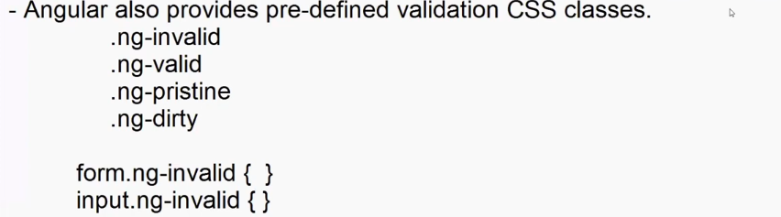

**template-form.component.css**

input.ng-invalid{

    border:2px solid  red;

}

input.ng-valid{

    border:2px solid  green;

    box-shadow: 2px 2px 2px green;

}

form.ng-invalid{

    background-color: rgb(255, 143, 143);

}

form.ng-valid{

    background-color: rgb(143, 255, 180);

}

**Template-form.component.html**

<!-- Angular Error Object -->

  <div class="container-fluid">

    <form class="mt-2 p-4" #frmRegistration="ngForm">

        <h2>Register User</h2>

        <dl>

            <dt>User Name</dt>

            <dd><input type="text" required minlength="4" maxlength="10"  name="UserName" ngModel #UserName="ngModel"></dd>

            <dd class="text-danger" *ngIf="frmRegistration.submitted && UserName.invalid">

                <div *ngIf="UserName.errors?.['required']">User Name Required</div>

                <div *ngIf="UserName.errors?.['minlength']">User Name too short min 4 chars required</div>

                <div *ngIf="UserName.errors?.['maxlength']">User Name too long max 10 chars required</div>

                <!-- <span>User Name Invalid</span> -->

            </dd>

            <dt>Password</dt>

            <dd><input type="password" name="Password" ngModel #Password="ngModel" required pattern="(?=.*[A-Z])\w{4,15}"></dd>

            <dd class="text-danger" *ngIf="(frmRegistration.submitted && Password.invalid) || (Password.touched && Password.invalid )">

                <div *ngIf="Password.errors?.['required']">Password Required</div>

                <div *ngIf="Password.errors?.['pattern']">Password 4 to 15 chars with at least 1 uppercase letter.</div>

            </dd>

            <dt>Mobile</dt>

            <dd><input type="text" name="Mobile" required pattern="\+91\d{10}" ngModel #Mobile="ngModel"></dd>

            <dd class="text-danger" *ngIf="frmRegistration.submitted && Mobile.invalid">

                <div *ngIf="Mobile.errors?.['required']">Mobile Required</div>

                <div *ngIf="Mobile.errors?.['pattern']">Invalid Mobile +91 and 10 digits</div>

            </dd>

            <dt>City</dt>

            <dd>

                <select (change)="CityChannged($event)" ngModel #City="ngModel"  name="City">

                    <Option value="-1">Select Your City</Option>

                    <Option value="Hyd">Hyd</Option>

                    <Option value="Pune">Pune</Option>

                    <Option value="Delhi">Delhi</Option>

                </select>

            </dd>

            <dd class="text-danger">{{CityError}}</dd>

        </dl>

        <button class="btn btn-primary">Register</button>

    </form>

  </div>

**Template-form.component.ts**

  public CityError:string="";

  public CityChannged(e:any):void{

    if(e.target.value==-1){

      this.CityError = "Please select your City";

    }

    else{

      this.CityError="";

    }

  }

**Model Driven or Reactive Forms**

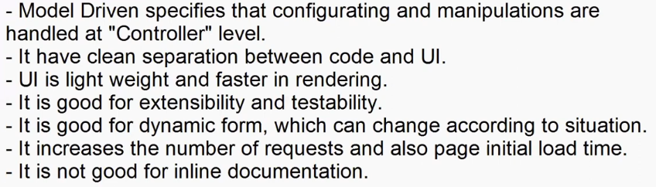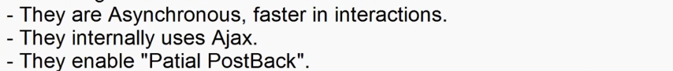 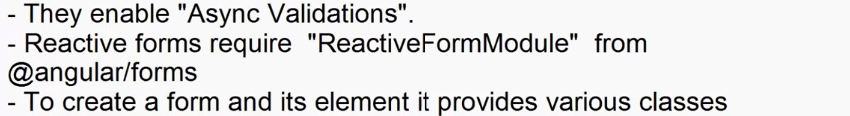

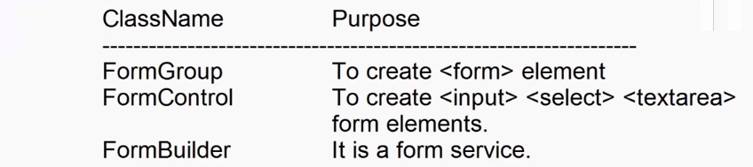 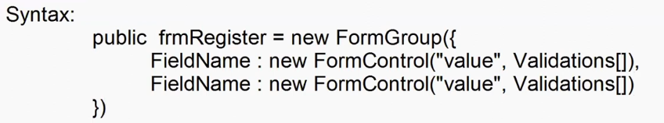

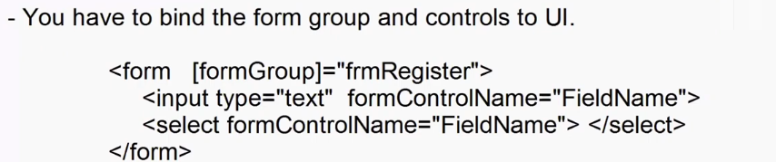



**reactive-form.component.html**

<div class="container-fluid">

    <h2>Register User</h2>

    <form [formGroup]="frmRegister" (submit)="SubmitClick(frmRegister.value)">

        <dl>

            <dt>User Name</dt>

            <dd><input type="text" formControlName="UserName" ></dd>

            <dt>Age</dt>

            <dd><input type="number" formControlName="Age"></dd>

            <dt>Mobile</dt>

            <dd><input type="text" formControlName="Mobile"></dd>

        </dl>

        <button>Register</button>

    </form>

</div>

**reactive-form.component.ts**

import { Component } from '@angular/core';

import {FormGroup, FormControl, Validators} from '@angular/forms'

@Component({

  selector: 'app-reactive-form',

  templateUrl: './reactive-form.component.html',

  styleUrl: './reactive-form.component.css'

})

export class ReactiveFormComponent {

  public frmRegister = new FormGroup({

    UserName: new FormControl('Enter Your Name'),

    Age: new FormControl(0),

    Mobile : new FormControl('')

  })

  public SubmitClick(data:any){

    alert(JSON.stringify(data));

  }

}

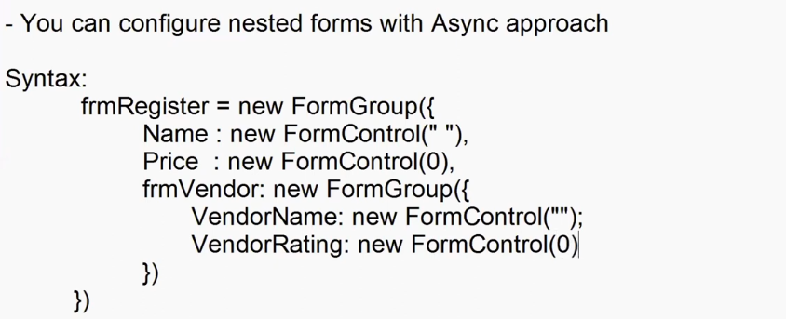

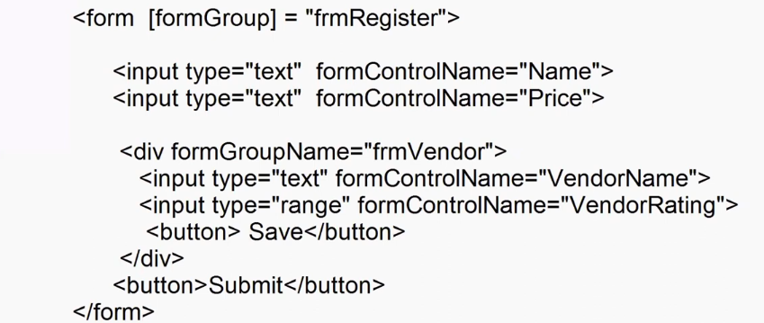

 

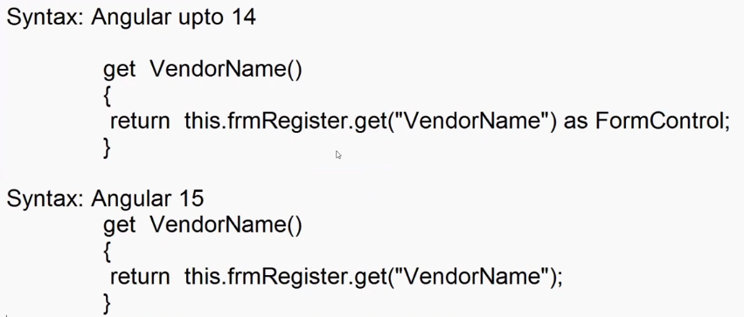 

**reactive-form.component.ts**

  public frmRegister = new FormGroup({

    Name : new FormControl(''),

    Price : new FormControl(0),

    frmVendor: new FormGroup({

      VendorName : new FormControl(''),

      VendorRating: new FormControl(0)

    })

  })

  get VendorName(){

    return this.frmRegister.get("VendorName");

  }

  get VendorRating(){

    return this.frmRegister.get("VendorRating");

  }

  RegisterClick(data:any) {

    alert(JSON.stringify(data));

  }

UpdatePrice() {

    this.frmRegister.patchValue({

      Price:70000.40,

      frmVendor:{

        VendorRating:4.5

      }

    })

    }

**reactive-form.component.html**

<!-- Nested Forms -->

<div class="container-fluid">

    <h2>Product Register</h2>

    <form [formGroup]="frmRegister" (ngSubmit)="RegisterClick(frmRegister.value)">

        <dl>

            <dt>Name</dt>

            <dd><input type="text" formControlName="Name"></dd>

            <dt>Price</dt>

            <dd><input type="number" formControlName="Price"></dd>

        </dl>

        <div formGroupName="frmVendor">

            <h3>Vendor Details</h3>

                <dl>

                    <dt>Vendor Name</dt>

                    <dd><input type="text" formControlName="VendorName"></dd>

                    <dt>Rating</dt>

                    <dd><input type="number" formControlName="VendorRating"></dd>

                </dl>

        </div>

        <button>Register</button><button type="button" (click)="UpdatePrice()">Update</button>

    </form>

</div>

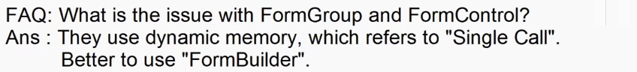

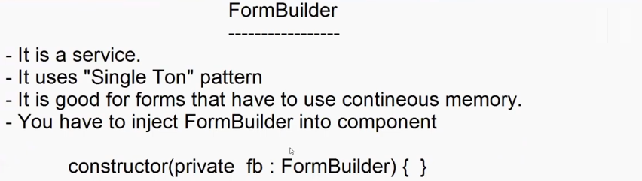

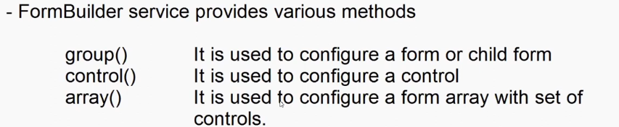

  constructor(private fb:FormBuilder){

  }

  public frmRegister = this.fb.group({

   Name : this.fb.control('' ),

    Price : this.fb.control(0),

    frmVendor: this.fb.group({

      VendorName : this.fb.control(''),

      VendorRating: this.fb.control(0)

    })

  })

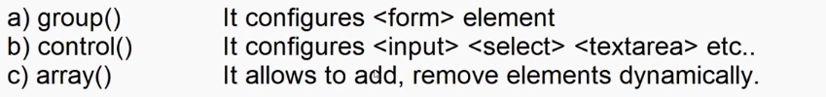

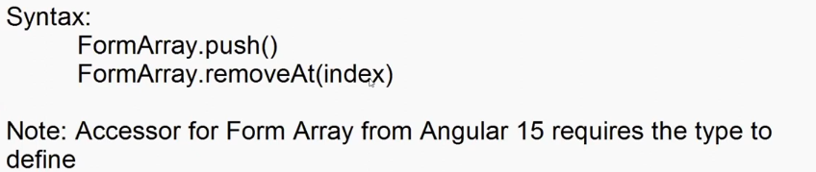

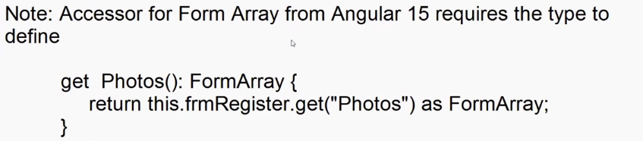

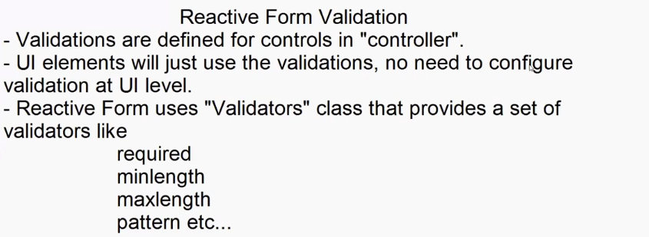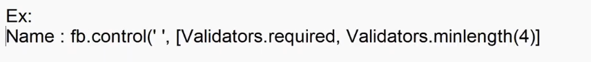

**Reactive-validations.components.ts**

import { Component } from '@angular/core';

import { FormBuilder, FormControl, Validators } from '@angular/forms';

@Component({

  selector: 'app-rective-validations',

  templateUrl: './rective-validations.component.html',

  styleUrl: './rective-validations.component.css'

})

export class RectiveValidationsComponent {

  constructor(private fb:FormBuilder){

  }

  public frmRegister = this.fb.group({

    Name : this.fb.control('',[ Validators.required,Validators.minLength(4)]),

    Mobile: this.fb.control('',[Validators.required,Validators.pattern(/\+91\d{10}/)])

  })

  get Name():FormControl{

    return this.frmRegister.get("Name") as FormControl;

  }

  get Mobile():FormControl{

    return this.frmRegister.get("Mobile") as FormControl;

  }

}

**Reactive-validations.component.html**

<div class="container-fluid">

    <form [formGroup]="frmRegister">

        <h2>Register</h2>

        <dl>

            <dt>Name</dt>

            <dd><input type="text" formControlName="Name"></dd>

            <dd class="text-danger" *ngIf="Name.touched  && Name.invalid">

                <div *ngIf="Name.errors?.['required']">Name Required</div>

                <div *ngIf="Name.errors?.['minlength']">Name too Short Min 4 char required</div>

            </dd>

            <dt>Mobile No</dt>

            <dd><input type="text" formControlName="Mobile"></dd>

            <dd class="text-danger" *ngIf="Mobile.touched && Mobile.invalid">

                <div *ngIf="Mobile.errors?.['required']">Mobile No Required</div>

                <div *ngIf="Mobile.errors?.['pattern']">Invalid Mobile +91 and 10 digits</div>

            </dd>

        </dl>

        <button>Submit</button>

    </form>

</div>

**Angular Routing**

